GCSE ENGLISH 2022: THE RACE TO EXAMS
 | Monday | Tuesday | Wednesday | Thursday | Friday | Saturday | Sunday | MINS
28th March 2022
4th April 2022
11th April 2022
18th April 2022
25th April 2022
2nd May 2022
9th May 2022
16th May 2022 |  |  | Language Paper 1
23rd May 2022 |  |  | Lit 1  ACC + Poetry
30th May 2022
6th June 2022 |  |  | Lit 2 Macbeth + Unseen Poetry |  | Language paper 2
13th June 2022
MY KEY: | BRONZE | SILVER | GOLD
Every day you should complete at least one revision activity (min 5minutes). This can be a bronze, silver, or gold revision task. In this booklet you have a series of example tasks for each (bronze, silver, gold) and you can select them from the booklet or allocate them yourself. A bronze task means 5- 20 minutes, silver is 20-40 minutes, and gold is 40 minutes – 1 hour. There are a range of suggested tasks for each level. On here, record your level AND the number of minutes spent revising in the final column.

LIT | BRONZE:  5-20 minutes | SILVER:  20-40 minutes | GOLD:  40 minutes  – 1 hour
A CHRISTMAS CAROL | - Write a summary of a key character using quotations (Scrooge, each ghost, Cratchits)  - Choose a theme or character and write a plan entirely from memory (wealth, Christmas, family, redemption, supernatural, the poor)  - Spend 5-20 minutes learning a section of your knowledge organiser or do the quiz on P43  - Complete a quotation explosion  - Spend 10 minutes writing a paragraph | - Choose a theme and create a detailed mind-map. Begin with your own ideas from memory and then add any ideas from notes you have.  - Watch the 25-minute version of ‘A Christmas Carol’ and make a timeline  - Complete some revision into Victorian England and Charles Dickens’ influences. Write a summary of why you think he wrote ‘A Christmas Carol’  - Use the hexagon grid in the pack (you can ask for more!) to connect your knowledge of the novella. Add events, quotations etc and connect them.  - Pick a quotation from the text and explode it, then write a paragraph on it.  - Complete a brain dump for any of the themes using pages 45-47 | - Complete a full ‘A Christmas Carol’ response in 50 minutes.  - Re-read a section of the text and add additional notes
MACBETH | - Write a summary of a key character using quotations (Macbeth, Lady Macbeth, Banquo)  - Choose a theme or character and write a plan entirely from memory (power, ambition, supernatural, kingship, gender, secrecy)  - Spend 5-20 minutes learning a section of your knowledge organiser or do the quiz on P36  - Complete a quotation explosion  - Spend 10 minutes writing a paragraph | - Choose a theme and create a detailed mind-map. Begin with your own ideas from memory and then add any ideas from notes you have.  - Watch the animated 25 minute version of ‘Macbeth’ and make a timeline  - Complete some revision into Jacobean England and William Shakespeare’s’ influences. Write a summary of why you think he wrote ‘Macbeth’  - Use the hexagon grid in the pack (you can ask for more!) to connect your knowledge of the novella. Add events, quotations etc and connect them.  - Pick a quotation from the text and explode it, then write a paragraph on it.  - Complete a brain dump for any of the themes using pages 39-41 | - Complete a full ‘Macbeth’ response in 55 minutes.  - Re-read a section of the text and add additional notes
POETRY | - Write a summary of a poem using quotations  - Choose a theme and write a plan entirely from memory (power, conflict, war, memory, trauma, emotion, anger, nature, soldiers)  - Spend 5-20 minutes learning a section of your knowledge organiser or do the quiz on P51-52  - Annotate a fresh poem with basic ideas.  - Complete a quotation explosion  - Spend 10 minutes writing a paragraph | - Watch any of the videos annotating the poem, or other analysis videos  - Complete some revision into one of the poems. For example, research Wilfred Owen’s life and the inspiration behind his poems, as well as WWI.  - Use the hexagon grid in the pack (you can ask for more!) to connect your knowledge of the novella. Add events, quotations etc and connect them.  - Pick a quotation from the text and explode it, then write a paragraph on it.  - Complete a brain dump for any of the themes using pages 50-51  - Choose one poem and write it in the middle of a page. Create a mind-map where you link the poem to 5 other poems, giving quotations to make links. | - Complete a full poetry response in 50 minutes.  - Print a fresh poem and annotate it using research and online videos
UNSEEN POETRY | - Choose a song that you like and annotate a key line with your analysis ideas.  - Read the lyrics of a song you like and then write a paragraph explaining what it’s about  - Choose a poem using poetryfoundation.org and annotate it/ write a summary of it  - Spend 10 minutes writing a paragraph | - Use one of the practice questions, complete a 35 minute single poem response. Read the poem and write the response.  - Spend 20 minutes annotating a poem and considering all the things you might cover if you had to analyse it.  - Choose a song you like and write 3 analysis paragraphs covering how the song presents a topic or theme of your choice.  - Complete a comparison of methods question (5 mins reading, 15 writing) | - Complete a full exam for 50 minutes. Analyse a single poem for 35 minutes and then compare the methods for 15 minutes

LANG | BRONZE:  5-20 minutes | SILVER:  20-40 minutes | GOLD:  40 minutes  – 1 hour
PAPER 1 FICTION RESPONSE | - Read an extract (10 mins) and complete Q1 (5 mins) =15  - Read an extract (10 mins) and complete Q2 (10 mins) =20  - Read an extract (10 mins) and complete Q3 (10 mins) =20  - Complete any of the practice questions on pages 8-13 | - Read an extract (10 mins) and complete Q4 (25 mins) = 35 mins  - Complete either of the mini question 4s on page 12 and 13. There is space to plan your answer, but you could write it too.  - Complete the paper 1 overview grid on page 18 | - Complete a full mini mock in 1 hour total
PAPER 2 NON- FICTION RESPONSE | - Read an extract (10 mins) and complete Q1 (5 mins) =15  - Read an extract (10 mins) and complete Q2 (10 mins) =20  - Complete any of the practice questions on pages 19-22  - Spend 5-20 minutes reading news articles online and writing about what you think the writer’s viewpoint is | - Read an extract (10 mins) and complete Q3 (15 mins) =25 mins  - Read an extract (10 mins) and complete Q4 (20 mins) = 30 mins  - Complete any of the mini question 4s on page 23-25. There is space to plan your answer, but you could write it too.  - Complete the paper 2 overview grid on page 32 | - Complete a full mini mock in 1 hour total
PAPER 1 CREATIVE WRITNG | - Use pixabay or unsplash (free photo sites) and choose a photo. Write a plan for that image (5 minutes) or a paragraph describing it (10 minutes).  - There are some practice questions in this booklet. Choose one and spend 5 minutes planning it.  - Use one of your plans/images/practice questions and list 5 words you might use for it. Use thesaurus.com to improve the words, and then try and use them in a sentence.  - Choose one of your plans and write the opening and closing sentence from each paragraph.  - Choose a random place and spend 10 minutes describing it.  - Choose a type of weather and spend 10 mins describing it. | - Spend 20-30 minutes creating a character you could use in any piece of writing. Find images of them on Pixabay or Unsplash, then create a profile for them of their background, hobbies etc. Then choose 3 practice questions and write about they would behave and move through that setting, and all their reactions.  - After writing a plan, write the drop and shift paragraphs (10 minutes each) focusing on juxtaposition between the two.  - Pick an image and write a sentence using each of the following: simile, metaphor, personification, zoomorphism, list of 3. Then spend 10 minutes upgrading the vocabulary you have used.  - Create a checklist of a good paragraph, and return to a paragraph you have previously written. Re-write it to hit your checklist. | - Complete a full response in 45 minutes
PAPER 2 VIEWPOINT WRITING | - Write a sentence about something you disagree with in school. Then write a plan for an article about that issue.  - Use the list of issues on page 5 and write 10 headlines about each of those topics.  - Use the list of issues on page 5 and write a statement giving a ridiculous view on one of the topics. Plan an article you would write in response to the statement.  - Go through the issues on page 5 and write an anecdote opening about the issue for 10 minutes.  - Complete research on one of the issues or statements on page 5 so you have an idea of what you might include.  - Research common article features and rhetorical devices. | - Write a letter to Mr Potter about what you would change about the school, persuading him to agree  - Go on BBC News, Guardian Newsbeat or Newsround website and find a topic you have an opinion on. Write your own article about that issue.  - Spend 10 minutes writing an anecdote on a topic of your choice. Then spend 10 minutes improving a range of words in the paragraph using an online thesaurus.  - Read an online article about a topic of your choice. Re-write a paragraph improving the vocabulary, sentence structures, adding a range of punctuation etc.  - Revise sentence types and punctuation types. | - Complete a full response in 45 minutes

Resources in this pack – contents page
Overview | Race to exams calendar |  |  | 1
Overview | Suggested revision activities (lit and lang) |  |  | 2-3
Overview | This contents page |  |  | 4
Writing | Paper 2, Question 5: viewpoint issues and tasks |  |  | 5
Writing | Paper 1, Question 5: images and tasks |  |  | 6-7
Paper 1 Practice Questions | Paper 1, Question 1 : 3 mini practice questions |  |  | 8
Paper 1 Practice Questions | Paper 1, Question 2 : 2 mini practice questions |  |  | 9
Paper 1 Practice Questions | Paper 1, Question 3 : 2 mini practice questions |  |  | 10-11
Paper 1 Practice Questions | Paper 1, Question 4 : 2 mini practice questions |  |  | 12-13
Paper 1 Practice Questions | Paper 1 full practice paper: ‘Fire Colour One’ Q1-5 |  |  | 14-15
Paper 1 Practice Questions | Paper 1 full practice paper: ‘Call of the Wild’ Q1-5 |  |  | 16-17
Paper 1 Practice Questions | Paper 1 overview grid |  |  | 18
Paper 2 Practice Questions | Paper 2, Question 1 : 3 mini practice questions |  |  | 19
Paper 2 Practice Questions | Paper 2, Question 2 : 1 mini practice question |  |  | 20-21
Paper 2 Practice Questions | Paper 2, Question 3 : 2 mini practice questions |  |  | 22
Paper 2 Practice Questions | Paper 2, Question 4 : 2 mini practice questions |  |  | 23-25
Paper 2 Practice Questions | Paper 2 full practice paper: travelling |  |  | 26-28
Paper 2 Practice Questions | Paper 2 full practice paper: parenting |  |  | 29-31
Paper 2 Practice Questions | Paper 2 overview grid |  |  | 32
Unseen | Unseen mixed poems to analyse x7 |  |  | 33-34
Unseen | Unseen practice papers – both questions |  |  | 35-37
Macbeth | Image quotations quiz |  |  | 38
Macbeth | Themes brain dump spaces |  |  | 39-41
Macbeth | Mini practice questions x8 |  |  | 42-43
A Christmas Carol | Image quotations quiz |  |  | 44
A Christmas Carol | Themes brain dump spaces |  |  | 45-47
A Christmas Carol | Mini practice questions x8 |  |  | 48-49
Poetry | Image quotations quiz |  |  | 50-51
Poetry | Themes brain dump spaces |  |  | 52-53
Poetry | Mini practice questions x6 |  |  | 54-55
General resources | Hexagon sheet for making links |  |  | 56-57
General resources | Terminology knowledge organiser |  |  | 58
General resources | ‘Macbeth’ knowledge organiser |  |  | 59
General resources | ‘A Christmas Carol’ knowledge organiser |  |  | 60
General resources | 4 x poetry knowledge organisers |  |  | 61-64
Paper 2, Question 5 – Viewpoint Writing
Below there are 60 viewpoint topics which are written as questions. You can use these to write statements or just write an article about them as they are (or make mini plans for each) |  |  | On this side there are 14 example P2Q5 questions for you to work through – write plans, or answers, or parts of answers.
- Is global climate change caused by humans?  - Is the death penalty effective?  - Is our election process fair?  - Is torture ever acceptable?  - Should men get paternity leave from work?  - Are school uniforms beneficial?  - Do we have a fair tax/benefits system?  - Do curfews keep teens out of trouble?  - Is cheating out of control?  - Are we too dependent on computers?  - Should animals be used for research?  - Should cigarette smoking be banned?  - Are cell phones dangerous?  - Are law enforcement cameras an invasion of privacy?  - Do we have a throwaway society?  - Is child behaviour getting better or worse?  - Should companies market to children?  - Should the government have a say in our diets?  - Does access to condoms prevent teen pregnancy?  - Should the summer holidays be shorter?  - Are actors and professional athletes paid too much?  - Are CEOs paid too much?  - Should athletes be held to high moral standards?  - Do violent video games cause behaviour problems?  - Should creationism be taught in public schools?  - Are beauty pageants exploitative?  - Should gambling be treated as a drug and limited?  - Should the racing industry be forced to use biofuels?  - Should the alcohol drinking age be increased?  - Should everyone be required to recycle?  - Is it okay for prisoners to vote?  - Should same-sex couples be able to marry?  - Are there benefits to attending a single-sex school?  - Does boredom lead to trouble?  - Should schools use corporal punishment?  - Does religion cause war?  - Should the government provide health care?  - Should abortion be illegal?  - Are girls too mean to each other?  - Is homework harmful or helpful?  - Is the cost of university too high?  - Is university admission too competitive?  - Should euthanasia be illegal?  - Should the government legalize marijuana use?  - Should rich people be required to pay more taxes?  - Should schools require improved PE provision?  - Should schools teach more real life skills?  - Is public prayer okay in schools?  - Are schools and teachers responsible for GCSE results?  - Is greater gun control in the US a good idea?  - Should it be illegal to not recycle?  - Do we need more youth clubs in the UK?  - Should school start later in the morning?  - Should women have free access to sanitary products?  - Is the prison system too soft/relaxed?  - Should everyone have to give to charity?  - Has Christmas become too commercialised?  - Should public transport be freely available to all?  - Should the NHS be free to everyone?  - Should the UK welcome more refugees? |  | “Students of exam age should not be allowed to work. They should concentrate on their studies, not earning extra money”  Write an article giving your view on this statement.
“Charity begins at home. Special events like Comic Relief are unnecessary, as we need to focus on looking after our own”
Write an article giving your view on this statement.
“All teenagers should be required to visit a museum and a theatre before they turn 18. It’s an important cultural experience that they will learn from”
Write an article giving your view on this statement.
“Reading is a thing of the past. The Government should stop funding libraries and spend that money on something more useful, like roads and public transport”
Write an article giving your view on this statement.
 |  | “Covid and lockdowns were dangerous to our mental health. Now more than ever we need to socialise and spend time with others” Write an article giving your view on this statement.
“We need to slow down our advances in technology. Soon there will be moral and ethical questions regarding things like time travel and virtual reality.”
Write an article giving your view on this statement.
“Encouraging women to work and be independent has damaged our children, who don’t have stable and welcoming homes anymore.”
Write an article giving your view on this statement.
“There should be limits and fines imposed on those in the media who spread fake news. It’s damaging to society!”
Write an article giving your view on this statement.
“Social media is doing damage to teenager’s mental health and body image. It should be limited to those age 18+
Write an article giving your view on this statement.”
“The time teenagers spend on tablets and phones should be limited. They should be encouraged to go outdoors more”
Write an article giving your view on this statement.
“Schools need to stop spending time on subjects like maths and English, and focus on the subjects of the future like IT”
Write an article giving your view on this statement.
“Everybody should contribute towards improving the environment. Morally, it’s the right thing to do”
Write an article giving your view on this statement.
“Cars and roads are much safer in the modern age. We should allow teenagers to drive from a much younger age in the UK.”
Write an article giving your view on this statement.
“Teenagers have to spend their time outside on the streets because there aren’t enough places for them to go”
Write an article giving your view on this statement.

Paper 1, Question 5 – Creative Writing
For the following mini questions you might choose to spend 5 minutes writing a plan, write an opening drop paragraph for multiple pictures, or perhaps use them to practice a whole piece.
Either write a description suggested by this picture:    OR write the opening a story titled ‘At the palace’ | Either write a description suggested by this picture:  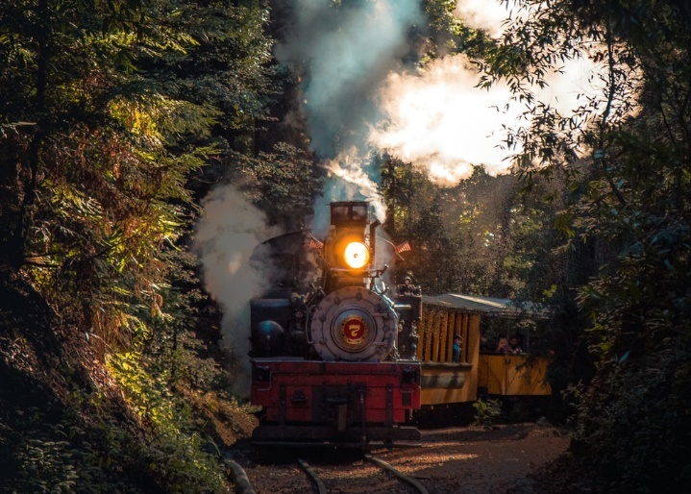  OR write the opening a story about a journey
Either write a description suggested by this picture:    OR write the opening a story beginning ‘It was cosy…’ | Either write a description suggested by this picture:    OR write the opening a story about a natural disaster
Either write a description suggested by this picture:  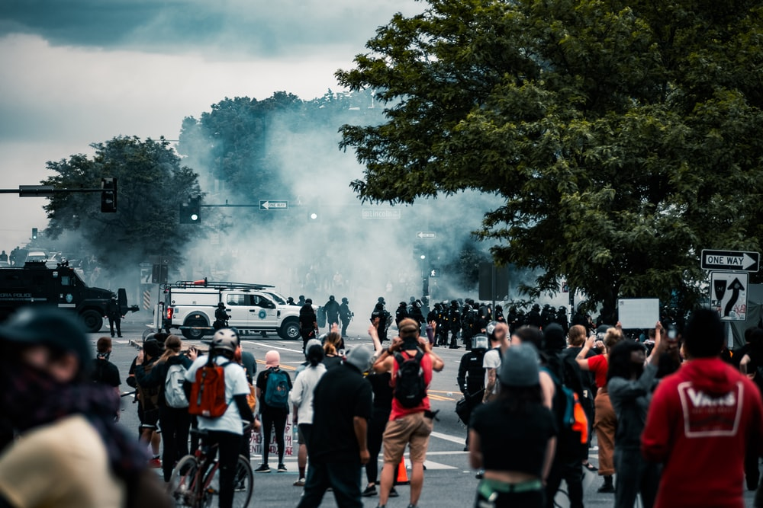  OR write the opening a story titled ‘Riot’. | Either write a description suggested by this picture:    OR write the opening a story set at night

Paper 1, Question 5 – Creative Writing
Either write a description suggested by this picture:    OR write the opening a story titled ‘The Escape’ | Either write a description suggested by this picture:    OR write the opening a story set at a public event
Either write a description suggested by this picture:  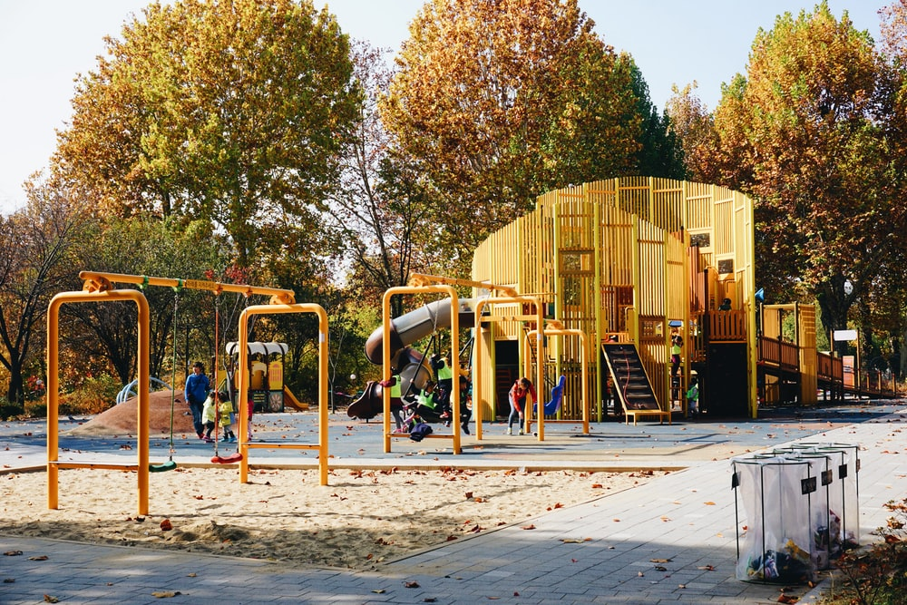  OR write the opening a story which includes children | Either write a description suggested by this picture:    OR write the opening a story set in an airport
Either write a description suggested by this picture:    OR write the opening a story which begins on a bridge | Either write a description suggested by this picture:    OR write the opening a story set on holiday

Paper 1, Question 1
Practice Questions |  |  |  |  |  | Quickly identify four pieces of information from the text
The Republican sniper smiled and lifted his revolver above the edge of the parapet.The distance was about fifty yards--a hard shot in the dim light, and his right arm was paining him like a thousand devils. He took a steady aim. His hand trembled with eagerness. Pressing his lips together, he took a deep breath through his nostrils and fired. He was almost deafened with the report and his arm shook with the recoil.  From ‘The Sniper’ by Liam OFlaherty |  |  |  |  |  | List four things you learn about what the sniper does.
 |  |  |  |  |  | A)
 |  |  |  |  |  | B)
 |  |  |  |  |  | C)
 |  |  |  |  |  | D)
The scurrying crowd came at last to the big gate in the wall of the doctor's house. They could hear the splashing water and the singing of caged birds and the sweep of the long brooms on the flagstones. And they could smell the frying of good bacon from the doctor's house. Kino hesitated a moment. This doctor was not of his people. Kino hesitated a moment. This doctor was not of his people. This doctor was of a  race which for nearly four hundred years had beaten and starved and robbed and despised Kino's race.  From ‘The Pearl’ by John Steinbeck |  |  |  |  |  | List four things you learn about the doctor.
 |  |  |  |  |  | A)
 |  |  |  |  |  | B)
 |  |  |  |  |  | C)
 |  |  |  |  |  | D)
Billy was seventeen years old. He was wearing a new navy-blue overcoat, a  new brown trilby hat, and a new brown suit, and he was feeling fine. He walked  briskly down the street. He was trying to do everything briskly these days.  Briskness, he had decided, was the one common characteristic of all successful  businessmen. The big shots up at Head Office were absolutely fantastically brisk all the time. They were amazing.  From ‘The Landlady by Roald Dahl |  |  |  |  |  | List four things you learn about Billy
 |  |  |  |  |  | A)
 |  |  |  |  |  | B)
 |  |  |  |  |  | C)
 |  |  |  |  |  | D)
Paper 1, Question 2
Practice Questions |  |  |  |  | Decide on the two-three quotations you would pick, your terminology and effect.
The sniper looked at his enemy falling and he shuddered. The lust of battle died in him. He became bitten by remorse. The sweat stood out in beads on his forehead. Weakened by his wound and the long summer day of fasting and watching on the roof, he revolted from the sight of the shattered mass of his dead enemy. His teeth chattered, he began to gibber to himself, cursing the war, cursing himself, cursing everybody. From ‘The Sniper’ by Liam OFlaherty
How does the writer use language to describe the sniper’s reaction?
Quotation | Terminology |  |  |  |  |  |  | Effect
Green curtains (some sort of velvety material) were hanging down on either side of the window. The flowers looked wonderful beside them. He went right up and peered through the glass into the room, and the first thing he saw was a bright fire burning in the hearth. On the carpet in front of the fire, a pretty little dachshund was curled up asleep with its nose tucked into its belly. The room itself, so far as he could see in the half-darkness, was filled with pleasant furniture. There was a baby-grand piano and a big sofa and several plump armchairs; and in one corner he spotted a large parrot in a cage. Animals were usually a good sign in a place like this, Billy told himself; and all in all, it looked to him as though it would be a pretty decent house to stay in. From ‘The Landlady by Roald Dahl How does the writer use language to describe the B&B?
Quotation |  | Terminology |  |  |  |  | Effect
Paper 1, Question 3
Use this space to draw and label freytag’s pyramid
Practice Question 1 |  |  |  | Use the terminology above to identify three key parts of the text and their effect on the reader.
The Republican sniper smiled and lifted his revolver above the edge of the parapet. The distance was about fifty yards--a hard shot in the dim light, and his right arm was paining him like a thousand devils. He took a steady aim. His hand trembled with eagerness. Pressing his lips together, he took a deep breath through his nostrils and fired. He was almost deafened with the report and his arm shook with the recoil.
Then when the smoke cleared, he peered across and uttered a cry of joy. His enemy had been hit. He was reeling over the parapet in his death agony. He struggled to keep his feet, but he was slowly falling forward as if in a dream. The rifle fell from his grasp, hit the parapet, fell over, bounded off the pole of a barber's shop beneath and then clattered on the pavement.
Then the dying man on the roof crumpled up and fell forward. The body turned over and over in space and hit the ground with a dull thud. Then it lay still.
The sniper looked at his enemy falling and he shuddered. The lust of battle died in him. He became bitten by remorse. The sweat stood out in beads on his forehead. Weakened by his wound and the long summer day of fasting and watching on the roof, he revolted from the sight of the shattered mass of his dead enemy. His teeth chattered, he began to gibber to himself, cursing the war, cursing himself, cursing everybody.
He looked at the smoking revolver in his hand, and with an oath he hurled it to the roof at his feet. The revolver went off with a concussion and the bullet whizzed past the sniper's head. He was frightened back to his senses by the shock. His nerves steadied. The cloud of fear scattered from his mind and he laughed.
Taking the whiskey flask from his pocket, he emptied it a drought. He felt reckless under the influence of the spirit. He decided to leave the roof now and look for his company commander, to report. Everywhere around was quiet. There was not much danger in going through the streets. He picked up his revolver and put it in his pocket. Then he crawled down through the skylight to the house underneath.
When the sniper reached the laneway on the street level, he felt a sudden curiosity as to the identity of the enemy sniper whom he had killed. He decided that he was a good shot, whoever he was. He wondered did he know him. Perhaps he had been in his own company before the split in the army. He decided to risk going over to have a look at him. He peered around the corner into O'Connell Street. In the upperpart of the street there was heavy firing, but around here all was quiet.
The sniper darted across the street. A machine gun tore up the ground around him with a hail of bullets, but he escaped. He threw himself face downward beside the corpse. The machine gun stopped.
Then the sniper turned over the dead body and looked into his brother's face.
How has the writer structured the text to interest the reader?
What? |  |  | What? |  |  |  |  |  | What?
Effect |  |  | Effect |  |  |  |  |  | Effect
Practice Question 2 |  |  |  | Use the terminology above to identify three key parts of the text and their effect on the reader.
Silence. A summer-night silence which lay for a thousand miles, which covered the earth like a white and shadowy sea. Faster, faster! She went down the steps. Run! Only a little way,
she prayed. One hundred eight, nine, one hundred ten steps! The bottom! Now, run! Across the bridge! She told her legs what to do, her arms, her body, her terror; she advised all parts of herself in this white and terrible moment, over the roaring creek waters, on the hollow, thudding, swaying almost alive, resilient bridge planks she ran, followed by the wild footsteps behind, behind.
He’s following. Don’t turn, don’t look! If you see him, you’ll not be able to move, you’ll be so frightened. Just run, run! She ran across the bridge. Oh, God, God, please, please let me get up the hill! Now up the path, now between the hills, oh God, it’s dark, and everything so far away. If I screamed now it wouldn’t help; I can’t scream anyway. Here’s the top of the path, here’s the street, oh, God, please let me be safe, if I get home safe I’ll never go out alone; I was a fool, let me admit it, I was a fool, I didn’t know what terror was, but if you let me get home from this I’ll never go without Helen or Francine again! Here’s the street. Across the street! She crossed the street and rushed up the sidewalk. Oh God, the porch! My house!
Oh God, please give me time to get inside and lock the door and I’ll be safe! And there—silly thing to notice—why did she notice, instantly, no time, no time—but there it was anyway, flashing by—there on the porch rail, the half-filled glass of lemonade she had abandoned a long time, a year, half an evening ago! The lemonade glass sitting calmly, imperturbably there on the rail . . . and . . .
She heard her clumsy feet on the porch and listened and felt her hands scrabbling and ripping at the lock with the key. She heard her heart. She heard her inner voice screaming. The key fit. Unlock the door, quick, quick! The door opened. Now - inside! Slam it! She slammed the door. “Now lock it, bar it, lock it!” she gasped wretchedly. “Lock it, tight, tight!” The door was locked and bolted tight. She listened to her heart again and the sound
of it diminishing into silence. Home! Oh God, safe at home! Safe, safe and safe at home! She slumped against the door. Safe, safe. Listen. Not a sound. Safe, safe, oh thank God, safe at home. I’ll never go out at night again. I’ll stay home. I won’t go over that ravine again ever. Safe, oh safe, safe home, so good, so good, safe! Safe inside, the door locked. Wait. Look out the window. She looked. Why, there’s no one there at all!
Nobody. There was nobody following me at all. Nobody running after me. She got her
breath and almost laughed at herself. It stands to reason. If a man had been following me, he’d have caught me! I’m not a fast runner. . . . There’s no-one on the porch or in the yard. How silly of me. I wasn’t running from anything. That ravine’s as safe as anyplace. Just the same, it’s nice to be home. Home’s the really good warm place, the only place to be.
She put her hand out to the light switch and stopped. “What?” she asked. “What, what?” Behind her in the living room, someone cleared his throat.
How has the writer structured the text to interest the reader?
What? |  |  | What? |  |  |  |  |  | What?
Effect |  |  | Effect |  |  |  |  |  | Effect

Paper 1, Question 4
Practice Question 1 |  |  | Split the statement into three different points then find your analysis and effect for each quotation.
After dithering about like this in the cold for two or three minutes, Billy decided that he would walk on and take a look at The Bell and Dragon pub before making up his mind. He turned to go. And now a strange thing happened to him. He was in the act of stepping back and turning away from the window when all at once his eye was caught and held in the most peculiar manner by the small notice that was there. BED AND BREAKFAST, it said. BED AND BREAKFAST,
BED AND BREAKFAST, BED AND BREAKFAST. Each word was like a large black eye staring at him through the glass, holding him, hypnotising him, forcing him to stay where he was and not to walk away from that house, and the next thing he knew, he was actually moving across from the window to the front door of the house, climbing the steps that led up to it, and reaching for the door-bell.
He pressed the bell. Far away in a back room he heard it ringing, and then at once – it must have been at once because he hadn’t even had time to take his finger from the bell-button – the door swung open and a woman was standing there. Now, normally you ring the door-bell and you have at least a half-minute’s wait before the door opens. But this woman was a like a jack-in-a-box. He
pressed the bell – and out she popped! It made him jump.
She was about forty-five or fifty years old, and the moment she saw him, she gave him a warm welcoming smile. “Please come in,” she said pleasantly. She stepped aside, holding the door wide open, and Billy found himself automatically starting forward into the house. The compulsion or, more accurately, the desire to follow after her into the house was extraordinarily strong. “I saw the notice in the window,” he said, holding himself back.
“Yes, I know.”
“I was wondering about a room.”
“It's all ready for you, my dear,” she said.
A student, having read this section of the text, said, “I like how the writer creates a creepy, strange atmosphere and makes the Landlady an unusual character”. To what extent do you agree?
Point/ Evidence
Term
Explain
Reader
Term
Explain
Reader
Paper 1, Question 4
Practice Question 2 |  |  | Split the statement into three different points then find your analysis and effect for each quotation.
She heard her clumsy feet on the porch and listened and felt her hands scrabbling and ripping at the lock with the key. She heard her heart. She heard her inner voice screaming. The key fit. Unlock the door, quick, quick! The door opened. Now - inside! Slam it! She slammed the door. “Now lock it, bar it, lock it!” she gasped wretchedly. “Lock it, tight, tight!” The door was locked and bolted tight. She listened to her heart again and the sound
of it diminishing into silence. Home! Oh God, safe at home! Safe, safe and safe at home! She slumped against the door. Safe, safe. Listen. Not a sound. Safe, safe, oh thank God, safe at home. I’ll never go out at night again. I’ll stay home. I won’t go over that ravine again ever. Safe, oh safe, safe home, so good, so good, safe! Safe inside, the door locked. Wait. Look out the window. She looked. Why, there’s no one there at all!
Nobody. There was nobody following me at all. Nobody running after me. She got her
breath and almost laughed at herself. It stands to reason. If a man had been following me, he’d have caught me! I’m not a fast runner. . . . There’s no-one on the porch or in the yard. How silly of me. I wasn’t running from anything. That ravine’s as safe as anyplace. Just the same, it’s nice to be home. Home’s the really good warm place, the only place to be.
She put her hand out to the light switch and stopped. “What?” she asked. “What, what?” Behind her in the living room, someone cleared his throat.
A student, having read this section of the text, said, “This part is where the tension falls but the reader is still nervous and worried for the main character”. To what extent do you agree?
Point/ Evidence
Term
Explain
Reader
Term
Explain
Reader

Fire colour one extract

Paper 1: Fire Colour One
- Use lines 1-4.
List four things you learn about the fire. [4 marks]

- Use lines 04-13.
How does the writer use language to describe the family’s reactions to the fire?
You could include the writer’s choice of:
- words and phrases
- language features and techniques
- sentence forms. [8 marks]

- You now need to think about the whole of the source. This text is from the opening of a novel.
How has the writer structured the text to interest you as a reader?
You could write about:
- what the writer focuses your attention on at the beginning
- how and why the writer changes the focus as the source develops
- any other structural features that interest you. [8 marks]

- Use lines 14 to the end of the text, line 42.
A student, having read this text, said “I like how the writer creates a sad mood here, we feel sorry for the narrator and start to dislike the other adults in the story”
To what extent do you agree?
In your response, you could:
- Write about your own impressions of the characters and mood
- Evaluate how the writer has created these impressions
- Support your opinions with references to the text. [20 marks]

- Using the image provided, write a description suggested by the picture OR
Write the opening of a story where a character is suffering from a loss. [40 marks]

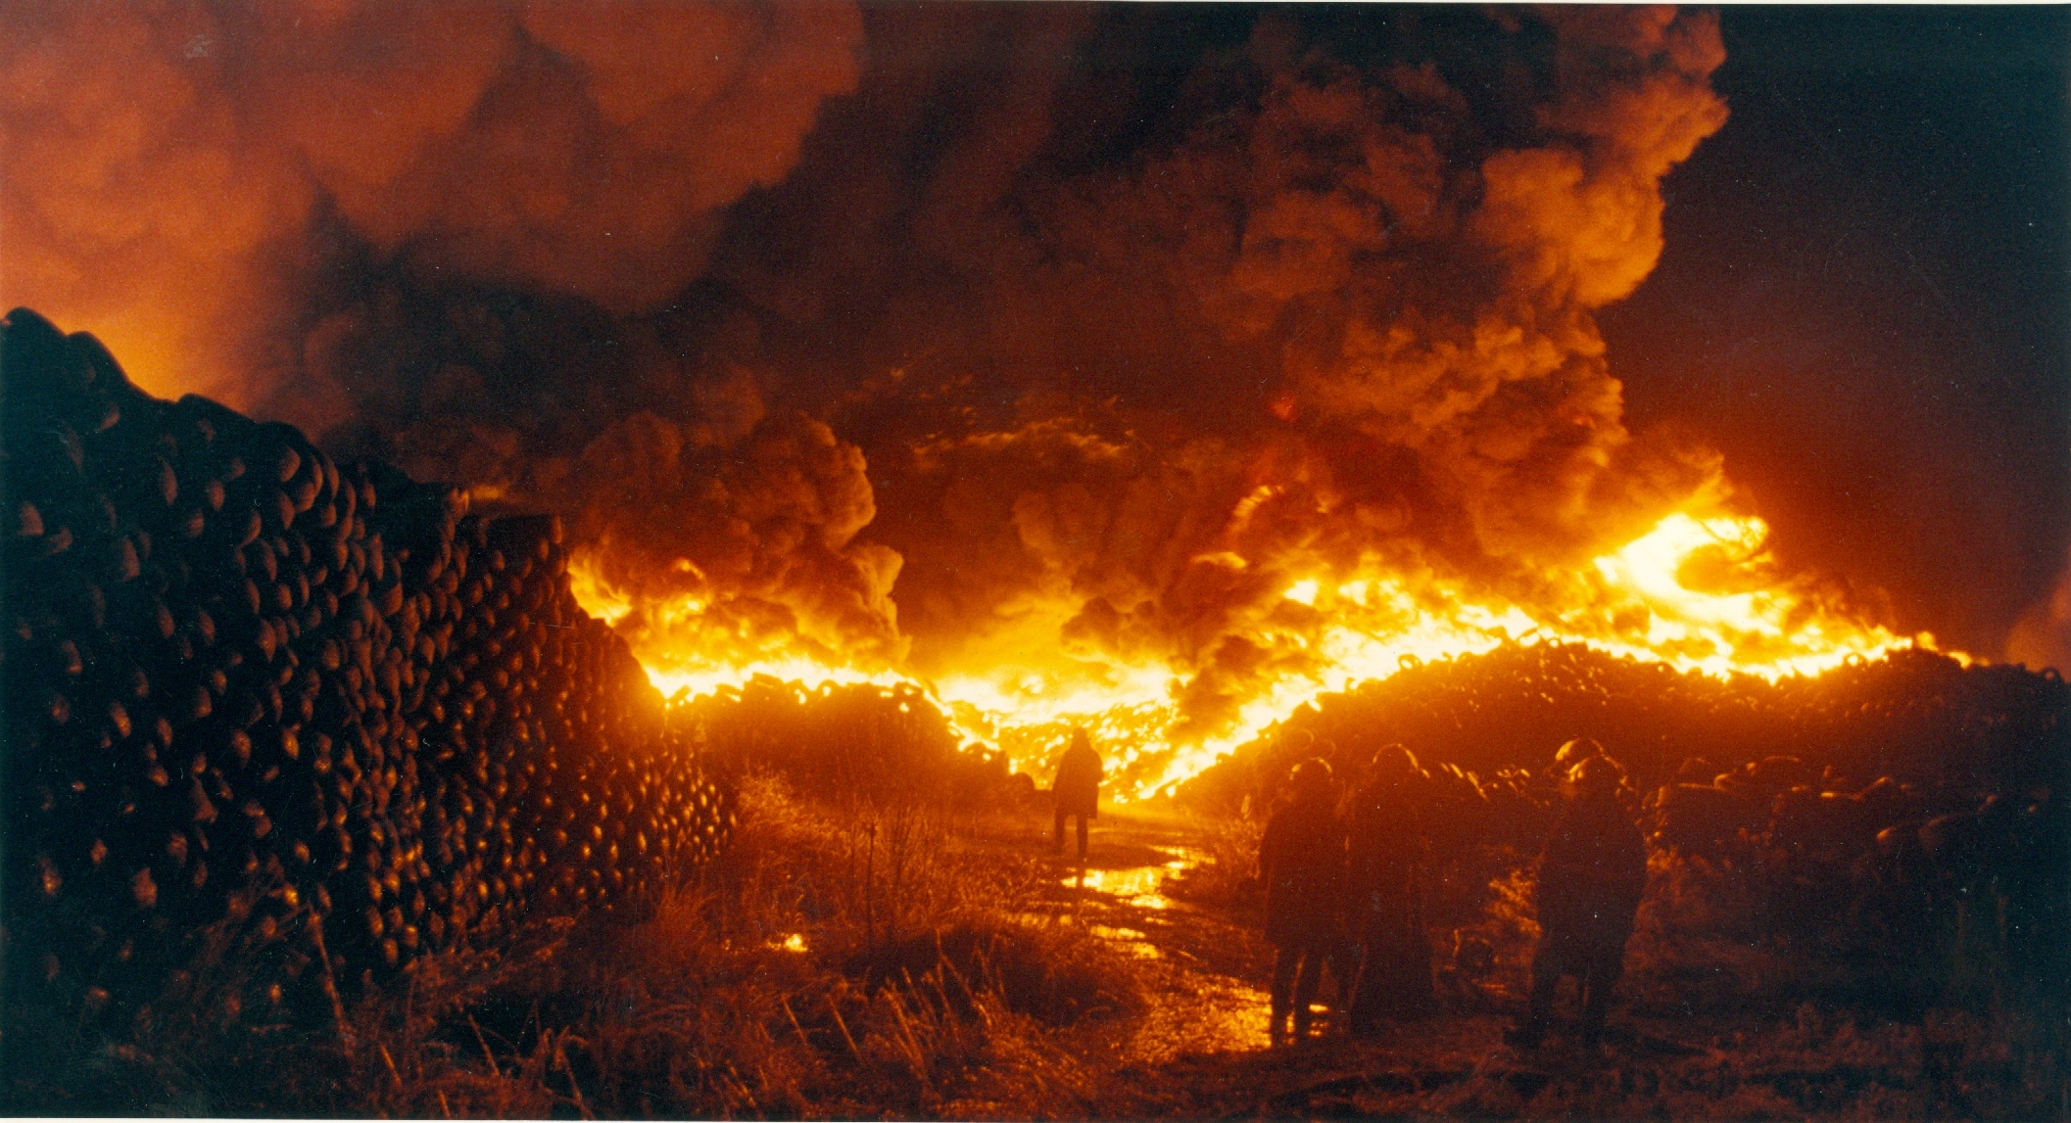

Call of the Wild page extract

Paper 1: The Call of the Wild
- Use lines 1-7.
List four things you learn about the men. [4 marks]

- Use lines 08-18.
How does the writer use language to describe Buck’s house and estate?
You could include the writer’s choice of:
- words and phrases
- language features and techniques
- sentence forms. [8 marks]

- You now need to think about the whole of the source.
This text is from the opening of a novel.
How has the writer structured the text to interest you as a reader?
You could write about:
- what the writer focuses your attention on at the beginning
- how and why the writer changes the focus as the source develops
- any other structural features that interest you. [8 marks]

- Use lines 19 to the end of the text, line 42.
A student, having read this text, said “The writer makes the reader like Buck even though he comes across as an arrogant narrator who sees himself as superior.”
To what extent do you agree?
In your response, you could:
- Write about your own impressions of the characters and mood
- Evaluate how the writer has created these impressions
- Support your opinions with references to the text. [20 marks]

- Using the image provided, write a description suggested by the picture OR
Write the opening of a story where the narrator is not human. [40 marks]


Paper 1 Overview
Q | Marks | Time | Marked on | How to answer the question
1
2
3
4
5
Paper 2, Question 1
Practice Questions | Use the text to shade the boxes of the four true statements
In London, misery is in the very air you breathe and enters in at every pore. There is nothing more gloomy or disquieting than the aspect of the city on a day of fog or rain or black frost. Only succumb to its influence and your head becomes painfully heavy, your digestion sluggish, your breathing laboured for lack of fresh air, and your whole body is overcome by fatigue. Then you are in the grip of what the English call “spleen”: a profound despair, unaccountable anguish, cantankerous hatred for those one loves the best, disgust with everything, and an irresistible desire to end one’s life by suicide. On days like this, London has a terrifying face: you seem to be lost in the necropolis of the world, breathing its sepulchral air. The light is wan, the cold humid; the long rows of identical sombre houses, each with its black iron grilles and narrow windows, resembles nothing so much as tombs stretching to infinity, whilst between them wander corpses awaiting the hour of burial. | - The writer thinks smog makes London seem gloomy
 | - The author claims that the houses resemble tombs
 | - The narrow windows are why the light is so dim
 | - The writer thinks London helps to improve your health
 | - The writer believes London makes you love your family
 | - She describes Londoners as the dead, awaiting burial
 | - She says that the smog causes you to feel fatigued
 | - The author regards London as an attractive city.
Other early initiatives would crumble to dust and ashes. One of the most interesting examples is the Dome, centrepiece of millennium celebrations inherited from the Conservatives. Blair was initially unsure about whether to forge ahead with the £1 billion gamble. He was argued into the Dome project by Peter Mandelson who wanted to be its impresario, and by John Prescott, who liked the new money it would bring to a blighted part of east London. Prescott suggested New Labour wouldn’t be much of a government if it could not make a success of this. Blair agreed, though had the Dome ever come to a cabinet vote he would have lost. Architecturally the Dome was striking and elegant, a landmark for London which can be seen by almost every air passenger arriving in the capital. Public money was spent on cleaning up a poisoned semicircle of derelict land and bringing new Tube and road links. | - Blair was happy for his party to take on the Dome project,
 | - The Dome project would cost £1 billion.
 | - Peter Mandelson and John Prescott convinced Blair.
 | - The dome would help the area of North London.
 | - The cabinet were against the Dome project.
 | - The Dome would create better transport links to the area.
 | - The Dome can be seen wherever you walk in London.
 | - They knocked down buildings to build the Dome.
Paper 2, Question 2
Practice Question 1 |  |  | Come up with a difference (this is your topic) and then find the evidence from each source and then make a suggestion.
A message came to me to prepare for 510 wounded on our side of the Hospital who were arriving from the dreadful affair of the 5th November from Balaklava, in which battle were 1763 wounded and 442 killed, besides 96 officers wounded and 38 killed. I always expected to end my Days as Hospital Matron, but I never expected to be Barrack Mistress. We had but half an hour’s notice before they began landing the wounded. Between one and 9 o’clock we had the mattresses stuffed, sewn up, laid down—alas! Only upon matting on the floor—the men washed and put to bed, and all their wounds dressed. I wish I had time. We have our Quarters in one Tower of the Barrack, and all this fresh influx has been laid down between us and the Main Guard, in two Corridors, with a line of beds down each side, just room for one person to pass between, and four wards. Yet in the midst of this appalling horror (we are steeped up to our necks in blood) there is some good, and I can truly say, like St. Peter: “It is good for us to be here”—though I doubt that if St. Peter had been here, he would have said so. -1854, Florence Nightingale. |  | More than eight of 10 nurses said they did not have enough time to give patients adequate care and a quarter believed they had put a patient’s life at risk because they were too busy or overworked. Staff shortages and too much paperwork were the most common factors stopping nurses from doing their job properly, they said. Around two-thirds of respondents, 66%, said they worried about the level of care that their ward, hospital or clinic could give to patients outside normal working hours. A similar percentage said their ward, hospital or clinic could not function at night, weekends or Bank Holidays without using agency staff. A massive 96% of respondents said there is too much paperwork in the NHS, in spite of ongoing efforts to reduce it, for example by improving technology, and it being a government priority. In addition, 76% of survey respondents said they did not feel valued by their manager and 86% said they did not get paid enough money for the job they do. A possible concern is that a significant chunk of respondents lacked confidence in their own work environment.  -2014, nursingtimes.net
Write a summary of the differences between the problems the nurses face.
Topic | Source A |  |  | Source B
Facilities | “matting on the floor” - Suggests the working environment has been set up suddenly, perhaps the nurses are concerned for the patients’ comfort and this makes work difficult. |  |  | “lacked confidence in their own work environment” reveals the nurses are worried about the health and safety element of their workplace.
Paper 2, Question 2
Practice Question 2 |  |  | Come up with a difference (this is your topic) and then find the evidence from each source and then make a suggestion.
Yesterday I went for the second time to the Crystal Palace. We remained in it about three hours, and I must say I was more struck with it on this occasion than at my first visit. It is a wonderful place—vast, strange, new, and impossible to describe. Its grandeur does not consist in one thing, but in the unique assemblage of all things. Whatever human industry has created, you find there, from the great compartments filled with railway engines and boilers, with mill-machinery in full work, with splendid carriages of all kinds, with harness of every description—to the glass-covered and velvet-spread stands loaded with the most gorgeous work of the goldsmith and silversmith, and the carefully guarded caskets full of real diamonds and pearls worth hundreds of thousands of pounds. It may be called a bazaar or a fair, but it is such a bazaar or fair as Eastern genii might have created. It seems as if magic only could have gathered this mass of wealth from all the ends of the earth—as if none but supernatural hands could have arranged it thus, with such a blaze and contrast of colours and marvellous power of effect. The multitude filling the great aisles seems ruled and subdued by some invisible influence. Amongst the thirty thousand souls that peopled it the day I was there, not one loud noise was to be heard, not one irregular movement seen—the living tide rolls on quietly, with a deep hum like the sea heard from the distance. -1851, Bronte |  | The millennium was certainly worth celebrating. But the problem ministers and their advisers could not solve was what their pleasure Dome should contain. Should it be for a great national party? Should it be educational? Beautiful? Thought-provoking? A fun park? Nobody could decide. The Dome would be magnificent, unique, a tribute to daring and can-do.  . When the Dome finally opened, at New Year, the Queen, Prime Minister and hundreds of donors, business people and celebrities were treated to a mishmash of a show which embarrassed many of them. Bad organization meant most of the guests had a long, freezing and damp wait to get in for the celebrations. Xanadu this was not. The fiasco meant the Dome was roasted in most newspapers and when it opened to the public, the range of mildly interesting exhibits was greeted as a huge disappointment. Far fewer people came and bought tickets than was hoped. It turned out to be a theme park without a theme, morphing in the public imagination into the earliest and most damaging symbol of what was wrong with New Labour: an impressively constructed big tent containing not very much at all. It was produced by some of the people closest to the Prime Minister and therefore boomeranged particularly badly on him and the group already known as ‘Tony’s cronies’. Optimism and daring, it seemed, were not enough. -2007, Andrew Marr, ‘A History of Modern Britain’
Write a summary of the differences between the exhibitions experienced.
Topic | Source A |  |  | Source B
Paper 2, Question 3
Practice Question |  | Decide on the three quotations you would pick, your terminology and effect.
THE MAJORITY OF NHS NURSES FEEL UNDERPAID, OVERWORKED AND UNDERVALUED, ACCORDING TO A SURVEY CARRIED OUT JOINTLY BY NURSING TIMES AND ITV.
More than eight of 10 nurses said they did not have enough time to give patients adequate care and a quarter believed they had put a patient’s life at risk because they were too busy or overworked. Staff shortages and too much paperwork were the most common factors stopping nurses from doing their job properly, they said.
The survey results were due to be featured this week in ITV’s breakfast programme Good Morning Britain, as part of a special edition on nursing. The findings are a stark reminder of the everyday pressures faced by frontline nursing staff, and their view that staffing remains the key factor in ensuring patient safety.
Despite an increasing recognition by many hospital trusts that they need to recruit more nurses, the findings suggest there is still a long way to go. This was further confirmed last week when persistent staff shortages were cited as a major factor for Heatherwood and Wexham Park Hospitals Foundation Trust being placed in “special measures” by healthcare regulators.
Around two-thirds of respondents, 66%, said they worried about the level of care that their ward, hospital or clinic could give to patients outside normal working hours. A similar percentage said their ward, hospital or clinic could not function at night, weekends or Bank Holidays without using agency staff. A massive 96% of respondents said there is too much paperwork in the NHS, in spite of ongoing efforts to reduce it, for example by improving technology, and it being a government priority that is often name-checked in ministerial speeches.
Quotation | Terminology |  | Effect
Paper 2, Question 4
Practice Question 1 |  | Choose two ways the writer’s views are different, then note quotations and methods. It’s easy to start by comparing the one of each article – see the example below.
These poor fellows bear pain and mutilation with an unshrinking heroism which is really superhuman, and die, or are cut up without a complaint.  The wounded are now lying up to our very door, and we are landing 540 more from the Andes. I  take rank in the Army as Brigadier General, because 40 British females, whom I have with me, are more difficult to manage than 4000 men. Let no lady come out here who is not used to fatigue and privation. Every ten minutes an Orderly runs, and we have to go and cram lint into the wound till a Surgeon can be sent for, and stop the Bleeding as well as we can. In all our corridor, I think we have not an average of three Limbs per man. And there are two Ships more “loading” at the Crimea with wounded—(this is our Phraseology). Then come the operations, and a melancholy, not an encouraging List is this. They are all performed in the wards—no time to move them; one poor fellow exhausted with hæmorrhage, has his leg amputated as a last hope, and dies ten minutes after the Surgeon has left him. -1854 |  |  | The survey results were due to be featured this week in ITV’s breakfast programme Good Morning Britain, as part of a special edition on nursing. The findings are a stark reminder of the everyday pressures faced by frontline nursing staff, and their view that staffing remains the key factor in ensuring patient safety.Despite an increasing recognition by many hospital trusts that they need to recruit more nurses, the findings suggest there is still a long way to go.  Meanwhile, when asked whether they would encourage their own child to go into nursing, based on their experience, 73% of participants said “no”, while only 27% answered “yes”.  Although, the survey results highlighted the struggles faced by nurses, respondents remained positive about their motivation. One nurse said: “My job is great and I love it, when I am given the opportunity to do it well,” while another stated: “Although my responses are negative, I love my job.” A further respondent said: “Despite all the pressures, the public should understand that as nurses we do try our best.” -2014
Compare the writers’ attitudes to nursing and healthcare.
 | Source A |  |  | Source B
Tone | Sympathetic tone “one poor fellow” – she feels for the patients as a nurse herself. Adjective “poor” reveals the struggles of the patients, not the nurse |  |  | “stark reminder of the everyday pressures” – frustrated tone, writer feels not enough is being done. Adjective “stark” highlights need for change.
Practice Question 2 |  |  | Choose three ways the writer’s views are different, then note quotations and methods. You could start by comparing the tone.
Over every English town there hangs a pall compounded of the Ocean vapours that perpetually shroud the British Isles, and the heavy noxious fumes of the Cyclops’ cave. No longer does timber from the forests provide fuel for the family hearth; the fuel of Hell - coal - snatched from the very bowels of the earth, has taken its place. It burns everywhere, feeding countless furnaces, replacing horse-power on the roads and wind-power on the rivers and the seas which surround the empire.  Above the monster city a dense fog combines with the volume of smoke and soot belching from thousands of chimneys to wrap London in a black cloud which allows only the dimmest light to penetrate and shrouds everything in a funeral veil.  In London, misery is in the very air you breathe and enters in at every pore. There is nothing more gloomy or disquieting than the aspect of the city on a day of fog or rain or black frost.  On such black days the Englishman is under the spell of his climate and behaves like a brute beast to anybody who crosses his path, giving and receiving knocks without a word of apology on either side. A poor old man may collapse from starvation in the street, but the Englishman will not stop to help him. He goes about his business and spares no thought for anything else. -1839, Flora Tristan |  |  | Air pollution in one of London's busiest roads has already exceeded the legal limit for the whole of 2015, in the space of just four days, experts have warned.  Campaign group Clean Air In London has reported that the excessive levels for nitrogen dioxide (NO2) in Oxford Street had passed the limit set by the EU by January 4, the Evening Standard has reported. Simon Birkett, founder and director of Clean Air In London, told The Independent the EU and UK regulations limited NO2 levels so they must not exceed 200 micrograms per cubic metre for more than 18 hours in an entire year. But Mr Birkett said Oxford Street had already reached 19 hours in excess of the limit by January 4, while Putney High Street also passed the limit yesterday.  According to statistics supplied by Clean Air In London, in 2014 Oxford Street clocked up 1,361 hours where the NO2 levels were exceeded. Putney High Street meanwhile saw a total of 999 hours where the levels were exceeded. The road with the highest number of hours where NO2 levels were exceeded in 2014 was Brixton Road, with 1,732 hours.  In November, the Government's scientific advisors were reported to be set to warn that air pollution, largely from diesel vehicle road traffic, may be to blame for as many as 60,000 early deaths in Britain each year. -2015
Compare the writers’ attitudes to pollution and the impacts of pollution
 | Source A |  |  | Source B
Practice Question 3 |  | Choose three ways the writer’s views are different, then note quotations and methods. You could start by comparing the tone.
Source A FOOTBALL is by far the most popular outdoor game of the winter months, and now that the South has caught the infection of the Northern and Midland counties in a very malignant form, many first-class professional clubs have sprung up all round London, and the enthusiastic onlooker has a wealth of talent to choose from, good enough to appease the most insatiable appetite. It is, however, only of recent years that Southern teams have challenged the superiority of the North, and those that have done so, to wit, Woolwich Arsenal and Chelsea, both having won their way into the golden circle of the First Division of the English League, have done much to earn the respect of their older rivals; and Fulham only just missed promotion during the past season.  The "tit-bit" of the season is the final of the Association Cup, which is played off at the Crystal Palace, and usually attracts a crowd of anything between 80,000 and 100,000 spectators, the record being over 101,000 when Tottenham Hotspur drew with Sheffield United, and subsequently won in the replay. As regards amateur clubs, there are many of first-class rank, and their engagements attract good attendances. To those who like to see sport as a sport and not a scientific display where fouling has unfortunately too great a predominance, will wish the newly-formed A.F.A. every success.  . -1879, Charles Dickens Jr |  | Source B There once was a day when you could watch your favourite football team play for as little as £5, having bought a ticket on the gate. But those days are long behind us.  Today, ticket prices across all leagues, especially the Championship and Premier League, have more than trebled in price. With some fans having to pay almost £50 for a singular game ticket.  Season tickets are a much more popular way of supporting teams these days, but even these are ridiculously expensive. Arsenal FC’s highest season ticket price is £2,013.  With prices like these populating the modern game, is football only for the rich?  The entire premise around a football day out, whether home or away is becoming more expensive as time goes on.  With ticket prices soaring, travel becoming increasingly expensive, a match programme coasting as much as five pounds at some stadiums. And let’s not even begin to discuss the price of stadium food and drinks.  The price of watching football has simply become far too expensive today. Meaning that many working-class families, students etc... are unable to enjoy the beautiful game. Football is becoming too focused on money rather than the game itself.  -2017, Sophie Coburn
Compare the writers’ attitudes to football and spectator sport
 | Source A |  | Source B

Travelling sources 1

Travelling sources 2

Paper 2: Travelling
- Read again the first part of the Source B from lines 1 to 17.
Choose four statements below which are TRUE.
- Shade the boxes of the ones that you think are true
- Choose a maximum of four statements. [4 marks]

A Bill Bryson arrived in England from Calais
B He caught a train to London after arriving
C It was raining when he arrived
D The ferry terminal was busy when he arrived
E Bryson attempts to stay at a guesthouse opposite the station
F The guesthouse owner offers him a roast beef sandwich
G The guesthouse owner is very welcoming
H Bryson trips over as he walks towards the guesthouse

- You need to refer to Source A and Source B for this question.
Use details from both sources. Write a summary of the differences between the journeys in each source. [8 marks]

- You now need to refer only to Source B, lines 10-24.
How does the writer use language to describe the weather on his journey? [12 marks]

- For this question, you need to refer to the whole of Source A, together with Source B.
Compare how the two writers convey their different attitudes to travelling and the places they are travelling in. In your answer, you could:
- Compare their different attitudes
- Compare the methods they use to convey their attitudes.
- Support your ideas with references to both texts. [16 marks]

- ‘Teenagers should be given opportunities to travel without their parents in order to experience the world around them.”

Write an article in which you explain your point of view on this statement.

(24 marks for content and organisation
16 marks for technical accuracy)
[40 marks]

Paper 2: Parenting and Education

- Read again the first part of the Source B from lines 1 to 17.
Choose four statements below which are TRUE.
- Shade the boxes of the ones that you think are true
- Choose a maximum of four statements. [4 marks]

A Shane Horner is a model pupil
B Shane Horner has been internally excluded many times
C In autumn 2006 Pent Valley school excluded 50 students
D Shane Horner is given £1 extra pocket money for behaving
E Samantha Horner gets worried when the phone rings
F Shane is not entirely honest about his poor behaviour
G Shane Horner’s dad is called Simon Horner
H Each year group at Pent Valley has a student manager

- You need to refer to Source A and Source B for this question.
Use details from both sources. Write a summary of the differences between the parents in each source. [8 marks]

- You now need to refer only to Source B, 107-132.
How does the writer use language to describe the father? [12 marks]

- For this question, you need to refer to the whole of Source A, together with Source B.
Compare how the two writers convey their different attitudes to parenting and education. In your answer, you could:
- Compare their different attitudes
- Compare the methods they use to convey their attitudes.
- Support your ideas with references to both texts. [16 marks]

- ‘School is the most important aspect of a young child’s life They should dedicate their time to school not working or doing hobbies.”
Write a speech in which you explain your point of view on this statement.
(24 marks for content and organisation
16 marks for technical accuracy)
[40 marks]

Parenting source 1

Parenting source 2

Paper 2 Overview
Q | Marks | Time | Marked on | How to answer the question
1
2
3
4
5
Unseen poetry – single poems

The Last Laugh

‘O Jesus Christ! I’m hit,’ he said; and died.
Whether he vainly cursed or prayed indeed,
The Bullets chirped—In vain, vain, vain!
Machine-guns chuckled—Tut-tut! Tut-tut!
And the Big Gun guffawed.

Another sighed,—‘O Mother,—mother,—Dad!’
Then smiled at nothing, childlike, being dead.
And the lofty Shrapnel-cloud
Leisurely gestured,—Fool!
And the splinters spat, and tittered.

‘My Love!’ one moaned. Love-languid seemed his mood, Till slowly lowered, his whole face kissed the mud.
And the Bayonets’ long teeth grinned;
Rabbles of Shells hooted and groaned;
And the Gas hissed.
-Wilfred Owen

In ‘The Last Laugh’ how does the poet present the speaker’s experience of war?

Leaving and Leaving You

When I leave you postcode and your commuting station,
When I left undone all the things we planned to do
You may feel you have been left by association
But there is leaving and leaving you.

When I leave your town and the club that you belong to,
When I leave without much warning or much regret,
Remember, there's doing wrong and there's doing wrong to
You, which I'll never do and I haven't yet,

And when I have gone, remember that in weighing
Everything up, from love to a cheaper rent,
You were all the reasons I thought of staying,
And none of the reasons why I went

And although I leave your sight and I leave your setting,
And our separation is soon to be a fact,
Though you stand beside what I'm leaving and forgetting,
I'm not leaving you, not if motive makes the act.
-Sophie Hannah

In ‘Leaving and Leaving You’ how does the poet present the speaker’s experience of leaving?
War Photographer

The reassurance of the frame is flexible
- you can think that just outside it
people eat, sleep, love normally
while I seek out the tragic, the absurd,
to make a subject.
Or if the picture's such as lifts the heart
the firmness of the edges can convince you
this is how things are

- as when at ascot once
I took a pair of peach, sun-gilded girls
rolling, silk crumpled, on the grass
in champagne giggles

-as last week, when I followed a small girl
staggering down some devastated street,
hip thrust out under a baby's weight.
she saw me seeing her; my finger pressed.

At the corner, the first bomb of the morning
shattered the stones .
Instinct prevailing, she dropped her burden
and, mouth too small for her dark scream,
began to run...

The picture showed the little mother
the almost-smile. Their caption read
'Even in hell the human spirit
triumphs over all.'
But hell' like heaven, is untidy,
its boundaries
arbitrary as a blood stain on a wall.

-Carole Satyamurti

In ‘War Photographer’ how does the poet present ideas about being a war photographer?

Unseen poetry – single poems

A Christmas Song
Why is the baby crying
On this, his special day,
When we have brought him lovely gifts
And laid them on the hay?

He’s crying for the people
Who greet this day with dread
Because somebody dear to them
Is far away or dead,

For all the men and women
Whose love affairs went wrong,
Who try their best at merriment
When Christmas comes along,

For separated parents
Whose turn it is to grieve
While children hang their stockings up
Elsewhere on Christmas Eve,

For everyone whose burden
Carried through the year,
Is heavier at Christmastime,
The season of good cheer.

That’s why the baby’s crying
There in the cattle stall:
He’s crying for those people.
He’s crying for them all.
-Wendy Cope
In ‘A Christmas Song’ how does the poet present the speaker’s feelings towards Christmas?

Women
Women have no wilderness in them,
They are provident instead,
Content in the tight hot cell of their hearts
To eat dusty bread.

They do not see cattle cropping red winter grass,
They do not hear
Snow water going down under culverts
Shallow and clear.

They wait, when they should turn to journeys,
They stiffen, when they should bend.
They use against themselves that benevolence
To which no man is friend.

They cannot think of so many crops to a field
Or of clean wood cleft by an axe.
Their love is an eager meaninglessness
Too tense, or too lax.

They hear in every whisper that speaks to them
A shout and a cry.
As like as not, when they take life over their door-sills
They should let it go by.
-Louise Bogan
In ‘Women’ how does the poet present the speaker’s feelings about the experiences of women?
Shakespeare at School

Forty boys on benches with their quills
Six days a week through almost all the year,
Long hours of Latin with relentless drills
And repetition, all enforced by fear.
I picture Shakespeare sitting near the back,
Indulging in a risky bit of fun
By exercising his prodigious knack
Of thinking up an idiotic pun,
And whispering his gem to other boys,
Some of whom could not suppress their mirth –
Behaviour that unfailingly annoys
Any teacher anywhere on earth.
The fun was over when the master spoke:
Will Shakespeare, come up here and share the joke.
.-Wendy Cope

In ‘Shakespeare at School’ how does the poet present the speaker’s feelings towards education?

Being Independent
I do not want to have you
To fill the empty parts of me.
I want to be full on my own.
I want to be so complete
I could light a whole city
And then
I want to have you
Cause the two of us combined
Could set it on fire.
-Rupi Kaur
In ‘Being Independent’ how does the poet present the speaker’s feelings about being independent?

Unseen Poetry – Both Questions

Tich Miller
Tich Miller wore glasses
with elastoplast-pink frames
and had one foot three sizes larger than the other.

When they picked teams for outdoor games
she and I were always the last two
left standing by the wire-mesh fence.

We avoided one another’s eyes,
stooping, perhaps, to re-tie a shoelace,
or affecting interest in the flight

of some fortunate bird, and pretended
not to hear the urgent conference:
‘Have Tubby!’ ‘No, no, have Tich!’

Usually they chose me, the lesser dud,
and she lolloped, unselected,
to the back of the other team.

At eleven we went to different schools.
In time I learned to get my own back,
sneering at hockey-players who couldn’t spell.

Tich died when she was twelve.
-Wendy Cope

07.2 In both ‘Timothy Winters’ and ‘Tich Miller’ the speakers describe their attitudes to children.
What are the similarities and/or differences between the methods the poets use to present these ideas?

07.1 In ‘Timothy Winters’ how does the poet present the speaker’s feelings towards Timothy Winters?

Extract from 'Timothy Winters'
Timothy Winters comes to school
With eyes as wide as a football-pool,
Ears like bombs and teeth like splinters:
A blitz of a boy is Timothy Winters.

His belly is white, his neck is dark,
And his hair is an exclamation-mark.
His clothes are enough to scare a crow
And through his britches the blue winds blow.

When teacher talks he won't hear a word
And he shoots down dead the arithmetic-bird,
He licks the pattern off his plate
And he's not even heard of the Welfare State.

Timothy Winters has bloody feet
And he lives in a house on Suez Street,
He sleeps in a sack on the kithen floor
And they say there aren't boys like him anymore.

-Charles Causley

07.1 In ‘Timothy Winters’ how does the poet present the speaker’s feelings towards Timothy Winters?

Unseen Poetry – Both Questions

The Land of Story-books
At evening when the lamp is lit,
Around the fire my parents sit;
They sit at home and talk and sing,
And do not play at anything.

Now, with my little gun, I crawl
All in the dark along the wall,
And follow round the forest track
Away behind the sofa back.

There, in the night, where none can spy,
All in my hunter's camp I lie,
And play at books that I have read
Till it is time to go to bed.

These are the hills, these are the woods,
These are my starry solitudes;
And there the river by whose brink
The roaring lions come to drink.

I see the others far away
As if in firelit camp they lay,
And I, like to an Indian scout,
Around their party prowled about.

So, when my nurse comes in for me,
Home I return across the sea,
And go to bed with backward looks
At my dear land of Story-books.
-Robert Louis Stevenson

07.2 In both ‘Slow Reader’ and ‘The Land of Story-books’ the speakers describe a child’s experience of reading.
What are the similarities and/or differences between the methods the poets use to present these ideas?

Slow Reader

He can make a sculpture
and fabulous machines,
invent games, tell jokes,
give solemn, adult advice-
but he is slow to read.
When I take him on my knee
with his Ladybird book
he gazes into the air,
sighing and shaking his head
like an old man
who knows the mountains
are impassible.

He toys with words,
letting them go cold
as gristly meat,
until I relent
and let him wriggle free:
a fish returning
to its element,
or a white-eyed colt-shying
from the bit - who sees
that if he takes it
in his mouth
he'll never run
quite free again
- Vicky Feaver
07.1 In ‘Slow Reader’ how does the poet present the speaker’s feelings towards the boy and his reading?

Unseen Poetry – Both Questions
Hope

Hope is with you when you believe
The earth is not a dream but living flesh,
that sight, touch, and hearing do not lie,
That all thing you have ever seen here
Are like a garden looked at from a gate.
You cannot enter. But you're sure it's there.
Could we but look more clearly and wisely
We might discover somewhere in the garden
A strange new flower and an unnamed star.
Some people say that we should not trust our eyes,
That there is nothing, just a seeming,
There are the ones who have no hope.
They think the moment we turn away,
The world, behind our backs, ceases to exist,
As if snatched up by the hand of thieves.

— Czesław Miłosz

07.2 In both ‘The Door’ and ‘Hope’ the speakers describe their views on how to live your life.
What are the similarities and/or differences between the methods the poets use to present these ideas?

The Door
Go and open the door.
Maybe outside there’s
a tree, or a wood,
a garden,
or a magic city.

Go and open the door.
Maybe a dog’s rummaging.
Maybe you’ll see a face,
or an eye,
or the picture
of a picture.

Go and open the door.
If there’s a fog
it will clear.

Go and open the door.
Even if there’s only
the darkness ticking,
even if there’s only
the hollow wind,
even if
nothing
is there,
go and open the door.

At least
there’ll be
a draught.

—Miroslav Holub
07.1 In ‘The Door’ how does the poet present the speaker’s feelings about how to live life?

Macbeth – Quotation Quiz Add the quotation, who says it, and when!
 |  | 
 |  | 
 |  | 
 |  | 
 |  | 
 |  | 
 |  | 
 |  | 

Macbeth Theme Brain Dumps
For each of the following brain dumps, spend at least 5 minutes adding anything you can think of about that theme (remember it is likely a theme will come up in the exam!). Once you have run out of ideas, use a KO/play to add some ideas.
Supernatural
Ambition
KINGSHIP
GENDER
POWER
APPEARANCE AND REALITY
Macbeth : Mini Mocks
For each of the following mini questions, you could do a full response or part of a response. Remember to spend 5 minutes reading the question at the bottom, information at the top, then the extract. Then spend 5 minutes reading the extract and highlighting useful quotations. You should then spend 5 minutes planning ideas from the extract and whole play. Finally, write your paragraphs.
Read the following extract from act 3, scene 2. Macbeth and Lady Macbeth are preparing for the banquet. Macbeth has just sent the murderers to kill Banquo and Fleance.  LADY MACBETH  Come on;  Gentle my lord, sleek o'er your rugged looks;  Be bright and jovial among your guests to-night.  MACBETH  So shall I, love; and so, I pray, be you:  Let your remembrance apply to Banquo;  Present him eminence, both with eye and tongue:  Unsafe the while, that we  Must lave our honours in these flattering streams,  And make our faces vizards to our hearts,  Disguising what they are.  LADY MACBETH  You must leave this.  MACBETH  O, full of scorpions is my mind, dear wife!  Starting with this extract, how does Shakespeare present Macbeth as guilty in Macbeth? | Read the following extract from act 3, scene 1. Macbeth has just spoken to Banquo and requested that he attends the banquet.  MACBETH  To be thus is nothing;  But to be safely thus.--Our fears in Banquo  Stick deep; and in his royalty of nature  Reigns that which would be fear'd: 'tis much he dares;  And, to that dauntless temper of his mind,  He hath a wisdom that doth guide his valour  To act in safety. There is none but he  Whose being I do fear: and, under him,  My Genius is rebuked; as, it is said,  Mark Antony's was by Caesar. He chid the sisters  When first they put the name of king upon me,  And bade them speak to him: then prophet-like  They hail'd him father to a line of kings:  Upon my head they placed a fruitless crown,  And put a barren sceptre in my gripe,  Starting with this extract, how does Shakespeare present Macbeth as powerful in Macbeth?
Read the following extract from act 5, scene 1. Lady Macbeth is being watched by the doctor and gentlewoman as she sleepwalks  LADY MACBETH  The thane of Fife had a wife: where is she now?--  What, will these hands ne'er be clean?--No more o'  that, my lord, no more o' that: you mar all with  this starting.  Doctor  Go to, go to; you have known what you should not.  Gentlewoman  She has spoke what she should not, I am sure of  that: heaven knows what she has known.  LADY MACBETH  Here's the smell of the blood still: all the  perfumes of Arabia will not sweeten this little  hand. Oh, oh, oh!  Doctor  What a sigh is there! The heart is sorely charged.  Gentlewoman  I would not have such a heart in my bosom for the  dignity of the whole body.  Starting with this extract, how does Shakespeare present Lady Macbeth as a fragile character in Macbeth? | Read the following extract from act 1, scene 4. Duncan is announcing that Malcolm will be the next King of Scotland.  DUNCAN  We will establish our estate upon  Our eldest, Malcolm, whom we name hereafter  The Prince of Cumberland; which honour must  Not unaccompanied invest him only,  But signs of nobleness, like stars, shall shine  On all deservers. From hence to Inverness,  And bind us further to you.  MACBETH  The rest is labour, which is not used for you:  I'll be myself the harbinger and make joyful  The hearing of my wife with your approach;  So humbly take my leave.  DUNCAN  My worthy Cawdor!  MACBETH  [Aside] The Prince of Cumberland! that is a step  On which I must fall down, or else o'erleap,  For in my way it lies. Stars, hide your fires;  Let not light see my black and deep desires.  Starting with this extract, how does Shakespeare present ideas about ambition in Macbeth?
Read the following extract from act 2, scene 1. Macbeth is speaking to Banquo, with Fleance present, after the evening’s meal.  BANQUO  What, sir, not yet at rest? The king's a-bed:  He hath been in unusual pleasure, and  Sent forth great largess to your offices.  This diamond he greets your wife withal,  By the name of most kind hostess; and shut up  In measureless content.  MACBETH  Being unprepared,  Our will became the servant to defect;  Which else should free have wrought.  BANQUO  All's well.  I dreamt last night of the three weird sisters:  To you they have show'd some truth.  MACBETH  I think not of them:  Yet, when we can entreat an hour to serve,  We would spend it in some words upon that business,  If you would grant the time  Starting with this extract, how does Shakespeare present ideas about loyalty and betrayal in Macbeth? | Read the following extract from act 3, scene 4. This discussion follows the banquet scene.  MACBETH  How say'st thou, that Macduff denies his person  At our great bidding?  LADY MACBETH  Did you send to him, sir?  MACBETH  I hear it by the way; but I will send:  There's not a one of them but in his house  I keep a servant fee'd. I will to-morrow,  And betimes I will, to the weird sisters:  More shall they speak; for now I am bent to know,  By the worst means, the worst. For mine own good,  All causes shall give way: I am in blood  Stepp'd in so far that, should I wade no more,  Returning were as tedious as go o'er:  Strange things I have in head, that will to hand;  Which must be acted ere they may be scann'd.  LADY MACBETH  You lack the season of all natures, sleep.  MACBETH  Come, we'll to sleep. My strange and self-abuse  Is the initiate fear that wants hard use:  We are yet but young in deed.  Starting with this extract, how does Shakespeare present ideas about the influence of the supernatural in Macbeth?
Read the following extract from act 5, scene 1. Lady Macbeth is being watched by the doctor and gentlewoman as she sleepwalks  LADY MACBETH  The thane of Fife had a wife: where is she now?--  What, will these hands ne'er be clean?--No more o'  that, my lord, no more o' that: you mar all with  this starting.  Doctor  Go to, go to; you have known what you should not.  Gentlewoman  She has spoke what she should not, I am sure of  that: heaven knows what she has known.  LADY MACBETH  Here's the smell of the blood still: all the  perfumes of Arabia will not sweeten this little  hand. Oh, oh, oh!  Doctor  What a sigh is there! The heart is sorely charged.  Gentlewoman  I would not have such a heart in my bosom for the  dignity of the whole body.  Starting with this extract, how does Shakespeare present Lady Macbeth as a fragile character in Macbeth? | Read the following extract from act 1, scene 4. Duncan is announcing that Malcolm will be the next King of Scotland.  DUNCAN  We will establish our estate upon  Our eldest, Malcolm, whom we name hereafter  The Prince of Cumberland; which honour must  Not unaccompanied invest him only,  But signs of nobleness, like stars, shall shine  On all deservers. From hence to Inverness,  And bind us further to you.  MACBETH  The rest is labour, which is not used for you:  I'll be myself the harbinger and make joyful  The hearing of my wife with your approach;  So humbly take my leave.  DUNCAN  My worthy Cawdor!  MACBETH  [Aside] The Prince of Cumberland! that is a step  On which I must fall down, or else o'erleap,  For in my way it lies. Stars, hide your fires;  Let not light see my black and deep desires.  Starting with this extract, how does Shakespeare present ideas about ambition in Macbeth?

A Christmas Carol – Quotation Quiz
Add the quotation, who says it, and when!
 |  | 
 |  | 
 |  | 
 |  | 
 |  | 
 |  | 
 |  | 
 |  | 
 |  | 

Macbeth Theme Brain Dumps
For each of the following brain dumps, spend at least 5 minutes adding anything you can think of about that theme (remember it is likely a theme will come up in the exam!). Once you have run out of ideas, use a KO/novella to add some ideas.
Christmas
Family
Redemption
Charity
Wealth
Poverty
A Christmas Carol : Mini Mocks
For each of the following mini questions, you could do a full response or part of a response. Remember to spend 5 minutes reading the question at the bottom, information at the top, then the extract. Then spend 5 minutes reading the extract and highlighting useful quotations. You should then spend 5 minutes planning ideas from the extract and whole play. Finally, write your paragraphs.
Read the following extract from stave 2. Scrooge has just watched a memory with Belle, his ex-fiancé, with the Ghost of Christmas Past.  He was about to speak; but with her head turned from him, she resumed.  "You may -- the memory of what is past half makes me hope you will -- have pain in this. A very, very brief time, and you will dismiss the recollection of it, gladly, as an unprofitable dream, from which it happened well that you awoke. May you be happy in the life you have chosen."  She left him, and they parted.  "Spirit!" said Scrooge, "show me no more! Conduct me home. Why do you delight to torture me?"  "One shadow more!" exclaimed the Ghost.  "No more!" cried Scrooge! "No more, I don't wish to see it! Show me no more!"  But the relentless Ghost pinioned him in both his arms, and forced him to observe what happened next.  Starting with this extract, how does Dickens present the importance of memory in A Christmas Carol? | Read the following extract from stave 3. Scrooge is watching the Cratchit family with the Ghost of Christmas Present.  Then all the Cratchit family drew round the hearth, in what Bob Cratchit called a circle, meaning half a one; and at Bob Cratchit's elbow stood the family display of glass. Two tumblers, and a custard-cup without a handle.  These held the hot stuff from the jug, however, as well as golden goblets would have done; and Bob served it out with beaming looks, while the chestnuts on the fire sputtered and cracked noisily. Then Bob proposed:  "A Merry Christmas to us all, my dears. God bless us."  Which all the family re-echoed.  "God bless us every one!" said Tiny Tim, the last of all.  He sat very close to his father's side upon his little stool. Bob held his withered little hand in his, as if he loved the child, and wished to keep him by his side, and dreaded that he might be taken from him. Starting with this extract, how does Dickens present the importance of family in A Christmas Carol?
Read the following extract from stave 1. Scrooge has been visited by the ghost of Jacob Marley.  "But you were always a good man of business, Jacob," faltered Scrooge, who now began to apply this to himself.  "Business!" cried the Ghost, wringing its hands again. "Mankind was my business. The common welfare was my business; charity, mercy, forbearance, and benevolence, were, all, my business. The dealings of my trade were but a drop of water in the comprehensive ocean of my business!"  It held up its chain at arm's length, as if that were the cause of all its unavailing grief, and flung it heavily upon the ground again.  "At this time of the rolling year," the spectre said "I suffer most. Why did I walk through crowds of fellow-beings with my eyes turned down, and never raise them to that blessed Star which led the Wise Men to a poor abode! Were there no poor homes to which its light would have conducted me!"  Starting with this extract, how does Dickens present the importance of charity in A Christmas Carol? | Read the following extract from stave 3. Scrooge and the Ghost visit various Christmases.  Built upon a dismal reef of sunken rocks, some league or so from shore, on which the waters chafed and dashed, the wild year through, there stood a solitary lighthouse. Great heaps of sea-weed clung to its base, and storm-birds -- born of the wind one might suppose, as sea-weed of the water -- rose and fell about it, like the waves they skimmed.  But even here, two men who watched the light had made a fire, that through the loophole in the thick stone wall shed out a ray of brightness on the awful sea. Joining their horny hands over the rough table at which they sat, they wished each other Merry Christmas in their can of grog; and one of them: the elder, too, with his face all damaged and scarred with hard weather, as the figure-head of an old ship might be: struck up a sturdy song that was like a Gale in itself.  Again the Ghost sped on, above the black and heaving sea -- on, on -- until, being far away, as he told Scrooge, from any shore, they lighted on a ship  Starting with this extract, how does Dickens present the importance of Christmas spirit in A Christmas Carol?
Read the following extract from stave 2. Scrooge has just watched a party with his old boss, Fezziwig, with the Ghost of Christmas Past.  "A small matter," said the Ghost, "to make these silly folks so full of gratitude."  "Small!" echoed Scrooge.  The Spirit signed to him to listen to the two apprentices, who were pouring out their hearts in praise of Fezziwig: and when he had done so, said,  "Why! Is it not! He has spent but a few pounds of your mortal money: three or four perhaps. Is that so much that he deserves this praise?"  "It isn't that," said Scrooge, heated by the remark, and speaking unconsciously like his former, not his latter, self. "It isn't that, Spirit. He has the power to render us happy or unhappy; to make our service light or burdensome; a pleasure or a toil. Say that his power lies in words and looks; in things so slight and insignificant that it is impossible to add and count them up: what then? The happiness he gives, is quite as great as if it cost a fortune."  He felt the Spirit's glance, and stopped.  "What is the matter?" asked the Ghost.  "Nothing in particular," said Scrooge.  "Something, I think?" the Ghost insisted.  "No," said Scrooge, "No. I should like to be able to say a word or two to my clerk just now! That's all."  Starting with this extract, how does Dickens present ideas about wealth in A Christmas Carol? | Read the following extract from stave 4. Scrooge sees an unknown man alone in death.  He thought, if this man could be raised up now, what would be his foremost thoughts. Avarice, hard-dealing, griping cares. They have brought him to a rich end, truly.  He lay, in the dark empty house, with not a man, a woman, or a child, to say that he was kind to me in this or that, and for the memory of one kind word I will be kind to him. A cat was tearing at the door, and there was a sound of gnawing rats beneath the hearth-stone. What they wanted in the room of death, and why they were so restless and disturbed, Scrooge did not dare to think.  "Spirit,." he said, "this is a fearful place. In leaving it, I shall not leave its lesson, trust me. Let us go."  Still the Ghost pointed with an unmoved finger to the head.  "I understand you," Scrooge returned, "and I would do it, if I could. But I have not the power, Spirit. I have not the power."  Again it seemed to look upon him.  "If there is any person in the town, who feels emotion caused by this man's death," said Scrooge quite agonise.  Starting with this extract, how does Dickens present ideas about how to live your life in A Christmas Carol.
Read the following extract from stave 4. Scrooge finally sees the name of the unknown death.  Scrooge crept towards it, trembling as he went; and following the finger, read upon the stone of the neglected grave his own name, EBENEZER SCROOGE.  "Am I that man who lay upon the bed?" he cried, upon his knees.  The finger pointed from the grave to him, and back again.  "No, Spirit! Oh no, no!"  The finger still was there.  "Spirit!" he cried, tight clutching at its robe, "hear me. I am not the man I was. I will not be the man I must have been but for this intercourse. Why show me this, if I am past all hope?"  For the first time the hand appeared to shake.  "Good Spirit," he pursued, as down upon the ground he fell before it: "Your nature intercedes for me, and pities me. Assure me that I yet may change these shadows you have shown me, by an altered life."  The kind hand trembled.  "I will honour Christmas in my heart, and try to keep it all the year. I will live in the Past, the Present, and the Future. The Spirits of all Three shall strive within me. I will not shut out the lessons that they teach.” Starting with this extract, how does Dickens present the Scrooge’s transformation in A Christmas Carol? | Read the following extract from stave 5. It is Boxing Day and Scrooge is at work with Bob.  "A merrier Christmas, Bob, my good fellow, than I have given you for many a year. I'll raise your salary, and endeavour to assist your struggling family, and we will discuss your affairs this very afternoon, over a Christmas bowl of smoking bishop, Bob. Make up the fires, and buy another coal-scuttle before you dot another i, Bob Cratchit!"  Scrooge was better than his word. He did it all, and infinitely more; and to Tiny Tim, who did not die, he was a second father. He became as good a friend, as good a master, and as good a man, as the good old city knew, or any other good old city, town, or borough, in the good old world. Some people laughed to see the alteration in him, but he let them laugh, and little heeded them; for he was wise enough to know that nothing ever happened on this globe, for good, at which some people did not have their fill of laughter in the outset; and knowing that such as these would be blind anyway, he thought it quite as well that they should wrinkle up their eyes in grins, as have the malady in less attractive forms. His own heart laughed: and that was quite enough for him.  Starting with this extract, how does Dickens present ideas about redemption in A Christmas Carol?  Redemption: the act of saving yourself from sin, error or evil.

Poetry – Quotation Quiz Add the quotation and the poem it’s from.
 |  | 
 |  | 
 |  | 
 |  | 
 |  | 
 |  | 
 |  | 
 |  | 
 |  | 
 |  | 
 |  | 
 |  | 
 |  | 
 |  | 
 |  | 
 |  | 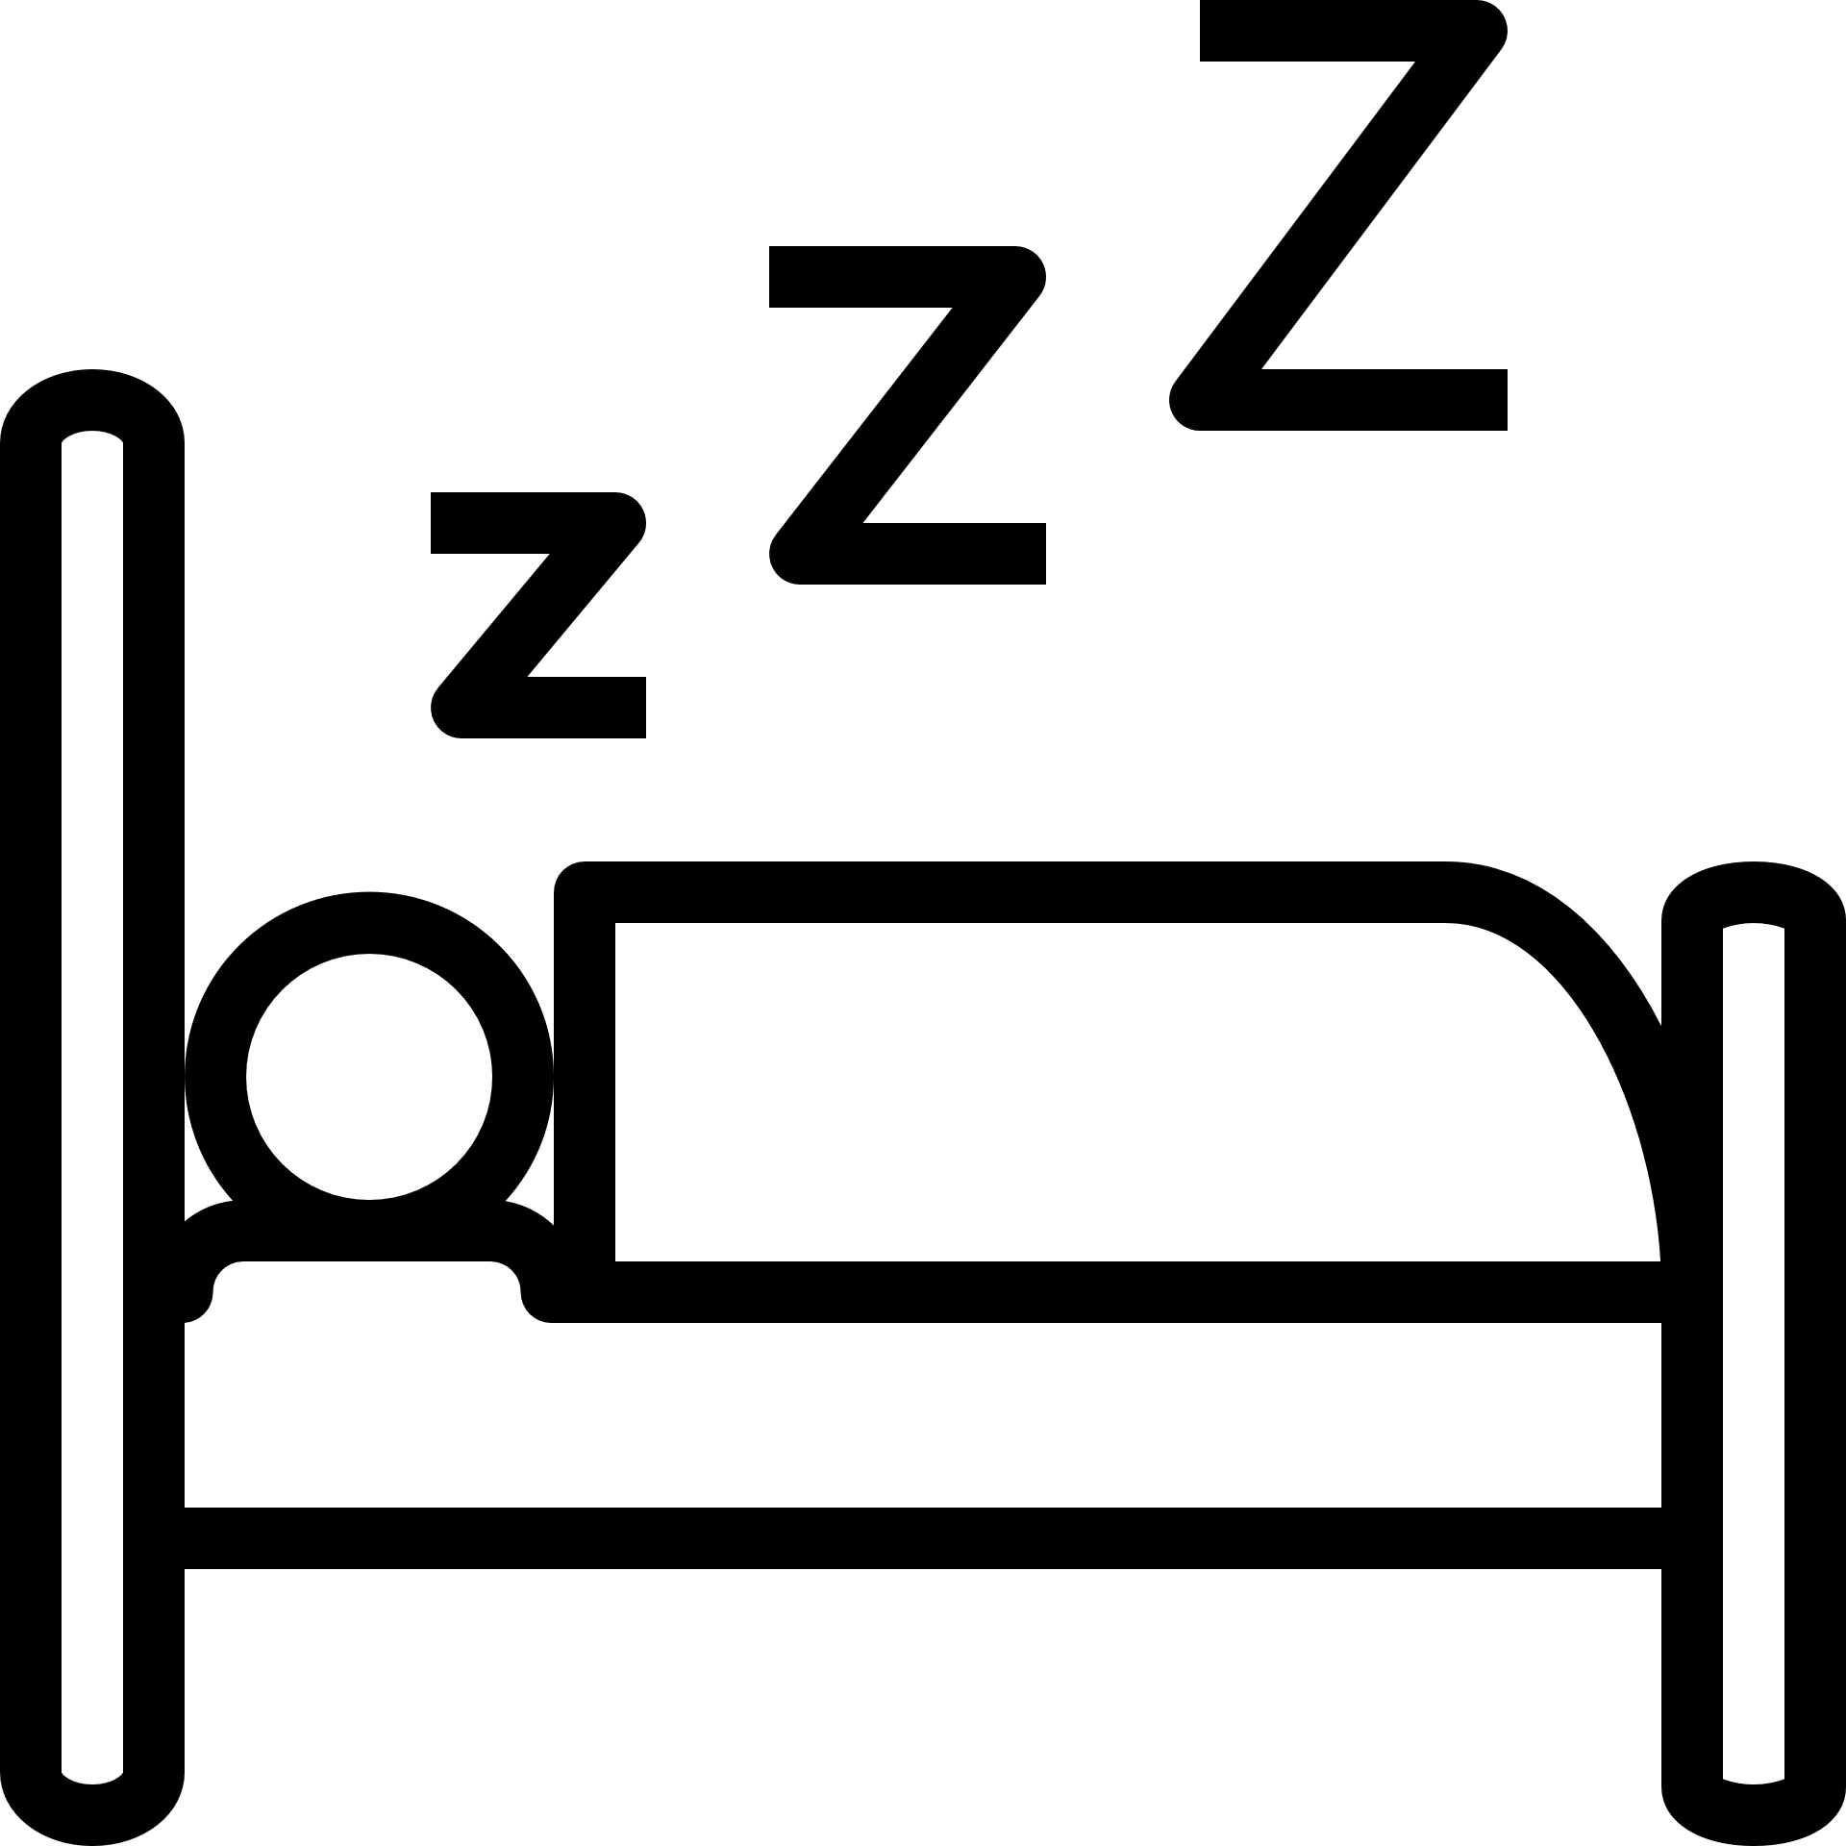
 |  | 
 |  | 
 |  | 


 |  | 
 |  | 

Poetry Theme Brain Dumps
For each of the following brain dumps, spend at least 5 minutes adding anything you can think of about that theme- poems, key ideas, key quotations etc.
Once you have run out of ideas, use a KO/anthology to add some ideas.
Humanity’s power
Nature’s power
Physical Conflict
Mental Conflict

Poetry – Mini Mocks.
For each of the following mini questions, you could do a full response or part of a response. Remember quickly read the question and the poem. You should then spend 5 minutes planning ideas. Finally, write your paragraphs.
02 Compare how poets present ideas about nature in ‘Storm on the Island’ and one other poem from ‘Power and Conflict’ [30 marks]  ‘Storm on the Island’ by Seamus Heaney  We are prepared: we build our houses squat,  Sink walls in rock and roof them with good slate.  This wizened earth has never troubled us  With hay, so, as you see, there are no stacks  Or stooks that can be lost. Nor are there trees  Which might prove company when it blows full  Blast: you know what I mean - leaves and branches  Can raise a tragic chorus in a gale  So that you listen to the thing you fear  Forgetting that it pummels your house too.  But there are no trees, no natural shelter.  You might think that the sea is company,  Exploding comfortably down on the cliffs  But no: when it begins, the flung spray hits  The very windows, spits like a tame cat  Turned savage. We just sit tight while wind dives  And strafes invisibly. Space is a salvo,  We are bombarded with the empty air.  Strange, it is a huge nothing that we fear. | 02 Compare how poets present ideas about human power in ‘London’ and one other poem from ‘Power and Conflict’ [30 marks]  ‘London’ by William Blake  I wander thro' each charter'd street,  Near where the charter'd Thames does flow.  And mark in every face I meet  Marks of weakness, marks of woe.  In every cry of every Man,  In every Infants cry of fear,  In every voice: in every ban,  The mind-forg'd manacles I hear  How the Chimney-sweepers cry  Every blackning Church appalls,  And the hapless Soldiers sigh  Runs in blood down Palace walls  But most thro' midnight streets I hear  How the youthful Harlots curse  Blasts the new-born Infants tear  And blights with plagues the Marriage hearse | 02 Compare how poets present ideas about conflict in ‘The Emigree’ and one other poem from ‘Power and Conflict’ [30 marks]  ‘The Emigree’ by Carol Rumens  There once was a country… I left it as a child  but my memory of it is sunlight-clear  for it seems I never saw it in that November  which, I am told, comes to the mildest city.  The worst news I receive of it cannot break  my original view, the bright, filled paperweight.  It may be at war, it may be sick with tyrants,  but I am branded by an impression of sunlight.  The white streets of that city, the graceful slopes  glow even clearer as time rolls its tanks  and the frontiers rise between us, close like waves.  That child’s vocabulary I carried here  like a hollow doll, opens and spills a grammar.  Soon I shall have every coloured molecule of it.  It may by now be a lie, banned by the state  but I can’t get it off my tongue. It tastes of sunlight.  I have no passport, there’s no way back at all  but my city comes to me in its own white plane.  It lies down in front of me, docile as paper;  I comb its hair and love its shining eyes.  My city takes me dancing through the city  of walls. They accuse me of absence, they circle me.  They accuse me of being dark in their free city.  My city hides behind me. They mutter death,  and my shadow falls as evidence of sunlight.
Poetry – Mini Mocks.
02 Compare how poets present ideas about loss and grief in ‘Poppies’ and one other poem from ‘Power and Conflict’ [30 marks]  ‘Poppies’ by Jane Weir  Three days before Armistice Sunday  and poppies had already been placed  on individual war graves. Before you left,  I pinned one onto your lapel, crimped petals,  spasms of paper red, disrupting a blockade  of yellow bias binding around your blazer.  Sellotape bandaged around my hand,  I rounded up as many white cat hairs  as I could, smoothed down your shirt's  upturned collar, steeled the softening  of my face. I wanted to graze my nose  across the tip of your nose, play at  being Eskimos like we did when  you were little. I resisted the impulse  to run my fingers through the gelled  blackthorns of your hair. All my words  flattened, rolled, turned into felt,  slowly melting. I was brave, as I walked  with you, to the front door, threw  it open, the world overflowing  like a treasure chest. A split second  and you were away, intoxicated.  After you'd gone I went into your bedroom,  released a song bird from its cage.  Later a single dove flew from the pear tree,  and this is where it has led me,  skirting the church yard walls, my stomach busy  making tucks, darts, pleats, hat-less, without  a winter coat or reinforcements of scarf, gloves.  On reaching the top of the hill I traced  the inscriptions on the war memorial,  leaned against it like a wishbone.  The dove pulled freely against the sky,  an ornamental stitch, I listened, hoping to hear  your playground voice catching on the wind. | 02 Compare how poets present ideas about the mental impact of conflict in ‘War Photographer’ and one other poem from ‘Power and Conflict’ [30 marks]  ‘War Photographer’ by Carol Ann Duffy  In his dark room he is finally alone  with spools of suffering set out in ordered rows.  The only light is red and softly glows,  as though this were a church and he  a priest preparing to intone a Mass.  Belfast. Beirut. Phnom Penh. All flesh is grass.  He has a job to do. Solutions slop in trays  beneath his hands, which did not tremble then  though seem to now. Rural England. Home again  to ordinary pain which simple weather can dispel,  to fields which don’t explode beneath the feet  of running children in a nightmare heat.  Something is happening. A stranger’s features  faintly start to twist before his eyes,  a half-formed ghost. He remembers the cries  of this man’s wife, how he sought approval  without words to do what someone must  and how the blood stained into foreign dust.  A hundred agonies in black and white  from which his editor will pick out five or six  for Sunday’s supplement. The reader’s eyeballs prick  with tears between the bath and pre-lunch beers.  From the aeroplane he stares impassively at where  he earns his living and they do not care. | 02 Compare how poets present ideas about war in ‘Bayonet Charge’ and one other poem from ‘Power and Conflict’ [30 marks]  ‘Bayonet Charge’ by Ted Hughes  Suddenly he awoke and was running – raw  In raw-seamed hot khaki, his sweat heavy,  Stumbling across a field of clods towards a green hedge  That dazzled with rifle fire, hearing  Bullets smacking the belly out of the air –  He lugged a rifle numb as a smashed arm;  The patriotic tear that had brimmed in his eye  Sweating like molten iron from the centre of his chest, –  In bewilderment then he almost stopped –  In what cold clockwork of the stars and the nations  Was he the hand pointing that second? He was running  Like a man who has jumped up in the dark and runs  Listening between his footfalls for the reason  Of his still running, and his foot hung like  Statuary in mid-stride. Then the shot-slashed furrows  Threw up a yellow hare that rolled like a flame  And crawled in a threshing circle, its mouth wide  Open silent, its eyes standing out.  He plunged past with his bayonet toward the green hedge,  King, honour, human dignity, etcetera  Dropped like luxuries in a yelling alarm  To get out of that blue crackling air  His terror’s touchy dynamite.

Hexagon sheets x 2
Knowledge organisers – 1 lang, Macbeth, ACC, 4x poetry

