
Which image and why?
You have been given three images to represent each word. Choose which one you think best represents the word and number it 1, and then explain why it is the best example for that word in the final box. Then, decide the worst image to represent that word and explain why you think it is the worst example.
Prejudice

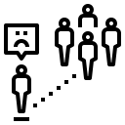

Equity

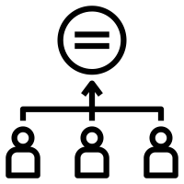

Segregation
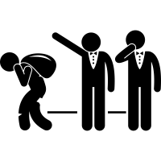
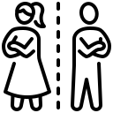
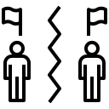

Which image and why?
You have been given three images to represent each word. Choose which one you think best represents the word and number it 1, and then explain why it is the best example for that word in the final box. Then, decide the worst image to represent that word and explain why you think it is the worst example.
Autonomy



Tolerance



Compassion

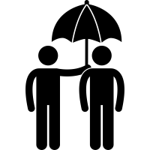


Which form of the word?
You have been given a word from your vocabulary list and different versions of the word. Read the sentences given and write the correct word from the ones you have been given in the final box.
radicalisation radicalised radical unradical
He became a ___________ when his views on religion changed following the conflict he witnessed.
The __________ of young people occurs when they come to support or be involved in extreme beliefs and ideas.
The teenager was __________ by an older man who told him to think differently about his political views.
tolerance tolerates tolerable
intolerable tolerating
Lucy found it __________ when he was chewing his food loudly and speaking as he was eating.
The mother ___________ her child’s messy room but she would prefer for him to keep it tidy.
Animals that live in the desert have a high __________ for heat and lack of water.
She found the meal _________ but did not want to give a tip or write a good review.
compassion compassionate
compassionately uncompassionate
One key difference with humans and animals is the belief that humans have the ability to offer ______________.
Mary was a ______________ individual who volunteered at a food bank at the weekend.
He did not want to give any money to homeless charity as he felt ___________ towards those who beg on the streets.
objectivity objectively objective objectify
Journalists must try and write about politics ___________ in order to share the truth with their readers.
The judge in the trial had to show complete ___________ towards the case and the defendant.
subjectivity subjectively subjective
When the critic wrote a personal review about the film, he offered his own __________ view of what he had seen.
Going to a gallery and viewing art requires ___________ in order to offer your own views on what you see.
Which sentence and why?
You have been given two grammatically correct sentences. However, one of the sentences uses the word incorrectly, because the person writing it does not properly understand the word. Choose which sentence is correct, and explain why the word has been used correctly. Then explain why the incorrect sentence is wrong. Remember, the sentence is written correctly. It is about why the word has not been used properly in terms of its meaning.
segregated
During Nazi Germany, ghettos were created in order to ensure that Jewish people were segregated from others. | ü | X
In the household the children were segregated into their rooms each night in order to get some sleep. | ü | X
prejudiced
The bully was prejudiced against his victims; he randomly selected someone to pick on from those who annoyed him. | ü | X
The bully was prejudiced against poor people; he picked on people who did not have branded and expensive clothing. | ü | X
compassion
He felt a strong sense of compassion towards the boy losing the race, so he cheered for him to cross the finish line. | ü | X
He felt a strong sense of compassion towards the boy winning the race, so he cheered for him when he finished first. | ü | X
marginalised
Before the war women were marginalised in society because they were viewed as weak and insignificant. | ü | X
During the war rich people were marginalised because they lost their status and money due to rationing. | ü | X
equity
A company with 75% male workers could achieve gender equity by interviewing more women than men for a new role. | ü | X
A company that wants to achieve gender equity should interview the same number of men and women. | ü | X

Which subject fits?
You are given three subjects and questions about the word within that subject. Choose one of the three options and write a sentence about the subject using the word – you can use any form of the word.
autonomy
History: at what point in history does a monarch have total autonomy?
DT: do you have complete autonomy when designing or creating a project?
Art: why might it be important for an artist to have autonomy over their work?
subjective
Music: When listening to a piece of music, is it possible to not be subjective?
Drama: is it easy to be subjective when offering feedback to another group?
Languages: is it important to offer your opinion and be subjective in another language?
tolerance
Maths: Why might there be a low tolerance for making mistakes in a lesson on degrees?
R.E: When in R.E do you need to show tolerance during your discussions?
P.E: how important is it for a sportsperson to have a high tolerance for pain?
objectivity
Maths: Why is objectivity important when carrying out an experiment?
Geography: Why might it be hard to show objectivity when learning about a country?
P.E: why is it important for a referee to show complete objectivity during a match?
compassion
History: During what periods of history have humans lacked compassion towards others?
R.E: Do you think religions value behaviour which shows compassion?
Drama: What gestures/facial expressions/tone of voice might show compassion in a character?

Can you finish the sentence?
You are given three subjects and questions about the word within that subject. Choose one of the three options and write a sentence about the subject using the word – you can use any form of the word.
tolerance
She found her little brother intolerable when he…
It’s important to have tolerance in school so that…
He was a very tolerant individual because he…
radicalisation
His views became radicalised when he…
The radicalisation of her views was caused by…
prejudice
The boss showed prejudice towards women when he…
The rich woman was prejudiced towards…
objectivity
A policeman has to remain objective when…
Objectivity is important when a teacher is marking an assessment because…
segregation
When people are segregated from others, they feel…
Segregation based on race was common when…
compassion
A friend should be compassionate when…
A doctor has to show compassion especially…

