MINI MINI MOCK PAPER 1, QUESTION 2 AND 5:
LINKED LANGUAGE ANALYSIS AND CREATIVE WRITING
They seem tentative and awkward at first, then in a hastening host a whole brief army falls, white militia paratrooping out of the close sky over various textures, making them one. Snow is white and gray, part and whole, infinitely various yet infinitely repetitious, soft and hard, frozen and melting, a creaking underfoot and a soundlessness. But first of all it is the reversion of many into one. It is substance, almost the idea of substance, that turns grass, driveway, hayfield, old garden, log pile, Saab, watering trough, collapsed barn, and stonewall into the one white.  From Seasons at Eagle Pond, Donald Hall | USING THE EXTRACT:  02 How does the writer use language to describe the snow?  You could include the writer’s choice of  - words and phrases  - language features and techniques  - sentence forms | 
USING THE IMAGE:
05

EITHER
Write a description as suggested by this image

OR
Write the opening of a story that begins in the snow

MINI MINI MOCK PAPER 1, QUESTION 2 AND 5:
LINKED LANGUAGE ANALYSIS AND CREATIVE WRITING
They seem tentative and awkward at first, then in a hastening host a whole brief army falls, white militia paratrooping out of the close sky over various textures, making them one. Snow is white and gray, part and whole, infinitely various yet infinitely repetitious, soft and hard, frozen and melting, a creaking underfoot and a soundlessness. But first of all it is the reversion of many into one. It is substance, almost the idea of substance, that turns grass, driveway, hayfield, old garden, log pile, Saab, watering trough, collapsed barn, and stonewall into the one white.  From Seasons at Eagle Pond, Donald Hall | USING THE EXTRACT:  02 How does the writer use language to describe the snow?  You could include the writer’s choice of  - words and phrases  - language features and techniques  - sentence forms
USING THE IMAGE:
05

EITHER
Write a description as suggested by this image

OR
Write the opening of a story that begins in the snow

MINI MINI MOCK PAPER 1, QUESTION 2 AND 5:
LINKED LANGUAGE ANALYSIS AND CREATIVE WRITING
No Human eye can isolate the unhappy coincidence of line and place which suggests evil in the face of the house, and yet somehow a maniac juxtaposition, a badly turned angle, some chance meeting of roof and sky, turned Hill House into a place of despair, more frightening because the face of Hill House seemed awake, with a watchfulness from the blank windows and a touch of glee in the eyebrow of a cornice. A house arrogant and hating, never off guard, can only be evil. It was a house without kindness, never meant to be lived in, not a fit place for people or for love or for hope. Exorcism cannot alter the countenance of a house; Hill House would stay as it was until it was destroyed. From The Haunting of Hill House by Shirley Jackson |  | USING THE EXTRACT:  02 How does the writer use language to describe the house?  You could include the writer’s choice of  - words and phrases  - language features and techniques  - sentence forms | 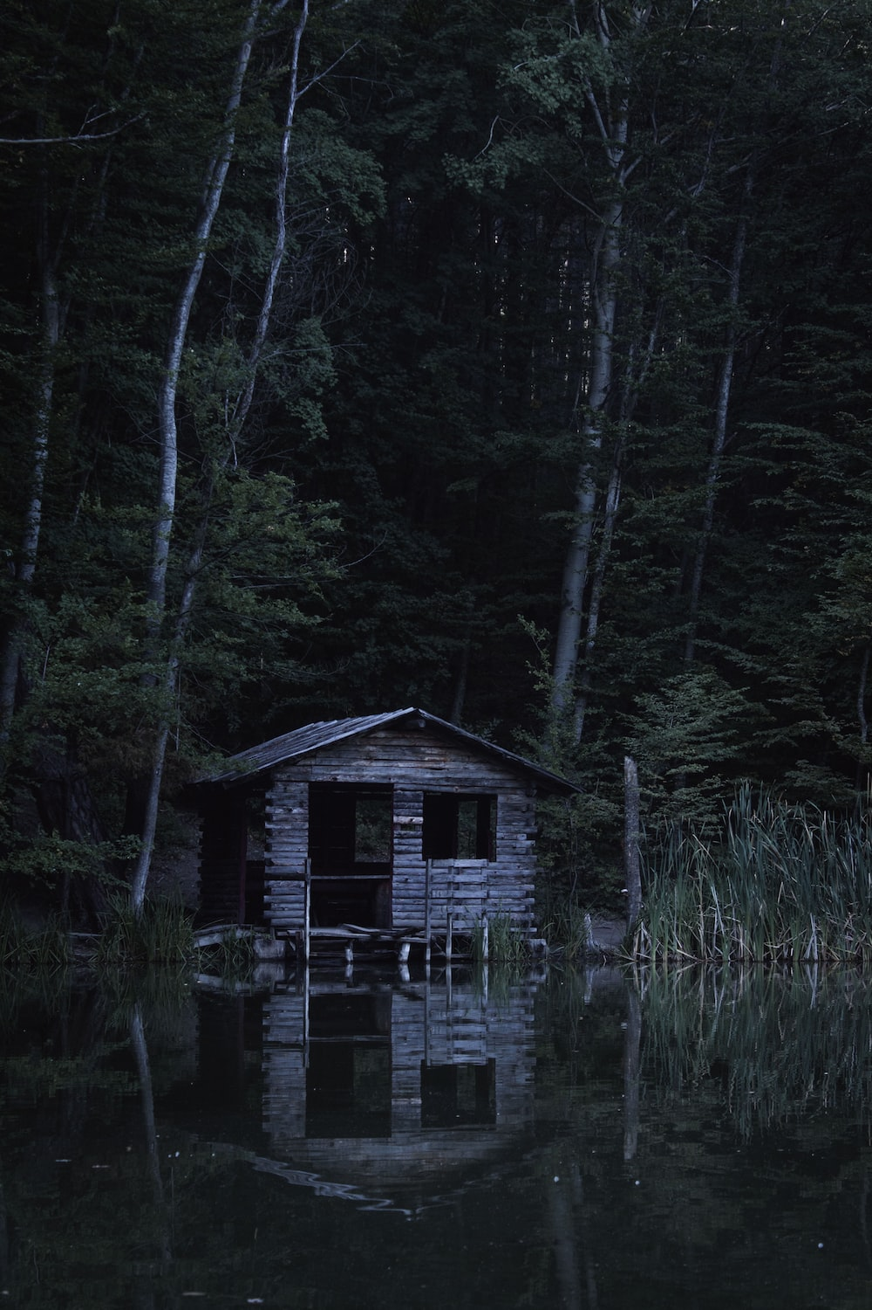
USING THE IMAGE:
05
EITHER
Write a description as suggested by this image
OR
Write the opening of a story that is set in an abandoned house.

MINI MINI MOCK PAPER 1, QUESTION 2 AND 5:
LINKED LANGUAGE ANALYSIS AND CREATIVE WRITING
No Human eye can isolate the unhappy coincidence of line and place which suggests evil in the face of the house, and yet somehow a maniac juxtaposition, a badly turned angle, some chance meeting of roof and sky, turned Hill House into a place of despair, more frightening because the face of Hill House seemed awake, with a watchfulness from the blank windows and a touch of glee in the eyebrow of a cornice. A house arrogant and hating, never off guard, can only be evil. It was a house without kindness, never meant to be lived in, not a fit place for people or for love or for hope. Exorcism cannot alter the countenance of a house; Hill House would stay as it was until it was destroyed. From The Haunting of Hill House by Shirley Jackson | USING THE EXTRACT:  02 How does the writer use language to describe the house?  You could include the writer’s choice of  - words and phrases  - language features and techniques  - sentence forms
USING THE IMAGE:
05
EITHER
Write a description as suggested by this image
OR
Write the opening of a story that is set in an abandoned house.

MINI MINI MOCK PAPER 1, QUESTION 2 AND 5:
LINKED LANGUAGE ANALYSIS AND CREATIVE WRITING
A black shadow dropped down into the circle. It was Bagheera the Black Panther, inky black all over, but with the panther markings showing up in certain lights like the pattern of watered silk. Everybody knew Bagheera, and nobody cared to cross his path, for he was as cunning as Tabaqui, as bold as the wild buffalo, and as reckless as the wounded elephant. But he had a voice as soft as wild honey dripping from a tree, and a skin softer than down.  From The Jungle Book by Rudyard Kipling | USING THE EXTRACT:  02 How does the writer use language to describe Bagheera the panther?  You could include the writer’s choice of  - words and phrases  - language features and techniques  - sentence forms | 
USING THE IMAGE:
05
EITHER
Write a description as suggested by this image
OR

Write the opening of a story that includes a predator.

MINI MINI MOCK PAPER 1, QUESTION 2 AND 5:
LINKED LANGUAGE ANALYSIS AND CREATIVE WRITING
A black shadow dropped down into the circle. It was Bagheera the Black Panther, inky black all over, but with the panther markings showing up in certain lights like the pattern of watered silk. Everybody knew Bagheera, and nobody cared to cross his path, for he was as cunning as Tabaqui, as bold as the wild buffalo, and as reckless as the wounded elephant. But he had a voice as soft as wild honey dripping from a tree, and a skin softer than down.  From The Jungle Book by Rudyard Kipling | USING THE EXTRACT:  02 How does the writer use language to describe Bagheera the panther?  You could include the writer’s choice of  - words and phrases  - language features and techniques  - sentence forms
USING THE IMAGE:
05
EITHER
Write a description as suggested by this image
OR

Write the opening of a story that includes a predator.

MINI MINI MOCK PAPER 1, QUESTION 2 AND 5:
LINKED LANGUAGE ANALYSIS AND CREATIVE WRITING
Detroit exudes shame and decay. Those are its bright spots. You lock your doors and cringe and stomach going from the safety of point A to point B. You hope that you don’t break down in the broken down east side. Your heart races when you come upon a long red light and all you see is burned out buildings and church and barbeque hovels. Was that gunfire or backfire? You stare to the left and a beggar from the right knocks on your window looking for a “dolla”. You survive and relax under an umbrella table at an outdoor cafe in beautiful downtown, all gleaming and white. Your tale brings nervous smiles and shaking heads. I love mysteries and dark dilemmas. I love Detroit. From Detroit Noir by EJ Olsen and Jon C Hocking | USING THE EXTRACT:  02 How does the writer use language to describe Detroit?  You could include the writer’s choice of  - words and phrases  - language features and techniques  - sentence forms | 
USING THE IMAGE:
05
EITHER
Write a description as suggested by this image
OR
Write the opening of a story that is set in a busy city of your choice.

MINI MINI MOCK PAPER 1, QUESTION 2 AND 5:
LINKED LANGUAGE ANALYSIS AND CREATIVE WRITING
Detroit exudes shame and decay. Those are its bright spots. You lock your doors and cringe and stomach going from the safety of point A to point B. You hope that you don’t break down in the broken down east side. Your heart races when you come upon a long red light and all you see is burned out buildings and church and barbeque hovels. Was that gunfire or backfire? You stare to the left and a beggar from the right knocks on your window looking for a “dolla”. You survive and relax under an umbrella table at an outdoor cafe in beautiful downtown, all gleaming and white. Your tale brings nervous smiles and shaking heads. I love mysteries and dark dilemmas. I love Detroit. From Detroit Noir by EJ Olsen and Jon C Hocking | USING THE EXTRACT:  02 How does the writer use language to describe Detroit?  You could include the writer’s choice of  - words and phrases  - language features and techniques  - sentence forms
USING THE IMAGE:
05
EITHER
Write a description as suggested by this image
OR
Write the opening of a story that is set in a busy city of your choice.
MINI MINI MOCK PAPER 1, QUESTION 2 AND 5:
LINKED LANGUAGE ANALYSIS AND CREATIVE WRITING
A reef of clouds and lightning raced across the skies from the sea. My hands were shaking, and my mind wasn’t far behind. I looked up and saw the storm spilling like rivers of blackened blood from the clouds, blotting out the moon and covering the roofs of the city in darkness. I tried to speed up, but I was consumed with fear and walked with leaden feet, chased by the rain. I took refuge under the canopy of a newspaper kiosk, trying to collect my thoughts and decide what to do next. A clap of thunder roared close by, and I felt the ground shake under my feet. On the flooding pavements the streetlamps blinked, then went out like candles snuffed by the wind. There wasn’t a soul to be seen in the streets, and the darkness of the blackout spread with a fetid smell that rose from the sewers. The night became opaque, impenetrable, as the rain folded the city in its shroud. From Shadow of the Wind by Carlos Ruiz Zafon | USING THE EXTRACT:  02 How does the writer use language to describe the weather?  You could include the writer’s choice of  - words and phrases  - language features and techniques  - sentence forms | 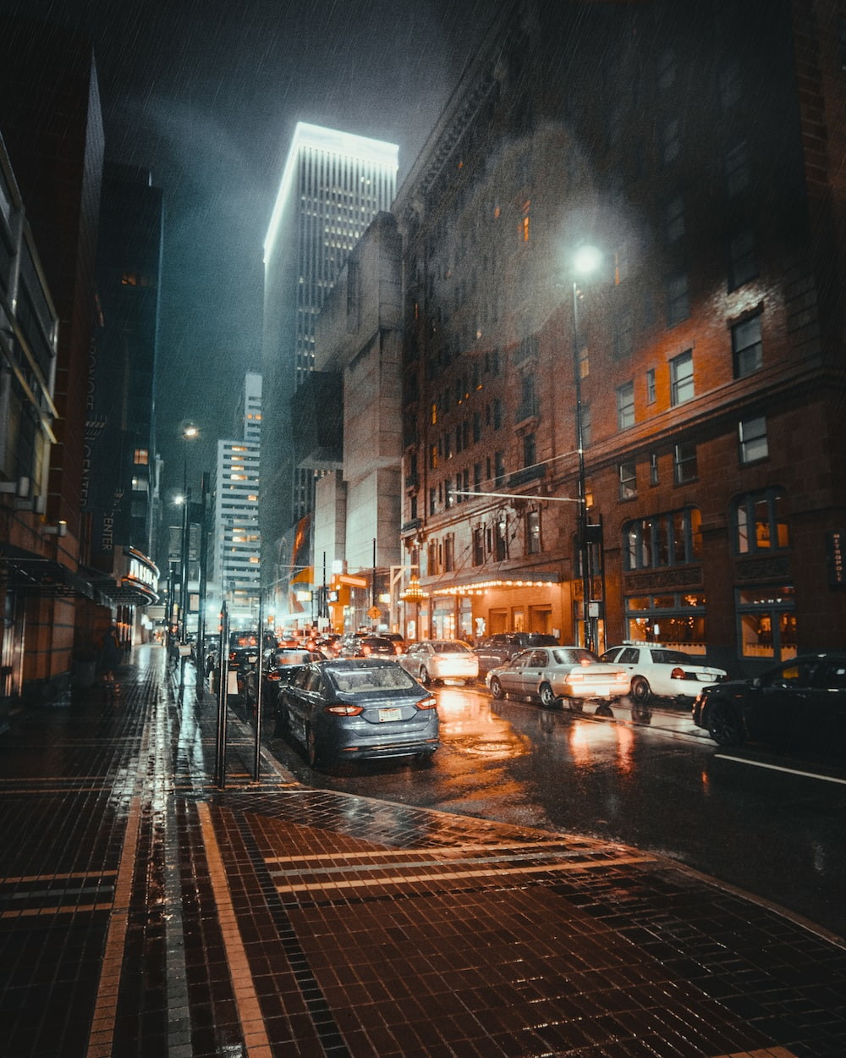
USING THE IMAGE:
05
EITHER
Write a description as suggested by this image

OR
Write the opening of a story that takes place during a storm

MINI MINI MOCK PAPER 1, QUESTION 2 AND 5:
LINKED LANGUAGE ANALYSIS AND CREATIVE WRITING
A reef of clouds and lightning raced across the skies from the sea. My hands were shaking, and my mind wasn’t far behind. I looked up and saw the storm spilling like rivers of blackened blood from the clouds, blotting out the moon and covering the roofs of the city in darkness. I tried to speed up, but I was consumed with fear and walked with leaden feet, chased by the rain. I took refuge under the canopy of a newspaper kiosk, trying to collect my thoughts and decide what to do next. A clap of thunder roared close by, and I felt the ground shake under my feet. On the flooding pavements the streetlamps blinked, then went out like candles snuffed by the wind. There wasn’t a soul to be seen in the streets, and the darkness of the blackout spread with a fetid smell that rose from the sewers. The night became opaque, impenetrable, as the rain folded the city in its shroud. From Shadow of the Wind by Carlos Ruiz Zafon | USING THE EXTRACT:  02 How does the writer use language to describe the weather?  You could include the writer’s choice of  - words and phrases  - language features and techniques  - sentence forms
USING THE IMAGE:
05
EITHER
Write a description as suggested by this image

OR
Write the opening of a story that takes place during a storm

