Class of 2025: Unit 1
GCSE English Literature
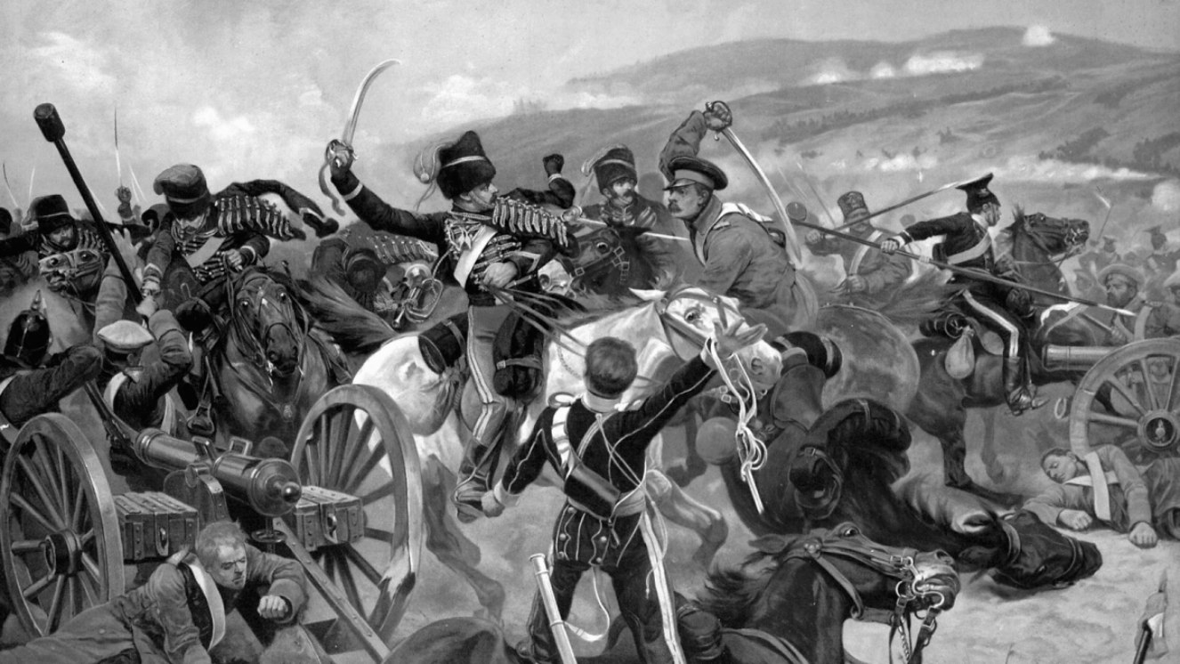
Poetry: War Cluster

Name:
Class:
Teacher:

CONTENTS PAGE
General | Front cover | 1
General | Contents page | 2
UNDERSTANDING CONFLICT
Background reading and writing | ‘Exposure’: Wilfred Owen’s letters and Private Peaceful | 4-6
Background reading and writing | ‘Bayonet Charge’: WWI Accounts and Birdsong | 7-9
Background reading and writing | ‘The Charge of the Light Brigade’: Times article | 10-12
Background reading and writing | ‘War Photographer’: Nick Ut interview | 13-15
Background reading and writing | ‘Remains’: Iraq & Afghanistan veteran interview | 16-18
Background reading and writing | Additional writing space | 19
EXPLORING THE POEMS
‘Exposure’ | Introductory tasks | 21
‘Exposure’ | ‘Exposure’ by Wilfred Owen | 22
‘Exposure’ | Quotation analysis | 23
‘Exposure’ | Consolidating understanding | 24
‘Bayonet Charge’ | Introductory tasks | 25
‘Bayonet Charge’ | ‘Bayonet Charge’ by Ted Hughes | 26
‘Bayonet Charge’ | Quotation analysis | 27
‘Bayonet Charge’ | Consolidating understanding | 28
‘Charge of the Light Brigade’ | Introductory tasks | 29
‘Charge of the Light Brigade’ | ‘Charge of the Light Brigade’ by Alfred Lord Tennyson | 30
‘Charge of the Light Brigade’ | Quotation analysis | 31
‘Charge of the Light Brigade’ | Consolidating understanding | 32
‘War Photographer’ | Introductory tasks | 33
‘War Photographer’ | ‘War Photographer’ by Carol Ann Duffy | 34
‘War Photographer’ | Quotation analysis | 35
‘War Photographer’ | Consolidating understanding | 36
‘Remains’ | Introductory tasks | 37
‘Remains’ | ‘Remains’ by Simon Armitage | 38
‘Remains’ | Quotation analysis | 39
‘Remains’ | Consolidating understanding | 40
CONNECTING THE POEMS
Comparison and written tasks | Five poems comparison grid | 42-43
Comparison and written tasks | Matching poems to summary and images | 44
Comparison and written tasks | Example question | 45
Comparison and written tasks | Example response | 46-47
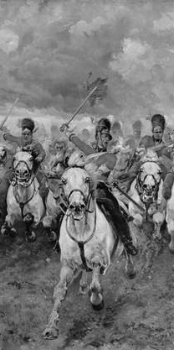
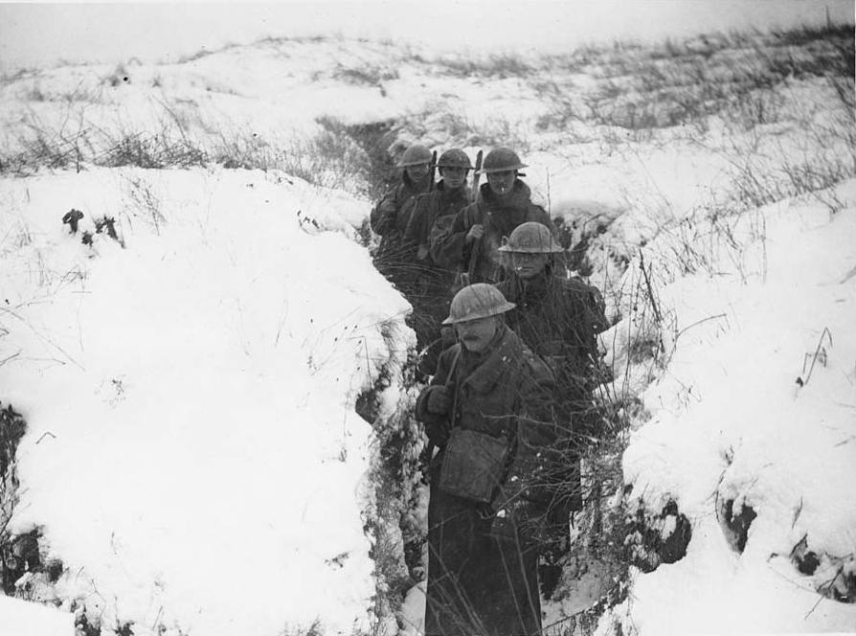

SECTION 1: Understanding
Conflict
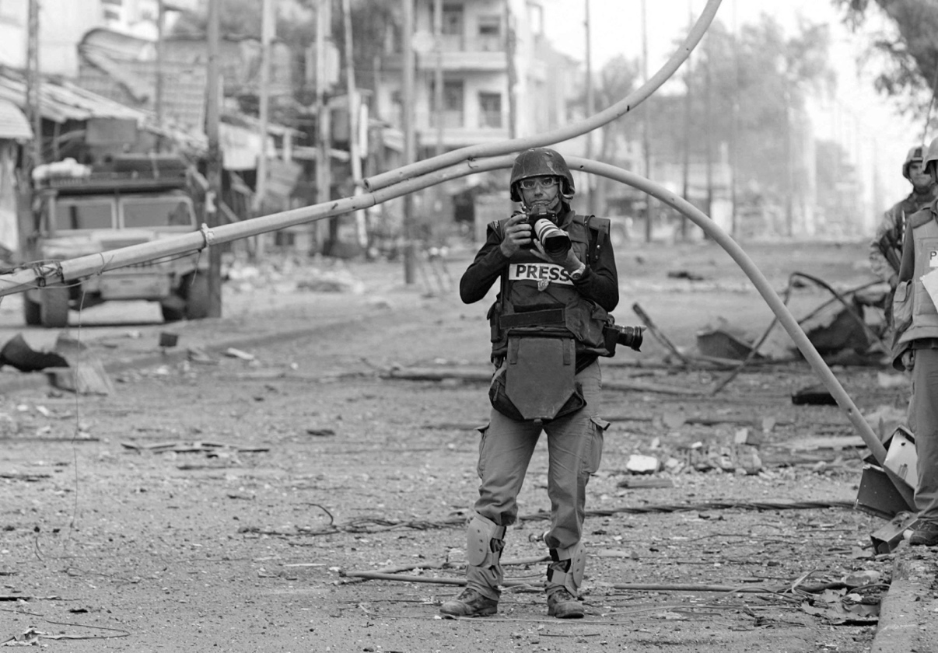
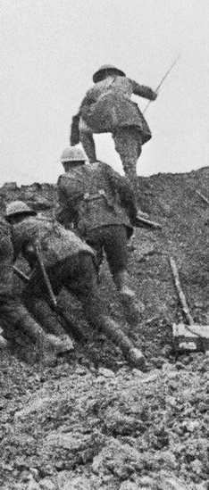

Wilfred Owen’s Letters
The following letters were written by Wilfred Owen whilst in active service. Owen describes his experience of the weather during war, and what it was like during attacks.
5  10  15  20  25  30  35  40  45 | 4th February 1917 – To Susan Owen (his mum)  I have no mind to describe all the horrors of this last Tour. But it was almost worse than the first, because in this place my Platoon had no Dug-Outs, but had to lie in the snow under the deadly wind. By day it was impossible to stand up or even to crawl about because we were behind only a little up ridge screening us from the Bosches’ periscope. We had 5 Tommy cookers between the Platoon, but they did not suffice to melt the ice in the water-cans. So we suffered cruelly from thirst.  The marvel is that we did not all die of cold. As a matter of fact, only one of my party actually froze to death before he got back, but I am not able to tell how may have ended in hospital. I had no real casualties from shelling, though for 10 minutes every hour whizz-bangs fell a few yards short of us. Showers of soil rained on us, but no fragments of shell could find us.  I had lost my gloves in a dug-out, but I found 1 mitten on the Field; I had my Trench Coat (without lining but with a Jerkin underneath). My feet ached until they could ache no more, and so they temporarily died. I was kept warm by the ardour of life within me. I forgot hunger in the hunger for Life. The intensity of your Love reached me and kept me living. I thought of you and Mary without break all the time. I cannot say I felt any fear. We were all half crazed by the buffeting of the High Explosives. I think the most unpleasant reflection that weighed on me was the impossibility of getting back any wounded, a total impossibility. All day impossible, and frightfully difficult by night.  We were marooned on a frozen desert. There is not a sign of life on the horizon and a thousand signs of death. Not a blade of grass, not an insect; once or twice a day the shadow of a big hawk scenting carrion.  I suppose I can endure cold, and fatigue, and the face to face death, as well as another; but extra for me there is the universal pervasion of Ugliness. Hideous landscapes, vile noises, foul language, even from one’s own mouth (for all are devil ridden). Everything is unnatural, broken, blasted; the distortion of the dead, whose unburiable bodes sit outside the dug-outs all day, all night, the most execrable sights on earth, In poetry we call them the most glorious, But to sit with them all day, all night … and a week later to come back and find them still sitting there in motionless groups THAT is what saps the ‘soldierly spirit.’  14th May 1917 – To Colin Owen (his brother)  Then we were caught in a Tornado of Shells. The various ‘waves’ were all broken up and we carried on like a crowd moving off a cricket field. When I looked back and saw the ground all crawling and wormy with wounded bodies, I felt no horror at all but only an immense exultation at having got through the Barrage. We were more than an hour moving over the open and by the time we came to the German Trench every Bosche had fled. But a party of them had remained lying low in a wood close behind us, and they gave us a very bad time for the next four hours |  |  |  | Platoon: (n) group, squad  Dug-out: (n) trench, shelter  Bosche:(n)German soldiers  Tommy:(n)English soldiers  marvel: (n)wonder, miracle  whizz-bands: (n) shells  marooned: (v) abandoned  carrion: (n) rotting flesh  pervasion: (n) is present everywhere, diffusion  execrable: (adj) extremely bad, horrible, horrifying  saps: (v) drains away  exultation: (n) triumph, joy  Barrage: (n) attack,  bombardment

TASK 1: Read the letters on page 2.
Pay attention to what you learn about the soldier’s experience of World War One.

TASK 2: Using lines 1-15, list four things you learn about the
weather at war. Try to give four specific details about the weather, in full clear sentences.

TASK 2: How does Owen use language to describe the landscape of
war? Read the extract below, annotating valuable quotations.
We were marooned on a frozen desert. There is not a sign of life on the horizon and a thousand signs of death. Not a blade of grass, not an insect; once or twice a day the shadow of a big hawk scenting carrion.
I suppose I can endure cold, and fatigue, and the face to face death, as well as another; but extra for me there is the universal pervasion of Ugliness. Hideous landscapes, vile noises, foul language, even from one’s own mouth (for all are devil ridden). Everything is unnatural, broken, blasted; the distortion of the dead
TASK 3: Finish the following sentence three times, using the examples
Owen presents the landscape of war as…
a horrific  sight. |  | an abandoned, empty place
TASK 4: Choose one quotation to write a paragraph answering the question.
This is an analysis question – ensure you zoom in on methods and discuss the meanings created.
Creative writing 1 : An Attack
The following extract comes from a fiction novel, Private Peaceful, written by Michael Morpurgo, published in 2003. It is set during World War 1, and this extract describes the narrator’s reaction to a gas attack.
5  10  15 | The awakening came suddenly. "Gas! Gas!"  "Fix bayonets!" Hanley's yelling while we're still trying frantically to pull on our gas masks. We grab our rifles and fix bayonets. We're on the firestep looking out into no-man's-land , and we see it rolling towards us, this dreaded killer cloud we have heard so much about but have never seen for ourselves until now. Its deadly tendrils are  searching ahead, feeling their way forward in long yellow wisps, scenting me, searching for me. Then finding me out, the gas turns and drifts straight for me. I'm shouting inside my gas mask. "Christ! Christ!" Still the gas comes on, through our wire, swallowing everything in its path.  The gas is only feet away now. In a moment it will be on me, around me, in me. I crouch down, hiding my face between my knees, hands over my helmet, praying it will float over my head, over the top of the trench, seek out someone else. But it does not. It's all around me. I tell myself I will not breathe, I must not breathe. Through a yellow mist I see the trench filling up with it. It drifts into the dugouts, snaking into every nook and cranny, looking for me. I see men running, staggering, falling. I see Pete shouting out for me. Then he's grabbing me and we run. Half-blinded by my mask I trip and fall, crashing my head against the trench wall, knocking myself half- senseless. My gas mask has come off. I pull it down, but I have breathed in and know already it's too late. My eyes are stinging. My lungs are burning. I am coughing, retching, choking. I don't care where I'm running so long as it is away from the gas.
TASK 1: Continue the story using the opening above.
Remember to think about your vocabulary, sentence structure, spelling and punctuation.

Going ‘Over the Top’
The following accounts come from WWI soldiers as they describe their experiences of going ‘Over the top’. This would involve fixing a bayonet to the top of their gun in order to prepare for face-to-face combat.
5  10  15  20  25  30  35  40  45  50 | Ordinary Seaman Joe Murray, Hood Battalion, Royal Naval Division, Gallipoli, 4th June 1915 We stood there, packed like sardines unable to stand up in comfort, and we still had another hour to go before we went over the top. It was a long hour. Some men were fast asleep on their feet, others just stood staring at the sky. The laddie next to me checked his rifle and ammunition again and again, still not satisfied. Others just stood and stared, silent as the grave. Maybe they were looking forward to it, who knows?  At 11:30 our guns ceased fire just as promptly as they had started. Many lives had depended on that half-hour bombardment – and we knew it. Had it destroyed the Turkish machine-gun posts? Had the riflemen been killed or driven to cover? We didn’t know, we only hoped. I’d never dreamt that even borrowed time could go so slowly.  Of course I’d advanced before – many times. I wasn’t afraid of advance. I didn’t like it, but I wasn’t afraid of Turkish soldiers. But I was afraid – I was afraid of myself. I wondered if I would live long enough to get out of the trench, and if I did, if I would have enough puff left in me to cover that four hundred yards or so across in one mad rush. And if not, and I had to bury my head in that burning scrub, would I have enough courage left to rise again and face that rain of lead?  Those were my thoughts as I stood beside Lieutenant Commander Parsons, my Company Commander, waiting for him to blow his whistle. Then, just before we went over the top, he turned round with the most confident smile and said “Five minutes to go men – four minutes – three minutes – two minutes – one minute to go, men. Are you ready? Come on boys, off we go!”  As I was getting out of the trench I could see the Collingwood Battalion leave their trench in perfect formation – it was like they were on a parade ground. Well, this heartened me […] But as we lay there we saw them being cut down.  I asked God to help me as I scrambled over the top into that withering fire. Many, many men were killed as soon as they showed their heads, and fell back into the trench. Very few of us reached the Turkish front line.  The trench was much too deep for us to occupy and as we were getting into position along the parapet I felt a sudden bang in the chest. Then I found myself crawling about on the bottom of the trench trying to find my rifle – my face was stiff and I could only see out of one eye. I eventually found my rifle and realised that all my equipment had been torn to shreds – my tunic was smouldering, my body was criss-crossed with rips and all the ammunition had gone. Apparently, a machine-gun sweep had caught me and blown the lot off, and down I went.  Sergeant-Major Richard Tobin, Hood Battalion, Royal Naval Division, The Somme, 1916 We were assembled at one or two in the morning but then had to wait until quarter to six. We stood there in silence, you couldn’t make a noise, and the fellow next to you felt like your best friend, you loved him, although you probably didn’t know him a day before. They were both the longest and the shortest hours of my life. An infantryman in the front line feels the coldest, deepest fear.  Then, it was just five minutes to go – then zero – and all hell let loose. There was our barrage, then the German barrage, and over the top we went. As soon as we got over the top the fear and the terror left us. You don’t look, you see; you don’t listen, you hear; your nose is filled with fumes and death and you taste the top of your mouth. You are one with your weapon, the veneer of civilization has dropped away and you see just a line of men and a blur of shells. Then came the mist of dawn – a November dawn – and a burst of shells which gave a dirty orange colour and left horrible fumes. We saw a gap in the line and closed in. |  |  |  | battalion: military unit  parapet: (n) a protective wall or defence, barricade  veneer: (n) a covering which hides or disguises something, a mask, façade  civilization: (n) an advanced or developed society
TASK 1: Read the accounts on page 7.
Pay attention to what you learn about the soldier’s experience of going over the top.
TASK 2: Using lines 24-36, list four things Murray does during this
attack. Try to give four specific details about his actions, in full clear sentences.
TASK 2: How does Murray use language to describe his feelings?
Read the extract below, annotating valuable quotations.
We stood there, packed like sardines unable to stand up in comfort, and we still had another hour to go before we went over the top. It was a long hour. Some men were fast asleep on their feet, others just stood staring at the sky. The laddie next to me checked his rifle and ammunition again and again, still not satisfied. Others just stood and stared, silent as the grave. Maybe they were looking forward to it, who knows?
TASK 3: Finish the following sentence three times, using the examples
During the event Murray feels…
restricted and claustrophobic.
TASK 4: Choose one quotation to write a paragraph answering the question.
This is an analysis question – ensure you zoom in on methods and discuss the meanings created.
Creative writing 2 : Over The Top
The following extract comes from a fiction novel, Birdsong, written by Sebasian Faulks, published in 1993. It is set during WW1, and this extract describes Stephen, a lieutenant, going over the top during a battle.
5  10  15 | The second hand of his watch in slow motion. Twenty-nine past. The whistle in his mouth. His foot on the ladder. He swallowed hard and blew.  He clambered out and looked around him. It was for a moment completely quiet as the bombardment ended and the German guns also stopped. Skylarks wheeled and sang high in the cloudless sky. He felt alone, as though he had stumbled on this fresh world at the instant of its creation.  Then the artillery began to lay down the first barrage and the German machine guns resumed. To his left Stephen saw men trying to emerge from the trench but being smashed by bullets before they could stand. The gaps in the wire became jammed with bodies. Behind him the men were coming up. He saw Gray run along the top of the trench, shouting encouragement.  He walked hesitatingly forward, his skin tensed for the feeling of metal tearing flesh. He turned his body sideways, tenderly, to protect his eyes. He was hunched like an old woman in the cocoon of tearing noise.  Byrne was walking beside him at the slow pace required by their orders. Stephen glanced to his right. He could see a long, wavering line of khaki, primitive dolls progressing in tense deliberate steps, going down with a silent flap of arms, replaced, falling, continuing as though walking into a gale. He tried to catch Byrne’s eye but failed. The sound of machine guns was varied by the crack of snipers and the roar of the barrage ahead of them.  He saw Hunt fall to his right. Studd bent to help him and Stephen saw his head opening up bright red under machine gun bullets as his helmet fell away.  His feet pressed onwards gingerly over the broken ground.
TASK 1: Continue the story using the opening above.
Remember to think about your vocabulary, sentence structure, spelling and punctuation.

The Battle of Balaclava
The following extracts are taken from William Howard Russell’s reports in The Times, published on 13 and 14 November 1854. He was the war correspondent for the newspaper at the time.
5  10  15  20  25  30  35  40  45  50 | Lord Lucan with reluctance gave the order to Lord Cardigan to advance upon the guns, conceiving that his orders compelled him to do so. The noble Earl…also saw the fearful odds against him.  At ten past eleven our Light Cavalry Brigade rushed to the front.…The whole brigade scarcely made one effective regiment, according to the numbers of continental armies; and yet it was more than we could spare. As they passed towards the front, the Russians opened on them from the guns in the redoubts on the right, with volleys of musketry and rifles.  They swept proudly past, glittering in the morning sun in all the pride and splendour of war. We could hardly believe the evidence of our senses! Surely that handful of men were not going to charge an army in position? Alas! it was too true – their desperate valour knew no bounds, and far indeed was it removed from its so called better part – discretion. They advanced in two lines, quickening their pace as they closed towards the enemy. A more fearful spectacle was never witnessed than by those who, without the power to aid, beheld their heroic countrymen rushing to the arms of death. At the distance of 1200 yards the whole line of the enemy belched forth, from thirty iron mouths, a flood of smoke and flame, through which hissed the deadly balls. Their flight was marked by instant gaps in our ranks, by dead men and horses, by steeds flying wounded or riderless across the plain. The first line was broken – it was joined by the second, they never halted or checked their speed an instant. With diminished ranks, thinned by those thirty guns, which the Russians had laid with the most deadly accuracy, with a halo of flashing steel above their heads, and with a cheer which was many a noble fellow’s death cry, they flew into the smoke of the batteries; but ere they were lost from view, the plain was strewed with their bodies and with the carcasses of horses. They were exposed to an oblique fire from the batteries on the hills on both sides, as well as to a direct fire of musketry.  Through the clouds of smoke we could see their sabres flashing as they rode up to the guns and dashed between them, cutting down the gunners as they stood. The blaze of their steel, as an officer standing near me said, was ‘like the turn of a shoal of mackerel’. We saw them riding through the guns, as I have said; to our delight we saw them returning, after breaking through a column of Russian infantry, and scattering them like chaff, when the flank fire of the battery on the hill swept them down, scattered and broken as they were. Wounded men and dismounted troopers flying towards us told the sad tale – demigods could not have done what they had failed to do.  At the very moment when they were about to retreat, an enormous mass of lancers was hurled upon their flank…With courage too great almost for credence, they were breaking their way through the columns which enveloped them, when there took place an act of atrocity without parallel in the modern warfare of civilized nations. The Russian gunners, when the storm of cavalry passed, returned to their guns. They saw their own cavalry mingled with the troopers who had just ridden over them, and to the eternal disgrace of the Russian name the miscreants poured a murderous volley of grape and canister on the mass of struggling men and horses, mingling friend and foe in one common ruin…At twenty five to twelve not a British soldier, except the dead and dying, was left in front of these bloody Muscovite guns. Our loss, as far as it could be ascertained in killed, wounded and missing at two o’clock today, was as follows:  Went into action: 607  Returned from action: 198 Loss: 409 |  |  |  |  |  |  |  |  |  |  | reluctance: (n) feelings of doubt, hesitation  conceiving: (v) grasping  compelled: (v) forced  scarcely: (adv) hardly  musketry: (n) guns  splendour: (n) beauty  valour: (n) bravery  discretion: (n) caution  beheld: (v) saw/looked  steeds: (n) horses  diminished: (v) reduced  batteries: (g) guns  strewed: (v) scattered  oblique: (adj) indirect  sabres: (n) swords  shoal: (n) group of fish  chaff: (n) the shell part which covers a seed, often thrown away  flank: (n) side  lancers: (n) a soldier on a horse with a lance (a long weapon)  credence: (n) belief  atrocity: (n) evil event  mingled: (v) mixed  miscreants (n) bad people  foe: (n) enemy  ascertained: (v) clarified
TASK 1: Read the article on page 10.
Pay attention to how the soldiers’ actions are described.
TASK 2: Using the lines given, find a quotation as evidence for
each of the following things that happened in the attack.
Lines |  | Event |  |  |  |  | Quotation
1-3 |  | The leaders were unsure about the order to advance
21-24 |  | The British soldiers continued despite the odds being against them
44-46 |  | The Russians injured their own soldiers
TASK 2: How does Russell use language to present the soldiers?
Read the extract below, annotating valuable quotations.
They swept proudly past, glittering in the morning sun in all the pride and splendour of war. We could hardly believe the evidence of our senses! Surely that handful of men were not going to charge an army in position? Alas! it was too true – their desperate valour knew no bounds, and far indeed was it removed from its so called better part – discretion. They advanced in two lines, quickening their pace as they closed towards the enemy. A more fearful spectacle was never witnessed than by those who, without the power to aid, beheld their heroic countrymen rushing to the arms of death.
TASK 3: Finish the following sentence three times
Russell presents the soldiers as…
TASK 4: Choose one quotation to write a paragraph answering the question.
This is an analysis question – ensure you zoom in on methods and discuss the meanings created.
Creative writing 3 : A Horse Charge
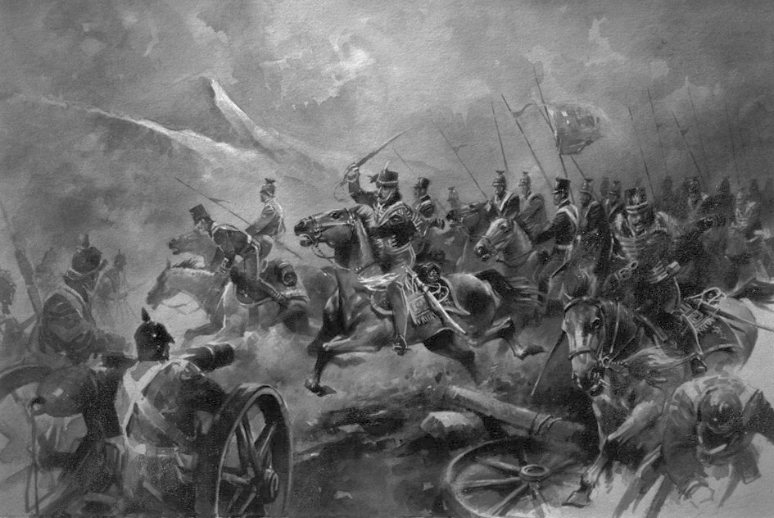
TASK 1: Using the images above, write a description of riding a horse into a battle. Remember to think about your vocabulary, sentence structure, spelling and punctuation.
An interview with a war photographer
The following comes from an interview with Nick Ut. During the Vietnam War he took a photo of a now world-famous photograph. In the interview he explains the events before and after taking the photograph.
5  10  15  20  25  30  35  40  45  50 | Do you remember what was happening leading up to your famous photo?  A friend of mine called saying that there was very heavy fighting in the village. When I got there, I parked my car. There was a lot of smoke and a lot of noise.  When I went back to the highway, David Burnett and a lot of members of the media were there. I already had a lot of pictures, so I didn’t want to take too long. At around noontime, I saw a South Vietnamese soldier with a guide bomb. He threw it, and yellow smoke started rising into the air.  Soon there was the noise of an airplane coming. The first plane dove and dropped two bombs. The second one, an A-1 Skyraider, poured napalm. We thought, “Wow, the bomb was very close,” but we didn’t think there were any people still there. I had a long lens, so I shot pictures of the bombs coming down, and the bomb explosions. I thought to myself, “Good pictures. Maybe no one will get pictures because everyone else left already.”  I looked at the smoke, and then I saw children running. Then a cat. Then another family running. Then I saw Kim Phuc’s grandmother running with a one-year-old baby in her arms. She was an old lady, and was shouting, “Help me, help me, help my grandson.”  When she was about 50 yards away, she stopped, and all the photographers and TV cameras started taking pictures of the baby. The boy, that one-year-old baby, died in her arms right away. I remember looking through my Leica at the boy when he died. As I was shooting, I saw in the corner of the viewfinder a girl running with her arms stretched out to the sides. I thought, “Oh my God,” and began running at her and shot all of my pictures.  After I had taken a picture of Kim, I thought, “Oh my God.” The girl was running all naked, and when she passed me, I saw her left arm burned and her the skin peeling off her back. I immediately thought that she was going to die. She was very hot even after the bomb. She was screaming and screaming, and I thought, “Oh my God.” That’s when I stopped taking pictures of her.  I had water, so I put water on her body. I then put my four cameras down on Highway One, and began helping her. I borrowed a raincoat to cover her, and then started carrying her. Her uncle said, “Please help the kids and take them to the hospital.” I replied, “Yes, my car is right here.” I put all the kids in my car right away.  In the van with my driver, every time I looked at Kim, she was saying, “I’m dying, I’m dying.” She was telling her brother that. “Brother, I think I’m going to die.”  When we finally got to the hospital, it was packed, with bodies, dying people, and the wounded everywhere. I ran inside to ask the nurses and the doctors to please help the kids, telling them about the napalm. After she saw them, she said, “Normal medicine cannot help. We cannot do anything.”  Then I showed her my media pass, and said, “If these kids die, you’ll be in trouble tomorrow.” Once they knew I was media, they carried Kim inside right away.  The picture was immediately on the front page of every newspaper and on TVs. The newspaper called me and said, “Nicky, good job. Congratulations. Good picture.”  The next day, there were anti-war protests all over the world. Japan, London, Paris… Every day after that, people were protesting in Washington DC outside the White House. “Napalm Girl” was everywhere. |  |  |  |  |  |  |  |  |  |  |  |  |  | napalm: (n) a type of bomb used in the Vietnam war  Leica: (n) the type of camera used by Nick Ut
TASK 1: Read the interview on page 13.
Pay attention to what you learn about the soldier’s experience of going over the top.
TASK 2: Using lines 1-10, list four things Ut sees when he arrives at
the scene. Try to give four specific details about his actions, in full clear sentences.
TASK 2: How does Murray use language to describe the events of the
photograph? Read the extract below, annotating valuable quotations.
As I was shooting, I saw in the corner of the viewfinder a girl running with her arms stretched out to the sides. I thought, “Oh my God,” and began running at her and shot all of my pictures.
After I had taken a picture of Kim, I thought, “Oh my God.” The girl was running all naked, and when she passed me, I saw her left arm burned and her the skin peeling off her back. I immediately thought that she was going to die. She was very hot even after the bomb. She was screaming and screaming, and I thought, “Oh my God.”
TASK 3: Finish the following sentence three times:
The events of the photograph are presented as …
TASK 4: Choose one quotation to write a paragraph answering the question.
This is an analysis question – ensure you zoom in on methods and discuss the meanings created.
Creative writing 4 : War photography
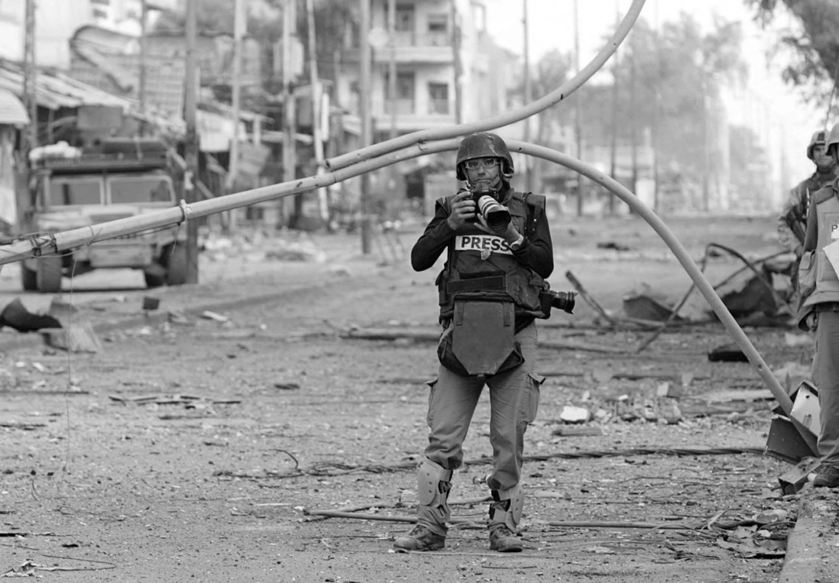 |  |  |  |  |  |  |  |  |  | 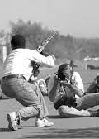
TASK 1: Using the images above, write a first person description of being a war photographer. Remember to think about vocabulary, sentence structure, spelling and punctuation.

Modern war veterans
The following interview took place in 2019. Two American war veterans, Fidel GomezTorres, and Isiah James, explain how the war impacted them one they returned home.
5  10  15  20  25  30  35  40  45  50 | On leaving the military and PTSD symptoms that followed  Isiah James: "I was deployed to Iraq two times and Afghanistan one time. My job in the Army was an 11 Bravo which is an infantryman. My first deployment was 15 months from October ‘06 to January ‘08. My second deployment was December ‘08 to December 2009. And my final deployment was June 2010 to May 2011. I was wounded in service. I loved being in the Army but not for the reasons you would think. I loved the kinship and the camaraderie and the brotherhood that it provided. And once I got hurt, I couldn't do it anymore. The Army medically retired me. So at 27 years old, I was literally a retiree. I didn't really deal with [PTSD] while I was in [the Army] because you're surrounded by ... like everybody is going through the same things. So you don't really want to manifest your problems on anybody else. But it's when you get outside the military, and the civilian world is a lot different, and you're on your own and you don't really have that support network there.”  Fidel GomezTorres: “I joined in 2008. I had one deployment to Afghanistan. I spent 10 months in Kandahar. The deployment included a leg before and after, so total deployment time was 15 months. I was a builder so I was attached to a construction battalion. Much of the work that we were doing in Kandahar was expanding the airfield, building some facilities [and] expanding the facilities there. And I came back in 2011. I absolutely enjoyed my time deployed. I enjoyed my time in the Navy.  "In terms of when my PTSD started manifesting itself, it took me a really long time to give it a name. And I think that for me, I was just having a hard time [adjusting] when I returned. I was living in New York City at the time. New York City can be a very overwhelming city. I felt overly stimulated by everything that was going on and I started to realize that I carried a lot of anger. It would really bother me when people would complain about how hot the subway was because I would always reference it back to where I just came from. So everything was always connected to where I had just came from. And in my head at that time, no one had any reason to complain about anything. But of course that's not the case. You know, sometimes we have bad days and people complain about it. So for me, I started noticing it in terms of my temperament, my anger. I was very quick to get upset and annoyed. It wasn't until last year when I actually started seeking treatment, so almost an eight-year journey to finally figuring out this is what it is. It's OK. This is what I need to do in order to make it better.”  On feeling overwhelmed while readjusting to civilian life and PTSD  IJ: “I do have to remember that I am in the civilian world now because one thing, my wife, my lovely, lovely wife, we'll go outside and she’ll be like, ‘It's hot.’ And I can remember back to the days of my first deployment, literally it was 130 degrees outside and we were going on eight-hour foot patrols. I always call, you know, our problems ‘first world problems.’ But yes, New York City can be a very overstimulating place and I speak to the fact that I do my therapy at the VA near my house and it's helped me get over being in New York City a lot and spending time my wife is probably my main therapeutic thing.”  IJ: “Mine was really severe. Mine was really, really bad. I would snap on anybody for any little thing and I'm a big guy. I'm 6 feet, 8 inches. I'm 300 pounds so I'm a very large individual. I would literally sit at home at night and just sit up all night, staring into the darkness, waiting for somebody to come through a door that wasn't coming through a door. When I knew I needed help was when I was younger and I was sitting in my bathroom on the floor with a giant bottle of scotch and a bottle of sleeping pills and just crying uncontrollably, not wanting to be here anymore, not wanting to live with this anymore because I have seen so much pain and so much death and destruction throughout my deployments." |  |  |  |  | PTSD: Post Traumatic Stress Disorder, a disorder that develops in people who have witnessed traumatic events.  deployed: (v) moved into position, stationed  infantryman: (n) a foot soldier  kinship: (n) family  camaraderie: (n) friendship  manifest: (v) show  civilian: (adj) non-military  battalion: (n) military unit  temperament: (n) personality  therapeutic: (adj) medically helpful
TASK 1: Read the interview on page 16.
Pay attention to what you learn about the soldier’s experience of going over the top.
TASK 2: Using lines 1-9, list four things you learn about Isiah’s time in the military. Try to give four specific details about his actions, in full clear sentences.
TASK 2: How does James use language to describe his feelings?
Read the extract below, annotating valuable quotations.
New York City can be a very overwhelming city. I felt overly stimulated by everything that was going on and I started to realize that I carried a lot of anger. It would really bother me when people would complain about how hot the subway was because I would always reference it back to where I just came from. So everything was always connected to where I had just came from. And in my head at that time, no one had any reason to complain about anything. But of course that's not the case.
TASK 3: Finish the following sentence three times, using the examples
When in New york City, James feels
.
TASK 4: Choose one quotation to write a paragraph answering the question.
This is an analysis question – ensure you zoom in on methods and discuss the meanings created.
Creative writing 5 : Returning Home
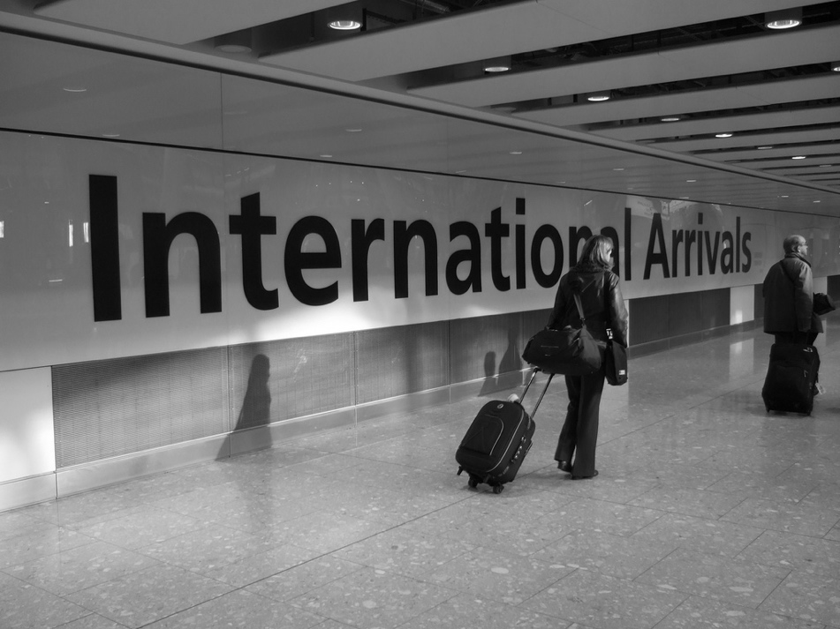 |  |  |  | 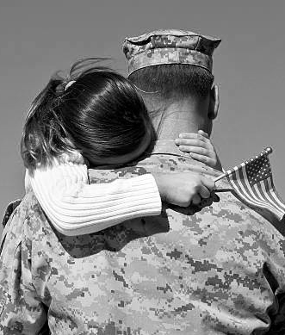
TASK 1: Using the images above, write a description of returning home from a journey or experience of your choice. It can be conflict related, or about another journey. Remember to think about your vocabulary, sentence structure, spelling and punctuation.
Additional creative writing space

SECTION 2: exploring the poems

‘Exposure’ : Introductory Tasks
TASK 1: Use the space below to record everything you know about WWI
WWI
TASK 2: We are going to watch a video animation of the poem. Use the
space below to record your thoughts and feelings about the poem.
You may want to record what the poem is about, your reaction, what the message might be, key images.
TASK 3: Write down 5 facts you learn about Wilfred Owen.
TASK 4: Use the space below to summarise what you found out about
WWI from Wilfred Owen’s letters on pages 4-5

‘Exposure’ by Wilfred Owen



What is happening? 3-4
What is happening? 7-8
What is happening? 5-6
What is happening? 1-2
Our brains ache, in the merciless iced east winds that knife us ...
Wearied we keep awake because the night is silent ...
Low drooping flares confuse our memory of the salient ...
Worried by silence, sentries whisper, curious, nervous,
But nothing happens.
Watching, we hear the mad gusts tugging on the wire.
Like twitching agonies of men among its brambles.
Northward incessantly, the flickering gunnery rumbles,
Far off, like a dull rumour of some other war.
What are we doing here?
The poignant misery of dawn begins to grow ...
We only know war lasts, rain soaks, and clouds sag stormy.
Dawn massing in the east her melancholy army
Attacks once more in ranks on shivering ranks of gray,
But nothing happens.
Sudden successive flights of bullets streak the silence.
Less deadly than the air that shudders black with snow,
With sidelong flowing flakes that flock, pause and renew,
We watch them wandering up and down the wind's nonchalance,
But nothing happens.
Pale flakes with lingering stealth come feeling for our faces--
We cringe in holes, back on forgotten dreams, and stare, snow-dazed,
Deep into grassier ditches. So we drowse, sun-dozed,
Littered with blossoms trickling where the blackbird fusses.
- Is it that we are dying?
Slowly our ghosts drag home: glimpsing the sunk fires glozed
With crusted dark-red jewels; crickets jingle there;
For hours the innocent mice rejoice: the house is theirs;
Shutters and doors all closed: on us the doors are closed--
We turn back to our dying.

Since we believe not otherwise can kind fires burn;
Now ever suns smile true on child, or field, or fruit.
For God's invincible spring our love is made afraid;
Therefore, not loath, we lie out here; therefore were born,
For love of God seems dying.
To-night, His frost will fasten on this mud and us,
Shrivelling many hands and puckering foreheads crisp.
The burying-party, picks and shovels in their shaking grasp,
Pause over half-known faces. All their eyes are ice,
But nothing happens.
- Wilfred Owen, written 1917

1

5

10

15

20

25

30

35

40
SUMMARY |  |  |  |  |   SEMANTIC FIELDS
 |  |  |  |  | Weather |  |  | Suffering
 |  |  |  |  | clouds |  |  | agonies
 |  |  |  |  | winds
 |  |  |  |  | rain
 |  |  |  |  | Death |  |  | Cold
 |  |  |  |  | burying
“merciless iced
east winds that
knive us”
“slowly our
ghosts
drag home”
“But nothing
happens”
‘Exposure’ : Consolidation Tasks
TASK 1: Find a quotation from the poem to describe each of the images
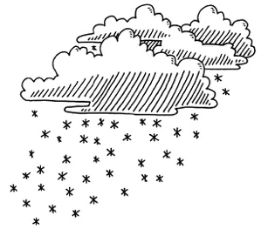 |  | 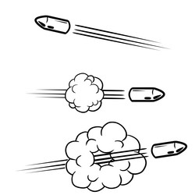 |  | 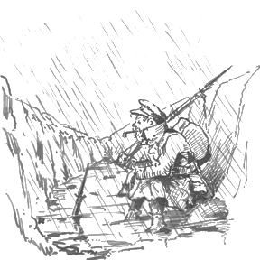 |  |  | 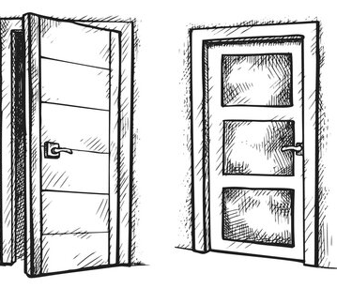 |  | 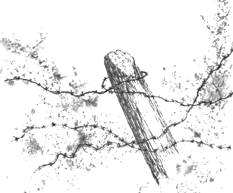
TASK 2: Explain Owen’s message about power and conflict in the
space below. Consider what Owen is saying about how war impacts soldiers physically and mentally.
Conflict:
Power:
TASK 3: Explore how Owen presents the reality of war for soldiers in ‘Exposure’. This requires a What, How, Why paragraph to explain your ideas in detail.
‘Bayonet Charge’ : Introductory Tasks
TASK 1: We are going to watch two videos of a Bayonet Charge. Note down what the soldiers can see, and then what they may be feeling.
 | What the soldiers can see/hear |  |  |  |  | What the soldiers feel/think
My Boy Jack
War Horse
TASK 2: We are going to watch a video animation of the poem. Use the
space below to record your thoughts and feelings about the poem.
You may want to record what the poem is about, your reaction, what the message might be, key images.
TASK 3: Write down 5 facts you learn about bayonets and charges
TASK 4: Use the space below to summarise what you found out about
going over the top from the soldiers’ accounts on pages 7-8
‘Bayonet Charge’ by Ted Hughes



What is happening?
What is happening?
What is happening?
Link one
Poem:
Link two
Poem:
Link three
Poem:
Suddenly he awoke and was running – raw
In raw-seamed hot khaki, his sweat heavy,
Stumbling across a field of clods towards a green hedge
That dazzled with rifle fire, hearing
Bullets smacking the belly out of the air –
He lugged a rifle numb as a smashed arm;
The patriotic tear that had brimmed in his eye
Sweating like molten iron from the centre of his chest, –

In bewilderment then he almost stopped –
In what cold clockwork of the stars and the nations
Was he the hand pointing that second? He was running
Like a man who has jumped up in the dark and runs
Listening between his footfalls for the reason
Of his still running, and his foot hung like
Statuary in mid-stride. Then the shot-slashed furrows

Threw up a yellow hare that rolled like a flame
And crawled in a threshing circle, its mouth wide
Open silent, its eyes standing out.
He plunged past with his bayonet toward the green hedge,
King, honour, human dignity, etcetera
Dropped like luxuries in a yelling alarm
To get out of that blue crackling air
His terror’s touchy dynamite.
- Ted Hughes, published in 1957
1

5

10

15

20
SUMMARY |  |  |  |  | SEMANTIC FIELDS
 |  |  |  |  | Movement |  |  | Nature
 |  |  |  |  | stumbling |  |  | hare
 |  |  |  |  | lugged
 |  |  |  |  | plunged
 |  |  |  |  | Confusion |  |  | Heat
 |  |  |  |  | bewilderment
“sweating like
molten iron”
“King, honour,
human dignity, etcetera
Dropped like luxuries”
“terror’s touchy
dynamite”
‘Exposure’ : Consolidation Tasks
TASK 1: Find a quotation from the poem to describe each of the images
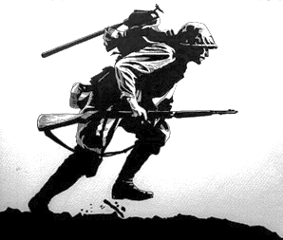 |  | 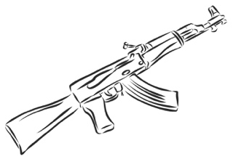 |  | 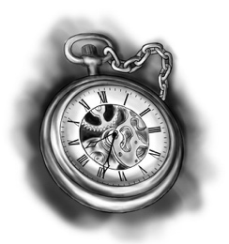 |  |  | 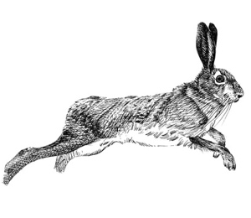 |  | 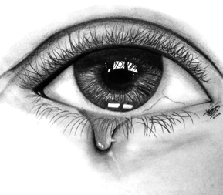
TASK 2: Explain Hughes’ message about power and conflict in the
space below. Consider Hughes is saying about how war impacts soldiers physically and mentally.
Conflict:
Power:
TASK 3: Explore how Hughes presents a soldier’s experience in ‘Bayonet Charge’. This requires a What, How, Why paragraph to explain your ideas in detail.
‘The Charge of the Light Brigade’ : Introductory Tasks
TASK 1: Use the space below to note down how war has changed.
Changes to
warfare
TASK 2: We are going to watch a video animation of the poem. Use the
space below to record your thoughts and feelings about the poem.
You may want to record what the poem is about, your reaction, what the message might be, key images.
TASK 3: Write down 5 facts you learn about the battle of Balaklava
TASK 4: Use the space below to summarise what you found out about
the charge from the newspaper report on pages 10-11
‘The Charge of the Light Brigade’ by Alfred Lord Tennyson
1.
HALF a league, half a league,
Half a league onward,
All in the valley of Death
Rode the six hundred.
'Forward, the Light Brigade!
Charge for the guns! ' he said:
Into the valley of Death
Rode the six hundred.
2.
'Forward, the Light Brigade! '
Was there a man dismay'd?
Not tho' the soldier knew
Some one had blunder'd:
Their's not to make reply,
Their's not to reason why,
Their's but to do and die:
Into the valley of Death
Rode the six hundred.
3.
Cannon to right of them,
Cannon to left of them,
Cannon in front of them
Volley'd and thunder'd;
Storm'd at with shot and shell,
Boldly they rode and well,
Into the jaws of Death,
Into the mouth of Hell
Rode the six hundred.
4.
Flash'd all their sabres bare,
Flash'd as they turn'd in air
Sabring the gunners there,
Charging an army, while
All the world wonder'd:
Plunged in the battery-smoke
Right thro' the line they broke;
Cossack and Russian
Reel'd from the sabre-stroke
Shatter'd and sunder'd.
Then they rode back, but not
Not the six hundred.

1

5

10

15

20

25

30

35

Link one
Poem:



-Alfred Lord Tennyson, written 1854
What is happening? 5-6

40

45

50

5.
Cannon to right of them,
Cannon to left of them,
Cannon behind them
Volley'd and thunder'd;
Storm'd at with shot and shell,
While horse and hero fell,
They that had fought so well
Came thro' the jaws of Death,
Back from the mouth of Hell,
All that was left of them,
Left of six hundred.
6.
When can their glory fade?
O the wild charge they made!
All the world wonder'd.
Honour the charge they made!
Honour the Light Brigade,
Noble six hundred!
What is happening? 3-4
What is happening? 1-2
Link three
Poem:
Link two
Poem:
SUMMARY |  |  |  |  | SEMANTIC FIELDS
 |  |  |  |  | Momentum |  |  | Attack
 |  |  |  |  | forward |  |  | storm’d
 |  |  |  |  | charge
 |  |  |  |  | onwards
 |  |  |  |  | Respect |  |  | Weapons
 |  |  |  |  | hero
“Into the jaws
of Death/Into
the mouth of Hell”
“Theirs not to
reason why/
Theirs but to
do or die”
“hero”
“glory”
“noble”
‘The Charge of the Light Brigade’ : Consolidation Tasks
TASK 1: Find a quotation from the poem to describe each of the images
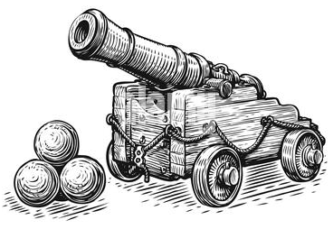 |  | 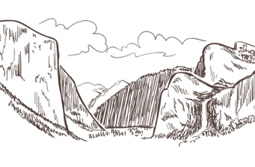 |  | 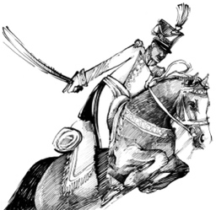 |  |  | 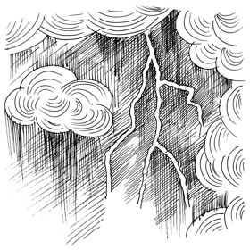 |  | 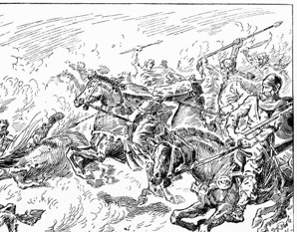
TASK 2: Explain Tennyson’s message about power and conflict in the
space below. Consider what Tennyson is saying about how soldiers behave during war.
Conflict:
Power:
TASK 3: Explore how Tennyson presents the bravery of soldiers in ‘Charge of the Light Brigade’ . This requires a What, How, Why paragraph.
‘War Photographer’ : Introductory Tasks
TASK 1: We are going to watch two videos of war photographers talking about their jobs and their purpose. Note down what the soldiers has to go through and experience, and their various feelings and emotions.
 | What the photographers experience |  |  |  |  | What the photographers feel/think
Video One
Video Two
TASK 2: We are going to watch a video animation of the poem. Use the
space below to record your thoughts and feelings about the poem.
You may want to record what the poem is about, your reaction, what the message might be, key images.
TASK 3: Use the space below to summarise what you found out about
the charge from the interview with Nick Ut on pages 13-14.
‘War Photographer’ by Carol Ann Duffy



Link three
Poem:
Link two
Poem:
Link one
Poem:
What is happening?
What is happening?
What is happening?
What is happening?
1

5

10

15

20

In his dark room he is finally alone
with spools of suffering set out in ordered rows. The only light is red and softly glows,
as though this were a church and he
a priest preparing to intone a Mass.
Belfast. Beirut. Phnom Penh. All flesh is grass.

He has a job to do. Solutions slop in trays
beneath his hands, which did not tremble then
though seem to now. Rural England. Home again to ordinary pain which simple weather can dispel, to fields which don’t explode beneath the feet
of running children in a nightmare heat.

Something is happening. A stranger’s features faintly start to twist before his eyes,
a half-formed ghost. He remembers the cries
of this man’s wife, how he sought approval without words to do what someone must
and how the blood stained into foreign dust.

A hundred agonies in black and white
from which his editor will pick out five or six
for Sunday’s supplement. The reader’s eyeballs prick with tears between the bath and pre-lunch beers. From the aeroplane he stares impassively at where he earns his living and they do not care.
- Carol Ann Duffy, published in 1985
SUMMARY |  |  |  |  | SEMANTIC FIELDS
 |  |  |  |  | Hurt |  |  | Memory
 |  |  |  |  | agonies |  |  | nightmare
 |  |  |  |  | suffering
 |  |  |  |  | pain
 |  |  |  |  | Place |  |  | Photography
 |  |  |  |  | home
“spools of suffering
set out in
ordered rows”
“Home again/
to ordinary pain”
“blood stained
into foreign
dust”
‘War Photographer’: Consolidation Tasks
TASK 1: Find a quotation from the poem to describe each of the images
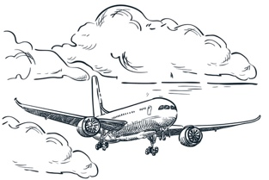 |  |  |  | 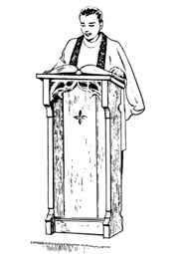 |  |  | 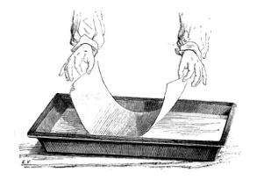 |  | 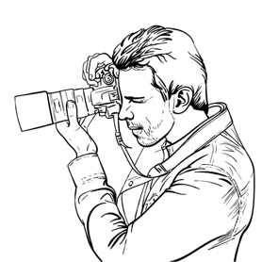
TASK 2: Explain Duffy’s message about power and conflict in the
space below. Consider what Duffy is saying about who can be affected by war.
Conflict:
Power:
TASK 3: Explore how Duffy presents the mental impact of war in ‘War Photographer’. This requires a What, How, Why paragraph.
‘Remains’: Introductory Tasks
TASK 1: We are going to watch some clips from ‘The Not Dead’, a documentary about soldiers returning from war. Guardsman Tromans inspired Armitage to write the poem ‘Remains’
Use the prompts/questions below to make notes as you watch the video.
How did Tromans act on the outside and how did he feel on the inside? |  |  | Outside:  Inside:
What did Tromans think about war before he became a soldier? Why?
How did the soldiers feel when the mortars were raining down on them?
Explain the events of the looter in the bank from Tromans’ perspective. What happened before, during and after this event?
How does Tromans feel about killing the looter? How does he reflect on the event, and what bothers him?
How do people in the army react when Tromans shares his feelings?
TASK 2: We are going to watch a video animation of the poem. Use the
space below to record your thoughts and feelings about the poem.
You may want to record what the poem is about, your reaction, what the message might be, key images.
TASK 3: Use the space below to summarise what you found out about the impact of war from the interview on pages 16-17
‘Remains’ by Simon Armitage
1

5

10

15

20

25

30

On another occasion, we got sent out
to tackle looters raiding a bank.
And one of them legs it up the road,
probably armed, possibly not.

Well myself and somebody else and somebody else
are all of the same mind,
so all three of us open fire.
Three of a kind all letting fly, and I swear

I see every round as it rips through his life –
I see broad daylight on the other side.
So we’ve hit this looter a dozen times
and he’s there on the ground, sort of inside out,

pain itself, the image of agony.
One of my mates goes by
and tosses his guts back into his body.
Then he’s carted off in the back of a lorry.

End of story, except not really.
His blood-shadow stays on the street, and out on patrol
I walk right over it week after week.
Then I’m home on leave. But I blink

and he bursts again through the doors of the bank.
Sleep, and he’s probably armed, and possibly not.
Dream, and he’s torn apart by a dozen rounds.
And the drink and the drugs won’t flush him out –

he’s here in my head when I close my eyes,
dug in behind enemy lines,
not left for dead in some distant, sun-stunned, sand-smothered land
or six-feet-under in desert sand,

but near to the knuckle, here and now,
his bloody life in my bloody hands.
- Simon Armitage, published in 2008
What is happening? 1-2




What is happening? 7-8
What is happening? 3-4
What is happening? 5-6
Link three
Poem:
Link two
Poem:
Link one
Poem:
SUMMARY |  |  |  |  | SEMANTIC FIELDS
 |  |  |  |  | Casual actions |  |  | Uncertainty
 |  |  |  |  | letting fly |  |  | probably
 |  |  |  |  | inside out
 |  |  |  |  | tosses
 |  |  |  |  | Violence |  |  | Suffering
 |  |  |  |  | torn

“Sleep, and he’s probably
armed, possibly not”

“dug in behind
enemy lines”

“his bloody
life in my
bloody hands”
‘Remains’ : Consolidation Tasks
TASK 1: Find a quotation from the poem to describe each of the images
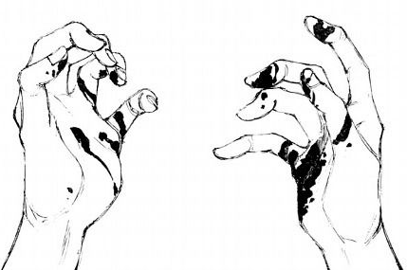 |  | 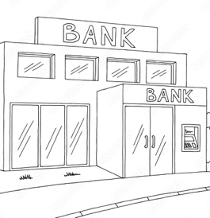 |  | 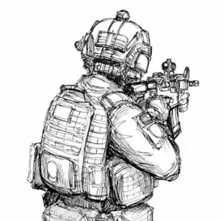 |  |  | 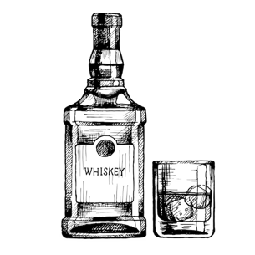 |  | 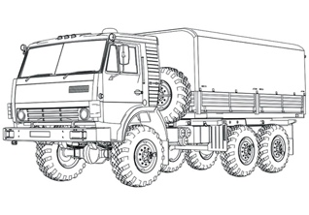
TASK 2: Explain Armitage’s message about power and conflict in the
space below. Consider what Armitage is saying about the impact on soldiers once they are home.
Conflict:
Power:
TASK 3: Explore how Armitage presents the mental impact of war in ‘Remains’ . This requires a What, How, Why paragraph.

SECTION 3: connecting
the poems

COMPARISON
 | EX |  |  |  |  | BC
‘Exposure’  EX | SUMMARY OF EX: |  |  |  |  | SIMILARITY BC + EX:
‘Bayonet Charge’  BC | DIFFERENCE BC + EX: |  |  |  |  | SUMMARY OF BC:
‘The Charge  of the Light Brigade’  COTLB | DIFFERENCE EX + COTLB: |  |  |  |  | DIFFERENCE BC + COTLB:
‘War Photographer’  WP | DIFFERENCE EX + WP: |  |  |  |  | DIFFERENCE BC + WP:
‘Remains’  RE | DIFFERENCE EX + RE: |  |  |  |  | DIFFERENCE BC + RE:
GRID
COTLB |  | WP |  |  |  |  | RE
SIMILARITY COTLB + EX: |  | SIMILARITY WP + EX: |  |  |  |  | SIMILARITY RE + EX:
SIMILARITY COTLB + BC: |  | SIMILARITY WP + BC: |  |  |  |  | SIMILARITY RE + BC:
SUMMARY OF COTLB: |  | SIMILARITY WP + COTLB: |  |  |  |  | SIMILARITY RE + COTLB:
DIFFERENCE COTLB +WP: |  | SUMMARY OF WP: |  |  |  |  | SIMILARITY WP + RE:
DIFFERENCE COTLB + RE: |  | DIFFERENCE WP + RE: |  |  |  |  | SUMMARY OF RE:
MATCHING POEMS
You have been given five images and simple summaries of each poem.  Use the codes below to name the poem for each image and each summary. |  |  |  |  | 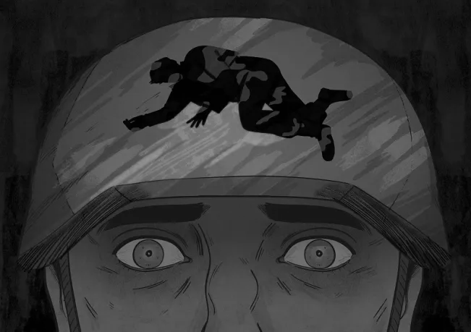
‘Exposure’ |  |  | EX
‘Bayonet Charge’ |  |  | BC
‘The Charge of the Light Brigade’ |  |  | COTLB
‘War Photographer’ |  |  | WP
‘Remains’ |  |  | RE
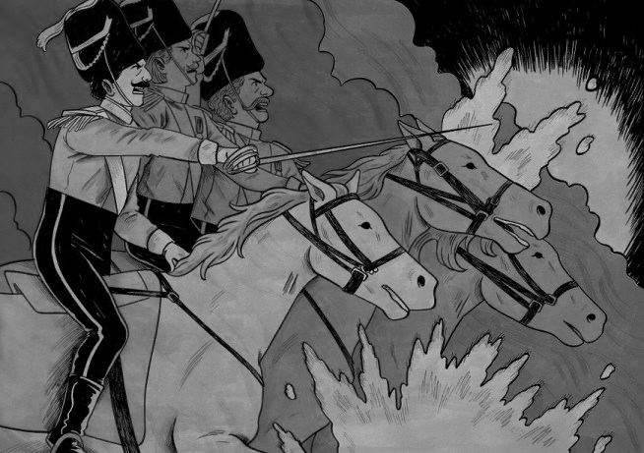 |  |  |  |  | 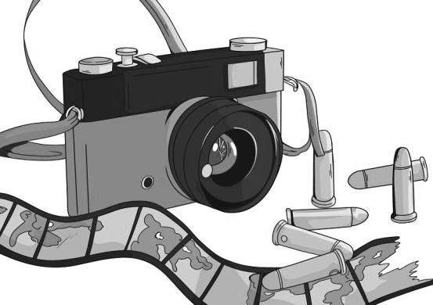
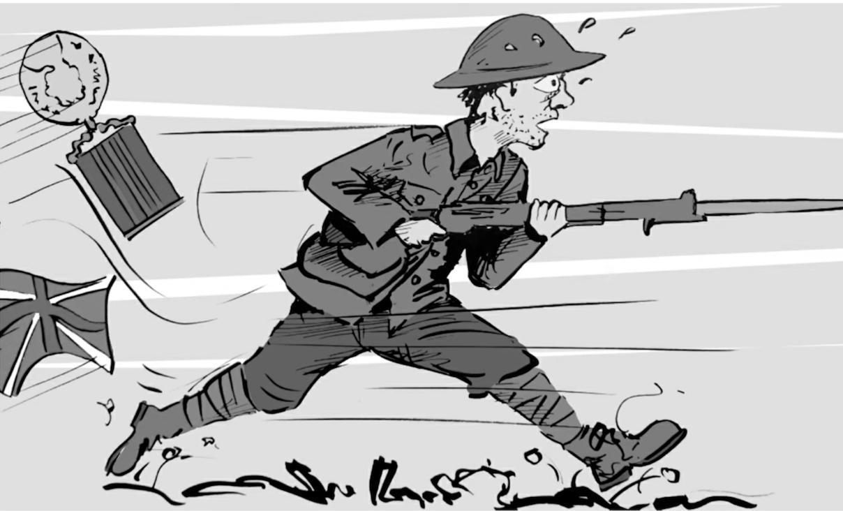 |  |  |  |  | 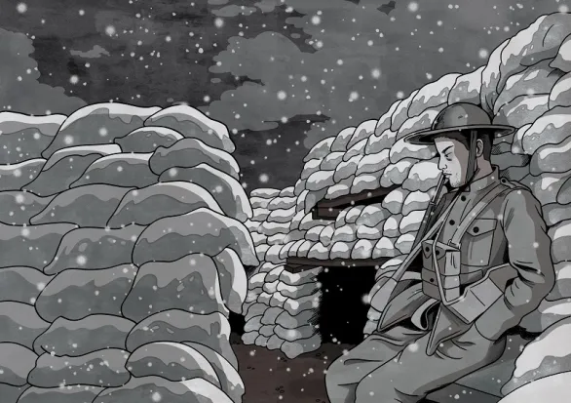
A group of soldiers suffer through the cold weather conditions
A single soldier goes over the top and questions his purpose
A group of soldiers ride into a valley of inevitable death
A photographer returns home and struggles to process his memories
A soldier returns home and is haunted by the memory of killing a looter

The poems you have studied are:

Alfred Lord Tennyson | The Charge of the Light Brigade
Wilfred Owen | Exposure
Ted Hughes | Bayonet Charge
Simon Armitage | Remains
Carol Ann Duffy | War Photographer

Compare how poets present the effects of war in ‘Bayonet Charge’ and one
other poem from the ‘Power and Conflict’ cluster.

Suddenly he awoke and was running – raw
In raw-seamed hot khaki, his sweat heavy,
Stumbling across a field of clods towards a green hedge
That dazzled with rifle fire, hearing
Bullets smacking the belly out of the air –
He lugged a rifle numb as a smashed arm;
The patriotic tear that had brimmed in his eye
Sweating like molten iron from the centre of his chest, –

In bewilderment then he almost stopped –
In what cold clockwork of the stars and the nations
Was he the hand pointing that second? He was running
Like a man who has jumped up in the dark and runs
Listening between his footfalls for the reason
Of his still running, and his foot hung like
Statuary in mid-stride. Then the shot-slashed furrows

Threw up a yellow hare that rolled like a flame
And crawled in a threshing circle, its mouth wide
Open silent, its eyes standing out.
He plunged past with his bayonet toward the green hedge,
King, honour, human dignity, etcetera
Dropped like luxuries in a yelling alarm
To get out of that blue crackling air
His terror’s touchy dynamite.
-Ted Hughes

PLAN:

Bayonet Charge+Exposure
individual vs group
EX: “our brains ache”
BC: “he awoke”
effects
of war
both lose their patriotism/ purpose
EX: “nothing happens”
BC: “patriotic tear that had brimmed"
Bayonet Charge
loss of emotion
“terror’s touchy
dynamite”
intense heat and pressure of war “raw in raw-seamed”
In this paragraph the essay tackles the first idea in the plan, about ‘Bayonet Charge’ only.  Using highlighters, find the WHW sections of the paragraph, and tick them off on the checklist. |  |  | One of the main effects of war is having to deal with the intense heat and pressure that it creates. For the speaker in ‘Bayonet Charge’, he is “running/ raw in raw-seamed hot khaki”. The repetition of raw tells us the way the soldier feels, as the adjective “raw” can suggest someone is in pain. Furthermore, this adds to a semantic field of heat in the first stanza with “hot” “sweating” and “molten” all highlighting the intense pressure the soldier is under. He might be hot because of running, the explosions around him, or perhaps the feeling of nervousness from having to run into inevitable death. Hughes might want to show his readers the reality of war: it is a high-pressured environment, and this affects soldiers mentally and physically.
WHAT |  | Clear point made about the poem in response to the focus of the question
WHAT |  | Evidence from the poem given, such as a quotation, used to support the ideas.
HOW |  | A method used by the poet is examined, with meanings explored
HOW |  | A second method used by the poet is examined, with meanings explored
WHY |  | The poet’s purpose or message is considered in relation to the theme given in the question.
In this paragraph the essay tackles the second idea, again focusing only on ‘Bayonet Charge’ in response to the theme in the question.  Using highlighters, find the WHW sections of the paragraph, and tick them off on the checklist. |  |  | Also, we find out that one effect of war is a loss of emotion, or humanity. By the end of the poem he has become “touchy dynamite”. This metaphor hints to us that the soldier is losing what makes him human, like his emotions, his purpose to fight, and his reasons to be there. The war is obviously so difficult that he has become like a human explosive or weapon, and the adjective “touchy” suggests he might go off at any minute. Hughes is encouraging the reader to feel sympathy for soldiers who begin to feel that there is no point feeling emotion when at war. Hughes might be telling the reader that war causes soldiers to become objects, or weapons, without humanity, as they have no choice but to fight and die for their country.
WHAT |  | Clear point made about the poem in response to the focus of the question
WHAT |  | Evidence from the poem given, such as a quotation, used to support the ideas.
HOW |  | A method used by the poet is examined, with meanings explored
HOW |  | A second method used by the poet is examined, with meanings explored
WHY |  | The poet’s purpose or message is considered in relation to the theme given in the question.
In this third paragraph, the student begins to compare the named poem in the question with the poem they have picked (in this case, ‘Exposure’).  You are now exploring how the poems offer different or similar ideas about the theme in the question, and also the methods they use, and the messages they offer to the reader.  Using highlighters, find the WHW sections of the paragraph, and tick them off on the checklist. |  |  | Whilst Hughes presents an individual’s experience of war and how it affects him, Owen seems to be sharing the voice of all soldiers and the effects on them. Hughes opens the poem with “Suddenly he awoke and was running” whereas Owen begins with “Our brains ache in the merciless iced east winds”. Both poems tell us immediately who is involved in the war, and begin to tell us how they are affected by it. The adverb “suddenly” suggests to us that events in war can happen without any notice, and the soldier must be prepared. It is clear he is alone with the pronoun “he” so Hughes is telling us the experience of one individual. However, for Owen, the effect he focuses on is not the suddenness of war but the sense of mental pain, with the verb “ache”. The use of first personal plural immediately tells the reader that Owen is commenting on all soldiers’ experience, and sharing how they are all impacted as a group. Therefore, Owen wants to tell the WWI readers that the soldiers had to rely on each other to deal with the impact of war, whereas Hughes decides to share how one individual mind can be affects – either way they tell the reader about how war is far more sudden and mentally painful than the reader might realise.
WHAT |  | Clear comparison (similarity or difference) point made about the two poems in response to the focus of the question
WHAT |  | Evidence from both poems given, for example a quotation from each poem.
HOW |  | A method used by the first poet is examined, with meanings explored
HOW |  | A second method used by the second poet is examined, with meanings and effects explored
WHY |  | A comparison of why each poet has offered their ideas about the focus theme will be given. This may be explored as similarity or difference, but will focus on the intended impact on the reader of the whole poem.
In the final paragraph the student continues to draw comparisons between the two poems, following the WHW structure but for both poems. |  |  | In both ‘Bayonet Charge’ and ‘Exposure’ the soldiers are affected by war because they lose their patriotism or reason to fight. In ‘Bayonet Charge’ he loses “the patriotic tear that had brimmed in his eye” and in ‘Exposure’ they start to realise that even though people are dying “nothing happens”. In ‘Bayonet Charge’ the use of personification reveals that he is losing his purpose, because the patriotism is leaving his body in the tears. On the other hand, Owen uses repetition constantly remind the reader that nothing happens, or nothing changes in war. This affects the soldiers as they lose all hope of being helped and protected from the harsh weather conditions. Perhaps both poets offer a similar, negative message on war. They want to educate the reader and help them understand that a soldier may enter war for the right reasons, but it does not take long for war to affect them mentally and take that away.
WHAT |  | Clear comparison (similarity or difference) point made about the two poems in response to the focus of the question
WHAT |  | Evidence from both poems given, for example a quotation from each poem.
HOW |  | A method used by the first poet is examined, with meanings explored
HOW |  | A second method used by the second poet is examined, with meanings and effects explored
WHY |  | A comparison of why each poet has offered their ideas about the focus theme will be given. This may be explored as similarity or difference, but will focus on the intended impact on the reader of the whole poem.

