GCSE English Literature:
Power Poetry Cluster

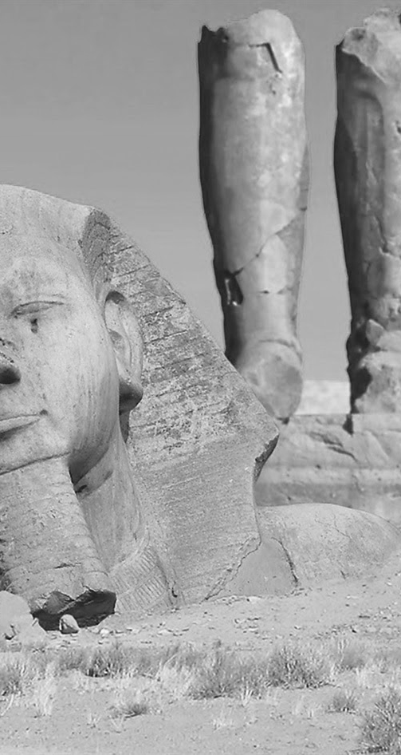
TEACHER GUIDE

Teacher:

UNIT OVERVIEW: Power cluster key learning episodes
BACKGROUND WORK | THE PRELUDE | STORM ON THE ISLAND | OZYMANDIAS | MY LAST DUCHESS | LONDON
BACKGROUND WORK | Reading  The Silent Land – building P1Q3 and P1Q4 skills | Reading  Jamaica Inn – building P1Q3 and P1Q4 skills | Reading  Animal Farm – building P1Q3 and P1Q4 skills | Reading  The Marriage Portrait –P1Q3 and P1Q4 skills | Reading  Oliver Twist – building P1Q3 and P1Q4 skills
BACKGROUND WORK | Writing  Images with a prompt about boating on a lake | Writing  Images with a prompt about a storm by the sea | Writing  Images with a prompt about statues in the desert | Writing  Images with a prompt about an isolated cabin | Writing  Images with a prompt about London in the past
PRE STUDY | - Linking to background task  - Watch animation here  - Watching Akala video here | - Arran island landscape mind-map video here  - Linking to background task  - Watch animation here | - Linking to background task  - Watch animation here  - Watching Akala video here | - Linking to background task  - Watch animation here  - Watching context video here | - Linking to background task  - Watch animation here  - Watching Akala video here
STUDYING | - Read poem again.  - Short summary in box  - Note down narrative in narrative boxes  - Identify language patterns in semantic fields boxes  - Match quotations to images | - Read poem again.  - Short summary in box  - Note down narrative in narrative boxes  - Identify language patterns in semantic fields boxes  - Match quotations to images | - Read poem again.  - Short summary in box  - Note down narrative in narrative boxes  - Identify language patterns in semantic fields boxes  - Match quotations to images | - Read poem again.  - Short summary in box  - Note down narrative in narrative boxes  - Identify language patterns in semantic fields boxes  - Match quotations to images | - Read poem again.  - Short summary in box  - Note down narrative in narrative boxes  - Identify language patterns in semantic fields boxes  - Match quotations to images
POST STUDY | - Summarise Wordsworth’s message about power and conflict (discuss first)  - Paragraph response designed to offer either analysis of the given poem or comparison with another (focus: power of nature) | - Summarise Heaney’s message about power and conflict (discuss first)  - Paragraph response designed to offer either analysis of the given poem or comparison with another (focus: conflict between nature and humanity)  - Links to three other poems | - Summarise Shelley’s message about power and conflict (discuss first)  - Paragraph response designed to offer either analysis of the given poem or comparison with another (focus: human power)  - Links to three other poems | - Summarise Browning’s message about power and conflict (discuss first)  - Paragraph response designed to offer either analysis of the given poem or comparison with another (focus: power) | - Summarise Blake’s message about power and conflict (discuss first)  - Paragraph response designed to offer either analysis of the given poem or comparison with another (focus: ideas about a place)  - Links to three other poems
Suggested approach 1: complete background work for all five poems, then work through the analysis stages. Then complete consolidating tasks.
Suggested approach 2: work through background, analysis, post study for each poem one by one. Then complete consolidating tasks.

