GCSE English Literature:
Power Poetry Cluster
TEACHER GUIDE
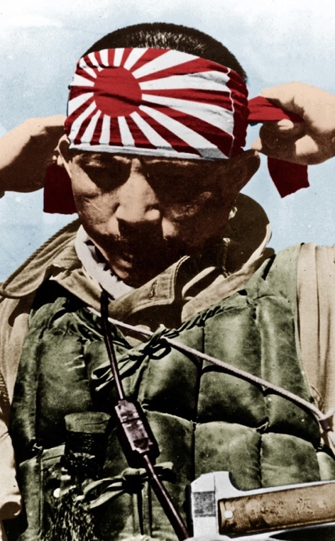


Teacher:

UNIT OVERVIEW: Identity cluster key learning episodes
BACKGROUND WORK | CHECKING OUT ME H | THE EMIGREE | KAMIKAZE | POPPIES | TISSUE
BACKGROUND WORK | Reading  Adventures of Mrs Seacole– building P1 skills | Reading  Refugee – building P1 skills | Reading  A Matter of Honour – building P1 skills | Reading  The Vendetta – building building P1 skills | Reading  The Treasure in the Forest – building P1 skills
BACKGROUND WORK | Writing  Images with a prompt about a conflict hospital | Writing  Images with a prompt for an unwanted journey | Writing  Images with a prompt about a jungle setting | Writing  Images with a prompt about living on a cliff | Writing  Images with a prompt about a canoe journey
PRE STUDY | - Linking to background task  - Agard reading poem  - Background video here | - Linking to background task  - Watch poem animation  - Background video here | - Linking to reading task  - Watch poem reading  - Background video here (skip middle section on Hiroshima) | - Background task 1  - Watch poem animation  - Background video here | - Linking to background task  - Watch poem animation  - Background video here 28:34
STUDYING | - Read poem again.  - Short summary in box  - Note down narrative in narrative boxes  - Identify language patterns in semantic fields boxes  - Match quotations to images | - Read poem again.  - Short summary in box  - Note down narrative in narrative boxes  - Identify language patterns in semantic fields boxes  - Match quotations to images | - Read poem again.  - Short summary in box  - Note down narrative in narrative boxes  - Identify language patterns in semantic fields boxes  - Match quotations to images | - Read poem again.  - Short summary in box  - Note down narrative in narrative boxes  - Identify language patterns in semantic fields boxes  - Match quotations to images | - Read poem again.  - Short summary in box  - Note down narrative in narrative boxes  - Identify language patterns in semantic fields boxes  - Match quotations to images
POST STUDY | - Summarise Agard’s message about power and conflict (discuss first)  - Paragraph response designed to offer either analysis of the given poem or comparison with another (focus: power of nature) | - Summarise Rumens’ message about power and conflict (discuss first)  - Paragraph response designed to offer either analysis of the given poem or comparison with another (focus: memory)  - Links to three other poems | - Summarise Garland’s message about power and conflict (discuss first)  - Paragraph response designed to offer either analysis of the given poem or comparison with another (focus: impact of war) | - Summarise Weir’s message about power and conflict (discuss first)  - Paragraph response designed to offer either analysis of the given poem or comparison with another (focus: impact of death)  - Links to three poems | - Summarise Dharker’s message about power and conflict (discuss first)  - Paragraph response designed to offer either analysis of the given poem or comparison with another (focus: power of humans)  - Links to three other poems
Suggested approach 1: complete background work for all five poems, then work through the analysis stages. Then complete consolidating tasks.
Suggested approach 2: work through background, analysis, post study for each poem one by one. Then complete consolidating tasks.

