Key Stage Four
GCSE English Language
Question 5 Booklet

Name:
Class:
Teacher:

Paper 1, Question 5: Example 1
You are advised to spend about 45 minutes on this section.
Write in full sentences.
You are reminded of the need to plan your answer
05 Either

Write a description of a motorbike journey, based on this picture:
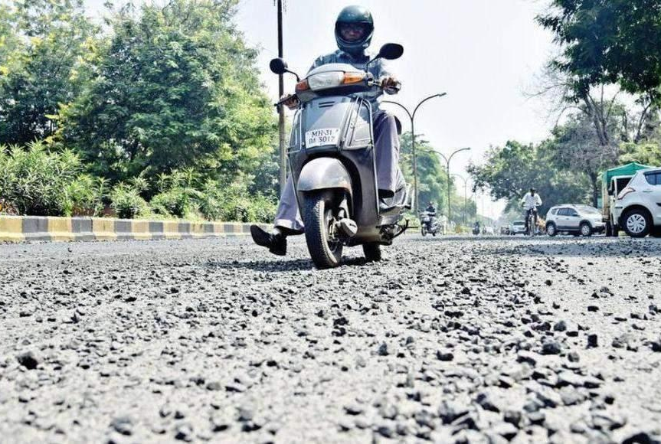

Or
Write a story about an event that happens at night time
Planning space

Space for your writing (with a quick mark scheme reminder)

CONTENT AND ORGANISATION: MARK OUT OF 24
Matched to audience (tone) | Ambitious vocabulary | Use of paragraphs
Matched to purpose (form) | Range of successful devices | Connected ideas

TECHNICAL ACCURACY: MARK OUT OF 16
Sentences: capital letters etc | Sentences: range of length | Sentences: range of structures
Ambitious vocabulary | Accurate spelling | Range of accurate punctuation

Paper 1, Question 5: Example 2
You are advised to spend about 45 minutes on this section.
Write in full sentences.
You are reminded of the need to plan your answer
05 Either
Write a description of a beach as suggested by this picture:
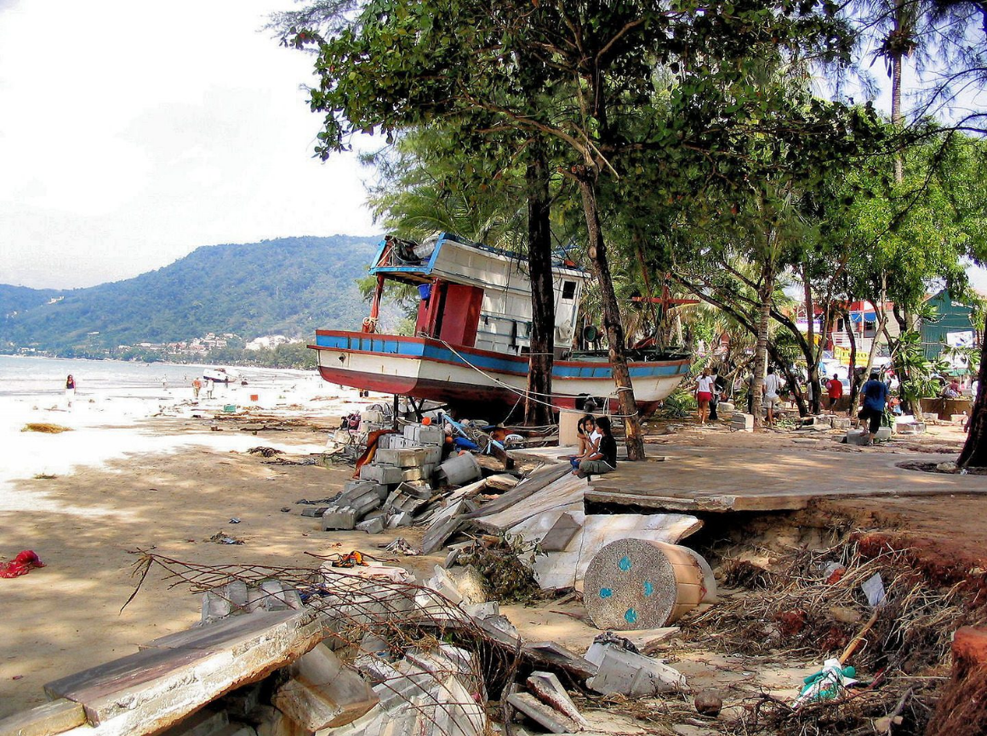
Or
Write a story about a time you faced something unexpected
Planning space
Space for your writing (with a quick mark scheme reminder)

CONTENT AND ORGANISATION: MARK OUT OF 24
Matched to audience (tone) | Ambitious vocabulary | Use of paragraphs
Matched to purpose (form) | Range of successful devices | Connected ideas

TECHNICAL ACCURACY: MARK OUT OF 16
Sentences: capital letters etc | Sentences: range of length | Sentences: range of structures
Ambitious vocabulary | Accurate spelling | Range of accurate punctuation

Paper 1, Question 5: Example 3
You are advised to spend about 45 minutes on this section.
Write in full sentences.
You are reminded of the need to plan your answer
05 Either

Write a description of a jungle as suggested by this picture:
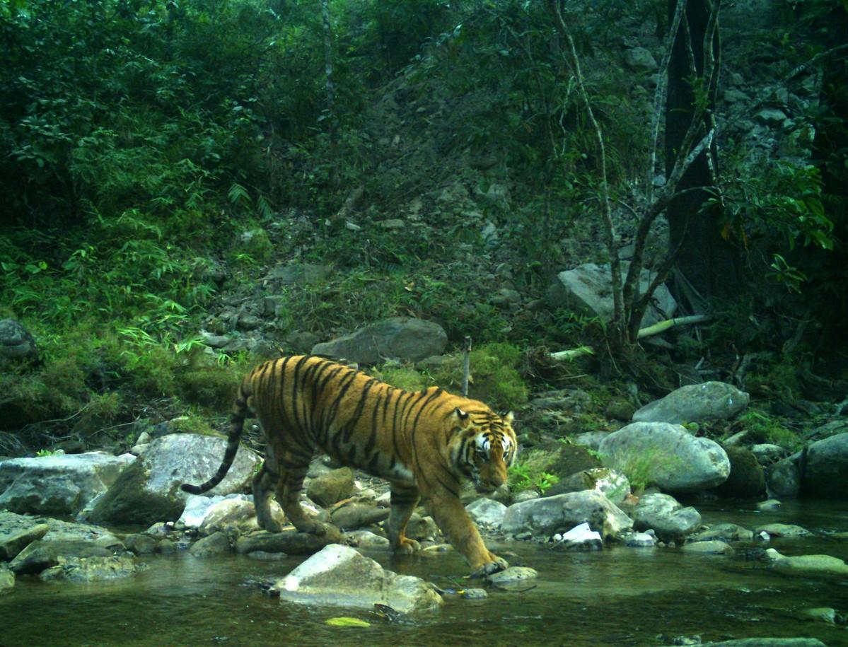
Or
Write a story involving something or somone being hunted
Planning space
Space for your writing (with a quick mark scheme reminder)

CONTENT AND ORGANISATION: MARK OUT OF 24
Matched to audience (tone) | Ambitious vocabulary | Use of paragraphs
Matched to purpose (form) | Range of successful devices | Connected ideas

TECHNICAL ACCURACY: MARK OUT OF 16
Sentences: capital letters etc | Sentences: range of length | Sentences: range of structures
Ambitious vocabulary | Accurate spelling | Range of accurate punctuation

Paper 1, Question 5: Example 4
You are advised to spend about 45 minutes on this section.
Write in full sentences.
You are reminded of the need to plan your answer
05 Either

Write a description of a train station as suggested by this picture:
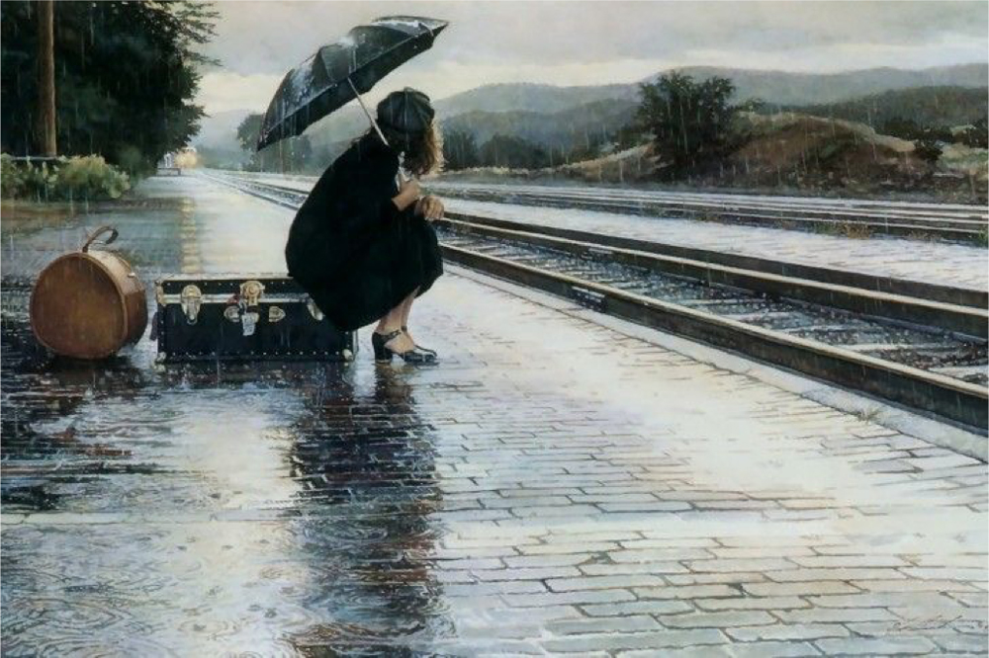

Or
Write a story about a time you felt alone
Planning space
Space for your writing (with a quick mark scheme reminder)

CONTENT AND ORGANISATION: MARK OUT OF 24
Matched to audience (tone) | Ambitious vocabulary | Use of paragraphs
Matched to purpose (form) | Range of successful devices | Connected ideas

TECHNICAL ACCURACY: MARK OUT OF 16
Sentences: capital letters etc | Sentences: range of length | Sentences: range of structures
Ambitious vocabulary | Accurate spelling | Range of accurate punctuation

Paper 1, Question 5: Example 5
You are advised to spend about 45 minutes on this section.
Write in full sentences.
You are reminded of the need to plan your answer
05 Either

Write a description of a snow scene as suggested by this picture:
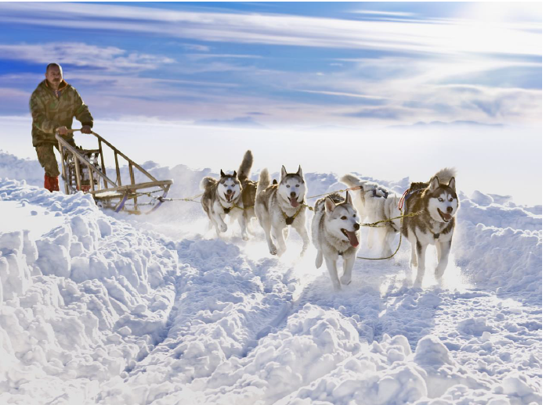

Or
Write a story about an animal that saves a life
Planning space
Space for your writing (with a quick mark scheme reminder)

CONTENT AND ORGANISATION: MARK OUT OF 24
Matched to audience (tone) | Ambitious vocabulary | Use of paragraphs
Matched to purpose (form) | Range of successful devices | Connected ideas

TECHNICAL ACCURACY: MARK OUT OF 16
Sentences: capital letters etc | Sentences: range of length | Sentences: range of structures
Ambitious vocabulary | Accurate spelling | Range of accurate punctuation

Paper 1, Question 5: Example 6
You are advised to spend about 45 minutes on this section.
Write in full sentences.
You are reminded of the need to plan your answer
05 Either

Write a description of a dark street as suggested by this picture:
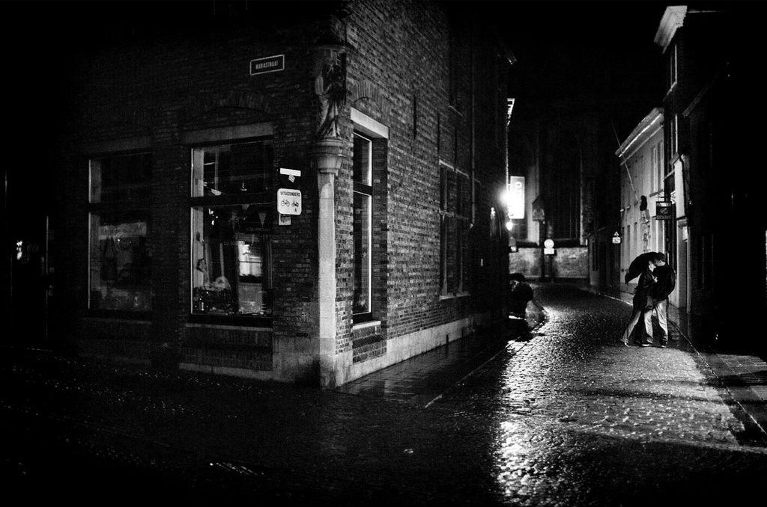

Or
Write a story about an event that happens at night time
Planning space
Space for your writing (with a quick mark scheme reminder)

CONTENT AND ORGANISATION: MARK OUT OF 24
Matched to audience (tone) | Ambitious vocabulary | Use of paragraphs
Matched to purpose (form) | Range of successful devices | Connected ideas

TECHNICAL ACCURACY: MARK OUT OF 16
Sentences: capital letters etc | Sentences: range of length | Sentences: range of structures
Ambitious vocabulary | Accurate spelling | Range of accurate punctuation

Paper 2, Question 5: Example 1
You are advised to spend about 45 minutes on this section.
Write in full sentences.
You are reminded of the need to plan your answer
05
‘Mobile phones are a danger to everyone, particularly teenagers, who are unable to limit their use of technology’

Write a speech to be given to the teachers in your school offering your view on this statement.

You are advised to plan your answer to Question 5 before you start to write

Initial ideas about this topic
Planning space

Space for your writing (with a quick mark scheme reminder)

CONTENT AND ORGANISATION: MARK OUT OF 24
Matched to audience (tone) | Ambitious vocabulary | Use of paragraphs
Matched to purpose (form) | Range of successful devices | Connected ideas

TECHNICAL ACCURACY: MARK OUT OF 16
Sentences: capital letters etc | Sentences: range of length | Sentences: range of structures
Ambitious vocabulary | Accurate spelling | Range of accurate punctuation

Paper 2, Question 5: Example 2
You are advised to spend about 45 minutes on this section.
Write in full sentences.
You are reminded of the need to plan your answer
05
‘Dangerous sports and adrenaline activities are selfish, often put others at risk, and should be made illegal for anyone under the age of 25’

Write a blog for a teenager’s website offering your view on this statement.

You are advised to plan your answer to Question 5 before you start to write

Initial ideas about this topic
Planning space

Space for your writing (with a quick mark scheme reminder)

CONTENT AND ORGANISATION: MARK OUT OF 24
Matched to audience (tone) | Ambitious vocabulary | Use of paragraphs
Matched to purpose (form) | Range of successful devices | Connected ideas

TECHNICAL ACCURACY: MARK OUT OF 16
Sentences: capital letters etc | Sentences: range of length | Sentences: range of structures
Ambitious vocabulary | Accurate spelling | Range of accurate punctuation

Paper 2, Question 5: Example 3
You are advised to spend about 45 minutes on this section.
Write in full sentences.
You are reminded of the need to plan your answer
05
‘Those who do not give to charity are selfish and negative. It is only once we begin to help those less fortunate that we can be truly grateful for what we have’

Write an article for a newspaper offering your view on this statement.

You are advised to plan your answer to Question 5 before you start to write

Initial ideas about this topic
Planning space

Space for your writing (with a quick mark scheme reminder)

CONTENT AND ORGANISATION: MARK OUT OF 24
Matched to audience (tone) | Ambitious vocabulary | Use of paragraphs
Matched to purpose (form) | Range of successful devices | Connected ideas

TECHNICAL ACCURACY: MARK OUT OF 16
Sentences: capital letters etc | Sentences: range of length | Sentences: range of structures
Ambitious vocabulary | Accurate spelling | Range of accurate punctuation

Paper 2, Question 5: Example 4
You are advised to spend about 45 minutes on this section.
Write in full sentences.
You are reminded of the need to plan your answer
05
‘We should be proud of our homes and community. Happiness and wellbeing begins with being proud of who you are and where you live’

Write a letter to the editor of the local newspaper offering your views on the image of your home town.

You are advised to plan your answer to Question 5 before you start to write

Initial ideas about this topic
Planning space

Space for your writing (with a quick mark scheme reminder)

CONTENT AND ORGANISATION: MARK OUT OF 24
Matched to audience (tone) | Ambitious vocabulary | Use of paragraphs
Matched to purpose (form) | Range of successful devices | Connected ideas

TECHNICAL ACCURACY: MARK OUT OF 16
Sentences: capital letters etc | Sentences: range of length | Sentences: range of structures
Ambitious vocabulary | Accurate spelling | Range of accurate punctuation

Paper 2, Question 5: Example 5
You are advised to spend about 45 minutes on this section.
Write in full sentences.
You are reminded of the need to plan your answer
05
‘The pandemic taught us the value and importance of human connection. We should spend more time with family and friends in order to leave more happy, fulfilled lives’

Write a speech to be given in assembly offering your views on this statement.

You are advised to plan your answer to Question 5 before you start to write

Initial ideas about this topic
Planning space

Space for your writing (with a quick mark scheme reminder)

CONTENT AND ORGANISATION: MARK OUT OF 24
Matched to audience (tone) | Ambitious vocabulary | Use of paragraphs
Matched to purpose (form) | Range of successful devices | Connected ideas

TECHNICAL ACCURACY: MARK OUT OF 16
Sentences: capital letters etc | Sentences: range of length | Sentences: range of structures
Ambitious vocabulary | Accurate spelling | Range of accurate punctuation

Paper 2, Question 5: Example 6
You are advised to spend about 45 minutes on this section.
Write in full sentences.
You are reminded of the need to plan your answer
05
‘Exams are stressful and cause panic for teenagers. They are not a good way to test a child’s learning. We should go back to coursework and more practical assessments’

Write a article for a newspaper offering your views on this statement

You are advised to plan your answer to Question 5 before you start to write

Initial ideas about this topic
Planning space

Space for your writing (with a quick mark scheme reminder)

CONTENT AND ORGANISATION: MARK OUT OF 24
Matched to audience (tone) | Ambitious vocabulary | Use of paragraphs
Matched to purpose (form) | Range of successful devices | Connected ideas

TECHNICAL ACCURACY: MARK OUT OF 16
Sentences: capital letters etc | Sentences: range of length | Sentences: range of structures
Ambitious vocabulary | Accurate spelling | Range of accurate punctuation

P1 Q5, Example 1: EXEMPLAR
The tarmac stretched out like a vast, winding blanket of gradually-loosening rubble; the thin sheet of rainwater on the surface reflected back the glow from the streetlights above. The wind crashed against every centimetre of exposed flesh it could find: neck, wrists, hands. We weaved like a knitting needle round each bend – delicate and controlled – as the trees blurred into one single sheet of green on either side of us. The gutters on the side were spattered with the grey, hard pellets that flew off the road as vehicles careered up the mountain side. My arms were wound around the waist of the man driving the bike, my fingers gripping onto the leather of his jacket. I could feel the familiar weight of my bracelet pressing into my right wrist – the silver pendant pressed comfortingly against my flesh. My heart pounded thunderously inside my fragile ribcage.

I remembered subtly separating myself from the rest of the group. The memories flashed one after the other into my mind in short, sporadic bursts. I remembered approaching the group of strangers – all men – who propped themselves on one leg against their bikes. One of them had smiled at me ominously, only one side of his mouth turning up, as his eyes flicked to my wrist and the silver pendant dangling from it. I remembered the desperation clouding my mind: the desperation to feel a rush of adrenaline, the heat of risk-taking. I remembered unsteadily climbing on to the back of his bike, pulling the heavy helmet over my head, feeling the weight of it force my neck to sink lower into my shoulders.

Now, that rush of adrenaline continued to surge. But its effects were different. Instead of the pleasant, tingling sensation of risk-taking that I felt earlier, the feeling had become unpleasant. My stomach had twisted into a knot of uncertainty and regret. My fingernails were still biting into the leather of his jacket, but this time in anxiety. My silver bracelet was rubbing uncomfortably against tendons now. I had asked him to slow down; I had whispered urgent pleas into his ear. But he had ignored me – pretending my begging had been whisked away in the wind. I started to plot: how extensive would my injuries be if I just threw myself off the side?

I turned my head around to look back – trying to work out how many miles we had travelled. Just as before, the tarmac stretched out behind us in its winding blanket. It was the same when I looked forward: endless tarmac. The rain continued its fine drizzle, coating the trees in a luscious sheen. My heart pounded even more violently as I mustered enough courage to jump.

And then I did it.

And I was falling.

And I was crashing to the ground.

And I was thinking: no amount of adrenaline will save me from this.

And I was watching curiously as my silver pendant bracelet tumbled away from me, down the mountainside, with my wrist still attached.
P1 Q5, Example 2: EXEMPLAR
The sun glares down on my bronzed skin, casting lazy shadows onto the pages of my book which flutter slightly in the breeze. The air is hot and dense, the kind that makes you feel tired just breathing it in. I look up from my book momentarily, scanning the pool to find my sister. She’s practicing her front crawl; I notice the purple bracelet on her left wrist rise up out of the water with every other stroke. The other children splash each other and play in the shallow end, their parents standing on guard at the edge of the pool, just in case. I scan their faces but already know none of them will be my mother.

As I watch on, I feel my eyes glaze over as I am cast back in my memories to last summer. The same holiday, the very same resort. We had saved up all year to be able to afford separate rooms: one for mum and one for my sister and me. We’d chattered about it relentlessly for months leading up to the holiday; what we’d wear, what time we’d get up, how long we would spend in the pool each day. In reality, we had spent most of our time indoors, nursing mum’s self-inflicted headache. We would bring her cold water and a damp cloth for her forehead and she would grumble at us to close the curtains and turn over in bed, pulling the duvet high over her head.

I peel my eyes from my sister and turn back to my book. Suddenly, I feel a low grumble echo up through the ground. A swift gust of warm wind whips through the trees, almost swiping my book from my hands. Something in the air has changed, something sudden and sinister. Before I have time to react, a wall of water crashes into my body with such force that, for a moment, everything turns black. I am tossed and turned around like a rag doll, my limbs flailing helplessly around me. I am tumbling and tumbling; the cold water throws me effortlessly up and then drags me back down. The cold is so all-consuming that it begins to numb my body and blunt the edges of my panicked thoughts.

Unexpectedly, the water offers me a moment of grace and tosses me to the surface, giving me a few blessed seconds to suck in a lungful of hot, dense air. The oxygen seems to clear my head, restore some energy, and I realise that I must fight. After a few moments of thrashing, I manage to grab hold of a tree trunk and steady myself, flinching as the water relentlessly crashes into me. I scan the body of water around me, looking for signs of my sister. She was in the pool. She was right there in front of me. Water floods my mouth as I try to scream her name and I spit it back out, beginning to cry.

And then, in the distance, something catches my eye. The sun glares down, illuminating a flash of purple around a pale, white wrist that rests momentarily on the surface of the water before being swallowed by a wave.

P1 Q5, Example 3: EXEMPLAR
The sun’s rays beam down through the thick foliage of the forest, reflecting off the pool of water in the distance, guiding her towards the opening in the trees. The tigress takes long, effortless strides forward, the muscles rippling like a tide from shoulder to shoulder. She does not move but rather pours herself from one limb to the other: swaying left, right, left, right. A slight breeze carries the scent of stagnant water to her nose – stale and mossy – but she is thirsty enough for it still to appeal to her. As she reaches the emerald-green pool, she catches her reflection as she bows down to drink, noting the half-moon missing from the top of her left ear, the jagged edges still raw with healing.
She remembers the smell of blood in the air – the unmistakable stench of human desire, fervent and sickening. She remembers her great paws pounding the earth, cursing as she realised her steps were leaving unmissable prints for Them to trace. She remembers the sight and the sound of Them – most huge and threatening and with booming shouts, one not tall enough to reach her shoulder, calling out in a high-pitched, childish voice to his father. Each one of Them carrying guns. She remembers the bullets whistling past her ears, one making contact, maiming her for life. She remembers weaving between the trees, leaping from rock to rock, determined not to let them take her home as a trophy. She remembers the precious cargo she bore– her first cub – the scruff of its neck between her teeth as it swung and whimpered with every lurch forward.
She remembers one specific bullet skimming beneath her jaw, the feeling of relief as it narrowly missed her face. She remembers the piercing, shrill cry of a wounded infant – one of Them? – and the bitter smugness of victory. Good, They deserve it. One less to grow up and spend its life hunting us. Then she remembers noticing her precious cub no longer whimpering, hanging loosely from her mouth, and she remembers struggling to suppress the agonising yowl of a childless mother. She remembers carrying him all the way to safety, lying him, motionless, on the grass, the distant calls of Them being carried away in the wind.
Now, the water ripples beneath her as she dips a paw into the pool and brings it up to her head, soothing the pulsing in her wounded ear. She takes a moment to study her reflection: the slashes of onyx black interrupting burning orange. She curses her pronounced colouring, the flaming saffron that makes her so easy to spot. She wonders whether They know that, beneath her fur, her skin is also striped black – that being a tigress is literally etched into her flesh. She leaves the pool and continues her journey onwards.
The sun continues to pierce through the leaves of the towering trees above; the rays catch on a curious object on the floor, glinting in the light. A bullet casing. She knows she is near. She continues to pour herself from limb to limb, this time with a deliberate effort to remain silent and undetectable. She smells the smoke before she sees the tents. Her whiskers prickle with the unmistakable stench of bloodlust – hers or theirs, she cannot tell. She drops down on her haunches and waits patiently until the child appears from beneath the folds of his tent, his shrill voice indisputable. She crouches, ready to spring.
P1 Q5, Example 4: EXEMPLAR
The rain falls in cold, hard drops onto the flimsy shield of her umbrella, each one hitting the black material with an icy ‘tut’ before ricocheting back into the damp night air. The clouds loom above in threatening hoards, releasing a relentless stream of icy water. She is huddled in the middle of the platform, her body curved into a question mark as she perches on the edge of her weathered suitcase, which lies dejected on the wet cobbles. Her umbrella casts a shadow over her, throwing her face into darkness, as if trying to shroud her from any prying passers-by.
She reflects on the strained interaction she had with a stranger just moments before. A man approached her. He had a friendly face but she was still wary. He asked when the next train was due, smiling. She shook her head and shrugged. He made some redundant comment about the painful wait times and tried smiling again. She didn’t bother to acknowledge him that time. She swiveled round to face the other way, longing to be left in solitude.
Now, she is blessed with the silence she so desperately craves. She hears a train approaching the platform, rumbling down the tracks into view. Its lights projects a warm glow on the tracks, highlighting the blackened rubble, the greased metal, the spasms of colour provided by discarded pieces of rubbish. As the train moves closer, the light casts its net wider, throwing her petite frame into brightness. She thinks of the possibilities stretched out before her, thinks of abandoning her old life and leaping into her new one.
Her heart thunders inside her chest, rattling her fragile rib cage. She folds down her umbrella, flinching as the rain begins to pound her bruised face. Her breathing is quick and shallow. The adrenaline searing through her urges her to move her limbs. Her new life beckons her, alluring and captivating. The train moves closer, as if in slow motion, but the deafening sound it makes gives away its speed. She takes another step, approaching the platform edge. She casts a cursory glance back at her belongings, discarded on the cobbles, as the rain continues to fall on them in cold, hard drops. Her umbrella is sodden and flimsy as it rests against her suitcase.
She takes one last step, closing her eyes as her new life welcomes her with cold, metallic arms.
P1 Q5, Example 5: EXEMPLAR
The tarmac stretched out like a vast, winding blanket of gradually-The sun pierces through the clouds and bounces off the pure, white snow, creating a blinding glow that stings my eyes and makes me want to squeeze them shut. I feel the hardened leather tighten around my shoulders as I heave forward, the freezing air licks at every inch of me it can find: nose, mouth, ears. With every bound forward – front legs, back legs, front again – I feel the crushing weight of his heavy body pulling against my chest, threatening to snap my fragile ribs. My tongue begins lolling out the side of my mouth as I gasp for lungful after lungful of icy air that bring no comfort – only more searing pain.
‘This is what you’re made for’, I remind myself.
I remember how I used to look forward to this part; I would dance about in joy and anticipation any time I thought I would be allowed to run. I remember the first time I properly took in the sight of the glorious snow – stretched out like a wintery, endless desert. The fine powder used to crunch beneath my toes. That was before.
The rest is a blur of nights – each one as frightening as the last – chained up and shivering against a short, wooden post. The chain is only a few yards long, not long enough for us to reach each other, not even to share body heat in the glacial night air. I think back to the first time I pounced towards him, excited for mealtime, only to be greeted by a meagre portion of rotting vegetables and scraps of meat. This is my routine, now. I have learned to be grateful for what I am given. This is what I’m made for.
Now, we are approaching a bend. I already know what’s coming and I brace myself in preparation. The harness tightens on my right shoulder as I bend to the left. I think I’ve got it right this time. Or, at least, it seems impossible I could have got this part wrong for the hundredth time. But just when I am about to breathe a sigh of relief, I feel the stinging bite of the whip against my hind leg. Once: it bounces off, my thick fur protecting me. Twice: it reaches flesh. Third time: it slices right through, exposing me even more to the unforgiving winter wind. I imagine I leave a trail of crimson drops in the snow behind me. Perhaps a kinder human will see them, follow them, rescue me and take me to a home where I can sleep indoors and have some contact with others.
I quickly remind myself to halt my foolish daydreaming. This is what I am made for.
The sun continues to pierce through the clouds as I continue to heave towards our destination and the leather continues to rub against my skin. Finally, we are there. Finally, I am released from my binds. I revel in a few moments of luxurious, tantalising freedom; pacing up and down and then rolling on the ground, I let the cool snow numb the aching in my joints. But then the snakebite of the whip snaps me out of my few seconds of comfort, and I follow his stern finger that points towards my post. I obey and curl up in the snow, my chin resting on the arctic floor, before he comes and binds me up in chains once more.
‘This is what you’re made for’, I hear him say, as he walks away to the warmth of the indoors.
P1 Q5, Example 6: EXEMPLAR
The tarmac stretched out like a vast, winding blanket of gradually-The sun The cobblestones stretch out like wet dragon scales, reflecting back the lights from the flickering streetlamps above. The frosty winter wind nips at every centimetre of exposed flesh it can find: nose, forehead, neck. As I weave my way through the back streets – left, left, right, left again – I watch my breath fog in front of me, forming a temporary cloud before dissipating into the night air. My left wrist feels numb with the cold and ache of dragging behind me the laden magenta suitcase, which bumps and rattles noisily over the cobblestones, the wheels groaning frequently in protest. I keep my eyes down – avoiding the gaze of anyone who passes – and pay close attention instead to the sounds around me, listening for anyone approaching me, listening for anyone getting too close. Every now and then, I whip round in a panic, my breath hitching in my throat, before sighing with a combination of relief and annoyance at my own paranoia.
I remember passing through these same streets just a few months ago: the autumn sun hanging low in the sky, the leaves creating a crunchy carpet beneath my feet. I remember the weight of her hand in my mine – the electricity of our connection, even with the fleecy material of our gloves separating us. Her other hand dragged along the magenta suitcase, filled with her clothes and belongings and hope. I remember staring admiringly up at her as a passionate stream tumbled from her tongue, dripping one topic after another – art, literature, world news. I couldn’t comprehend how a woman like her could give up everything, move away from everything, to start a life with me. I remember catching the questioning glances of other pedestrians whose eyes lingered just a fraction of a moment too long, digesting her hand in mine, our intimate stares. I had to make a conscious effort to shake their momentary judgement from my mind, deciding not to care.
Now, I only wish that the disapproval of strangers could be my biggest concern.
I notice the train station – partially disguised by fog – appear in front of me, just a few hundred yards away. It rises up like a beast as I continue to wind my way over the cobbles. The flat roof, the crumbling brick, the graffitied shutters of a coffee shop with a sign with letters missing. The station and surrounding streets are entirely deserted: only a scruffy looking cat dares to sit in the abandoned darkness outside, licking each of its paws in turn. It glances up at me suspiciously when it hears the rumbling of the suitcase on the cobbles. The tracks stretch from the side of the grey, decrepit building far out into the distance – only one way. This is the end of a line.
Making my way inside the station, I stop at the ticket machine, tap away at the screen, and then yank my ticket impatiently out of the mouth of the machine. I make my way through the barrier and onto the only platform – again, entirely deserted – and wait anxiously for the train to arrive. I bounce the heel of my right foot up and down, glancing nervously every now and then at the suitcase. Eventually, the train approaches, quickly at first and then more slowly as the brakes are slammed on and it comes grinding to a halt, releasing a metallic screech. I wait a few seconds for the automatic doors to slide open, and then glance around one last time. I can see no one else on the platform. No one at all on the train. So I lift the magenta suitcase up in front of me, grunting with the dead weight of it, and push it to the left of the train doors, into the bottom of the storage shelves where commuters leave their cases and bags on a busy day. Then I step backwards, my feet firmly on the platform, and watch as the doors slide closed once more.
And then I watch as the train slides away into the fog, and the magenta suitcase disappears out of sight.
P2 Q5, Example 1: EXEMPLAR
Imagine this: outside, the sun is shining down, brilliant, beautiful rays spilling downwards. It is the kind of weather which has people rushing to grab beach towels and suncream, to throw together a picnic and be in the great outdoors as quickly as possible. Usually, the air would be filled with laughter, the population so happy, so content, that their joy infects everyone around them. Balls are kicked, glasses are clinked and, as one, the nation takes a sigh of relief.

Sound familiar? Now, look closer.

No one is outside. Well, there are a few moving slowly around, even one bravely tanning herself despite the isolation. But the children? None to be found. The young adults? They haven’t been seen in days. You think you spot somebody stepping from their front door – yet, before you can say anything, they have deposited the rubbish they are carrying into the bin and scurried back into their home.

What has happened? Where are the people? Why are they not enjoying this glorious sun?

This, I fear, is the future if we continue our collective love-affair with the tiny yet all-consuming screens we call our computers and our phones.

The last decade has seen a substantial increase in technology and its usage in our daily lives; it is only since 2005 that Google acquired Android and launched a new mobile experience. Whilst I can remember getting my first phone, and enjoying the security of being able to contact someone in an emergency, today these gadgets have become an extension of ourselves. When stuck for an answer, Google has it at my fingertips. When wanting a conversation, at least a dozen instant messaging apps are ready to help bridge the gap. When looking for something to do to pass an idle ten minutes (or several hours), a mindless scroll through any social networking site will do the trick. I admit to finding myself coming in from work, sitting down on a sofa, and “just having a look” through my phone; before I know it, an hour has gone by and I have nothing to show for it! Contactless is the new buzz-word in technological advances, but it is the side effect of becoming contact-less – that is, lacking real human interaction with people around you – that concerns not only me, but many others who are far more knowledgeable than I am. According to Susan Greenfield of Oxford University, research indicates that the more time you spend ‘interacting’ using instant messengers, the more difficult an individual will find a face-to-face conversation. What does this mean for the future of our children growing up with a screen inseparable from their bodies?

There are some who will argue that the positives far outweigh the negatives and that the establishment of a ‘global community’ is worth the risk of losing some physical interactivity. To a certain extent, I can see their point; after all, if the online community truly is the same as the global community in 1960 (according to Deloitte research) then that is a huge pool of people to play with. Yet whether or not we can connect to someone on the other side of the world, if we wouldn’t know how to talk to them if we ever met in person, what are we really gaining? I am not asking anybody to lock their phone away for good – and I am certainly not going to be making this sacrifice myself. All I hope is that sometimes – and especially on a day as glorious as today – we put them down for just a moment, step outside, and enjoy the socialising that makes us truly human.
P2 Q5, Example 2: EXEMPLAR
It was, he admitted, an all-too literally death-defying stunt. Having skied off the sheer precipice at the Targhee Resort in Wyoming, Pierre tucked his skis underneath him in an attempt to remain upright. “I prefer to land in the slouch position so you spread out the impact,’ he said afterwards. But about half way through his four-second freefall he lost control, and footage of the jump shows him plunging headfirst into the powder snow at the cliff’s base.

As his support crew rushed to extricate him from the 10ft impact crater, it was unclear whether he was still alive. Then a voice crackled over the radio: Pierre was unscathed but for a cut lip. It had, he admitted, been “way scary landing on my head”, but moments later he was celebrating a world-record-breaking feat that—even in the adrenaline-soaked world of extreme sports—blew people away. His wife Amee, at home with their baby, of course took a far dimmer view, and refused to speak to him for several days.

Jamie Pierre survived that impact but it was only a few years later, in 2003, while snowboarding off-piste on early season snow that he triggered an avalanche and was dragged off a cliff to his death.

He died doing something he loved, but what about his wife and two children? Wasn’t there something selfish in his adrenalin addiction? Shouldn’t we see have seen his need for increasingly dangerous stunts as being as dangerous as any other drug problem?

Certainly, in our increasingly safety-conscious world where we get toddlers wearing crash helmets at nursery and policemen told not to chase criminals in case they fall over it is perhaps strange that more and more people are looking for the thrills and spills in increasingly dangerous sporting activities. Parkour in Paris. Surfing in the States. Bungee-jumping in Belize. Britons are travelling the world looking for that ultimate adrenalin fix.

Yet it should be noted that, despite the headline-grabbing paragliding accidents, snowmobile crashes and shark attacks, statistically speaking there are far more dangerous activities we could be doing. It is, for example, estimated that smoking is responsible for about one in five deaths annually worldwide—more than 440,000 deaths per year, and an estimated 49,000 of these smoking-related deaths are the result of second-hand smoke exposure. Or what about alcohol? In the U.K. alone, more than 8,000 people died from alcohol related problems last year. And nearly 1000 people died last year on our roads. Hell, there are, on average, 13 deaths per year in the U.K caused by vending machines toppling over!

So next time you’re out on your cigarette break, think of the better ways you could be killing yourself. Wouldn’t it be more fun to try jumping off a cliff with a parachute? Or what about diving off the Niagara falls? Maybe you could even have a go at beating Jamie Pierre’s record and ski off a cliff without a parachute (it is 255ft if you’re interested). Let’s face it, not to sound like the Daily Mail, we do live in a health-and-safety obsessed world; isn’t there something to be said for pushing the limits now and again?
P2 Q5, Example 3: EXEMPLAR
CHOOSING CHARITY
I have to admit it: I am one of those who, given a spare few minutes, will get out my phone to indulge in a quick scroll. Facebook, Instagram, Twitter -- it doesn’t matter the app, or really what posts I am looking at. It is the mindlessness of the task which I enjoy, the fact that it requires very little of my brain power to do. Of course, it is this scrolling that many businesses are eager to pounce on with their brightly-coloured, eye-catching ads ready to divert my attention. Many dislike this feature. Yet there are some who – in my humble opinion – are using this new advertising regime for a better reason.

Those people are charities.

Whereas there are plenty of advertisements for the latest beauty product promising to strip away layers of my skin, sites such as JustGiving are starting to use the easy access to people to show them alternative ways they could spend their money. With just a click of a button or a swipe of a finger you can see a whole range of charitable events that fundraisers are taking part in. One more click and you can donate some money. One final click and you can share your donation with all of your friends or followers, encouraging them to do the same. Many sites also offer a chance to ‘upgrade’ your profile picture to show which charities or events you are supporting; the feed suddenly becomes awash with support for new causes. When huge charity fundraisers, like Red Nose Day, come around, the conversation online encourages greater interest from an even bigger pool of people, reaching all around the world.

Why, then, are some so cynical of this support of charity work?

I’ve heard it argued that this kind of charity support isn’t ‘real’, that those donating money are doing it more for the praise it gets them (“You’re such a good person!”) than to genuinely help the charities they are donating towards. Furthermore, there is a widespread fear that if you just donate money because the tagline – a sentence summarising the issue – pulls at your heartstrings, then you don’t really understand who or what you are supporting and you could be making a grave mistake.

To some extent, I do understand these ideas. After all, how many viral photographs or videos have you seen supporting a charity – and how many of those people participating actually donated money? For the famous Ice Bucket challenge, statistics from BBC News suggested that only one in ten people who produced a video then went on to make a donation.

However, I cannot help but feel that these cynics are somewhat missing the point. Is it self-centred to donate money just so people think you are a good person doing a good deed? Yes, of course. Is there the possibility that clever marketing could take advantage of this and encourage you to donate to a charity that perhaps isn’t going to use the money as wisely as they could? Absolutely. However, in the best case scenario, where a genuine charity wants to make a real, positive impact on the world and attracts the attention of people who wouldn’t otherwise go looking for them, doesn’t this ultimately mean that this positive change will happen more quickly and with better resources to play with? The answer, I feel, is yes.

We can always strive to make charity giving better and more genuine. However, I am not going to be a snob and say no to support. I don’t think you should, either.
P2 Q5, Example 4: EXEMPLAR
Dear Sir/Madam,
I have been an avid reader of your newspaper ever since moving to this area in 1996, a decision I have never regretted as I feel more at home here than any other place I have lived in. To quote one of your recent articles entitled ‘Hidden Gems of the West Midlands’, you have the benefit of city living but only have to drive for ten minutes in any direction to find yourself ‘in the middle of the secret solitude’ of the countryside. It was therefore with some surprise and sadness that I awoke to the news that our home has been voted nationally as the worst place to live in terms of being environmentally friendly. Although perhaps we can all recognise some truth behind this stark title I truly believe that a few minor adjustments should swiftly rid us of this accolade. Where better to pitch these ideas than the newspaper that brings so many readers together with one firm link in common: promoting the interest of our city?

One of the first reasons given for this infamous award was that Coventry has a serious issue with littering, particularly in the busy city centre and in more notable areas of beauty, such as Coombe Abbey. Regrettably, I am sure that your readership will agree with me that this is a problem which needs tackling as a priority; who hasn’t popped into town just recently without having to sidestep discarded packaging and fast food leftovers? Not only is this an eyesore, it is a genuine travesty when so much work has been done to spruce up the city generally. However, it has not failed to escape my notice that there are very few public litter bins. Although I am sure there are reasons behind this, I would suggest that an investment in this issue could naturally lead to people being tidier and taking care of their own rubbish. Furthermore, it would not take much work to display some reminder posters in various key areas as a prompt for the public to dispose of their waste.

Secondly, although this is certainly not a problem exclusive to Coventry, it can hardly fail to be noticed that traffic in the city has steadily been increasing over the past decade. With more individuals than ever before owning their own vehicles, and a ‘baby boom’ generation hitting the age of seventeen and looking for their own transport methods, the exhaust fumes alone must be contributing to our negative rating as an environmentally damaging area. Nevertheless, this is another issue that could be quickly improved by simply making the use of public transport a more attractive alternative. Why charge an extortionate amount for a single bus fare when a small reduction in cost could have such a positive effect on our city’s environmental image? Alternatively, even if the powers that be do not feel they can reduce the prices, a simple reward system to give people an incentive to use public transport is a tiny fix which could have a huge impact.

Finally, it is my firm belief that education is the most successful way to make improvements. Although I am aware that schools do feature issues around the Correct greeting One common link colon Outline problem Anecdote Reference previous event Reference reader Outline solution(s) Second problem Facts Second solution(s) Give alternative Third problem 35 environment, especially in subjects such as Science, it is my opinion that this could be focused on the local area rather than just the general concepts. In the case of Coventry, why not create a competitive system run by the local authority for schools to start projects aimed at becoming more environmentally friendly? With the competitive element and rewards for various achievements, not only would our young people have the opportunity to develop important life skills in running these projects but they would contribute to making Coventry an environmentally friendly city.

I hope that you feel that this is an issue worthy of publication in your newspaper. Coventry deserves to be recognised positively nationally and, with a little help from your readership, we can soon makeover the negative image we have sadly been given.
Yours faithfully,
Anne Smith

