KEY STAGE FOUR
GCSE English Literature
Unseen Poetry


Name:
Class:
Teacher:

Section C: Unseen poetry

Answer both questions in this section.

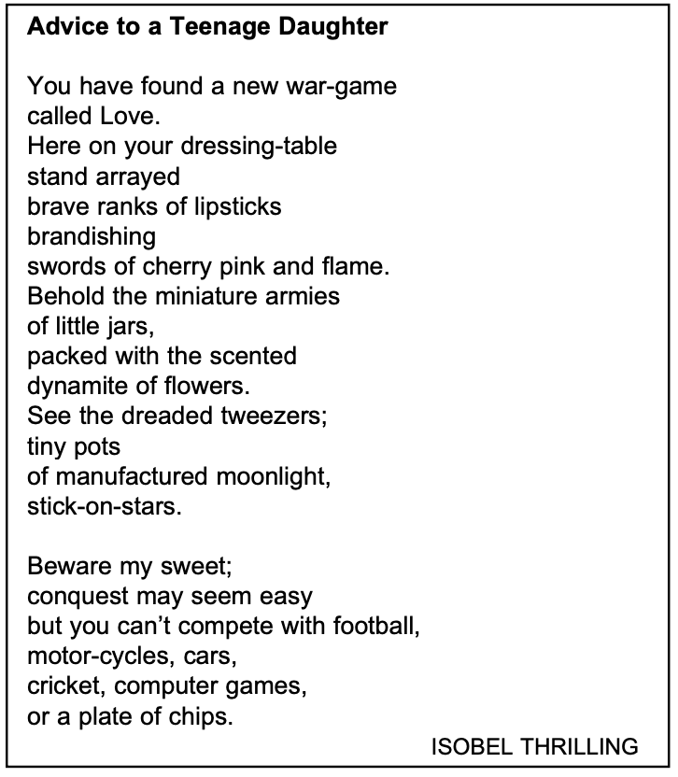

.
0
7
In ‘Advice to a Teenage Daughter’ how does the poet present the speaker’s feelings towards her daughter and young love?
1

[24 marks]

Section C: Unseen poetry

Answer both questions in this section.

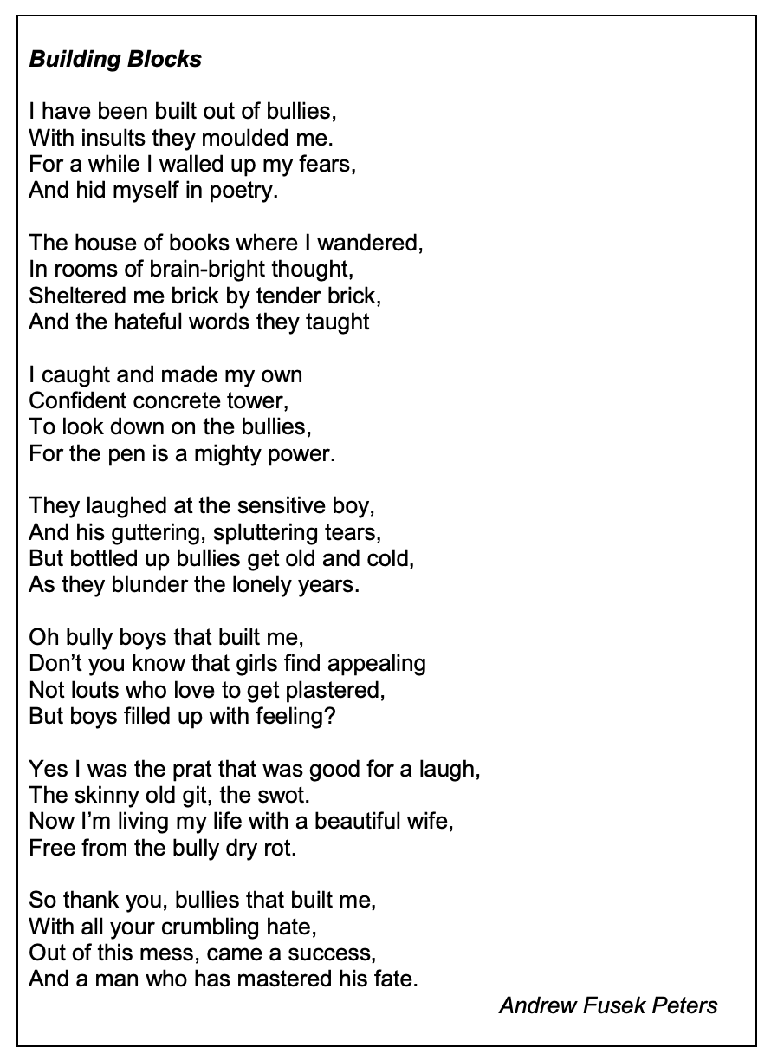

0
7
In ‘Building Blocks’ how does the poet present the speaker’s feelings towards the bullies?
.
1

[24 marks]

Section C: Unseen poetry

Answer both questions in this section.

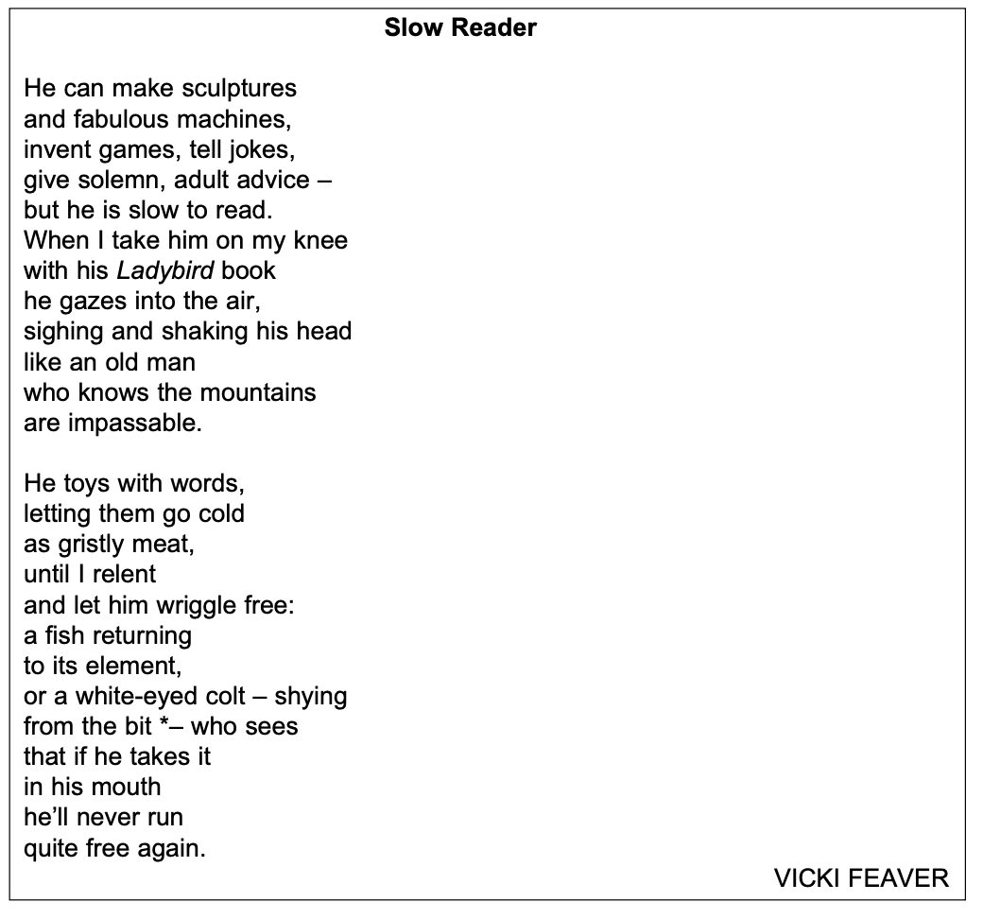

0
7
In ‘Slow Reader’ how does the poet present the speaker’s feelings towards the child and his experience of reading?
.
1

[24 marks]

Section C: Unseen poetry

Answer both questions in this section.

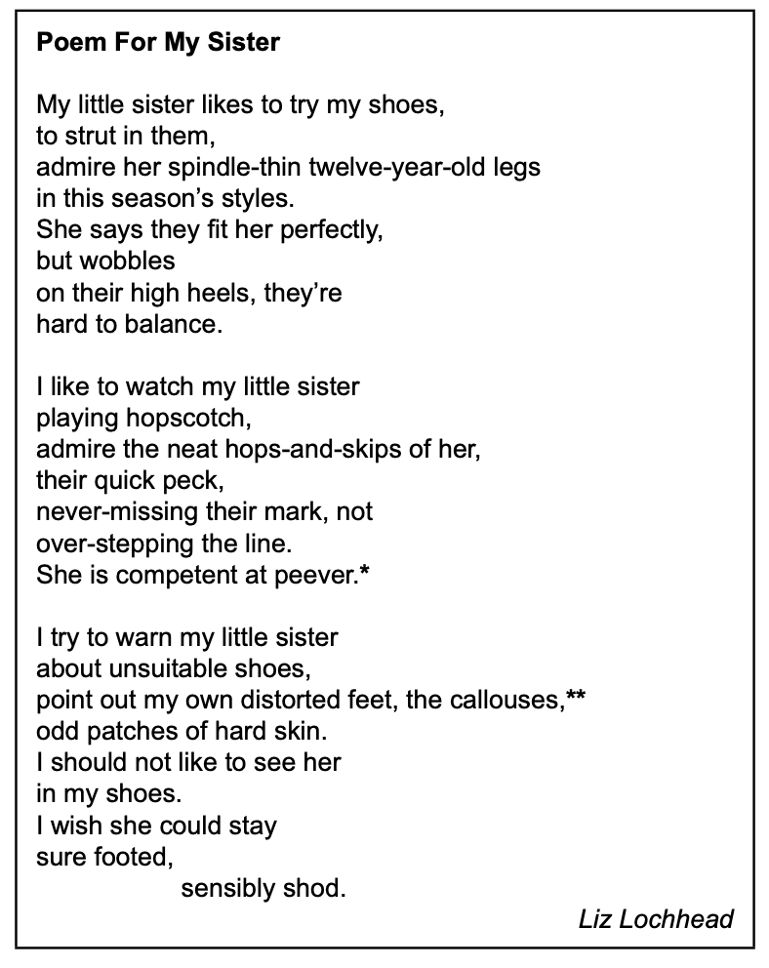

0
7
In ‘Poem For My Sister’ how does the poet present the speaker’s feelings towards her sister?
.
1

[24 marks]

Section C: Unseen poetry

Answer both questions in this section.



0
.
7
1
In ‘A Marriage’ how does the poet present the speaker’s feelings about marriage?

[24 marks]

Section C: Unseen poetry

Answer both questions in this section.

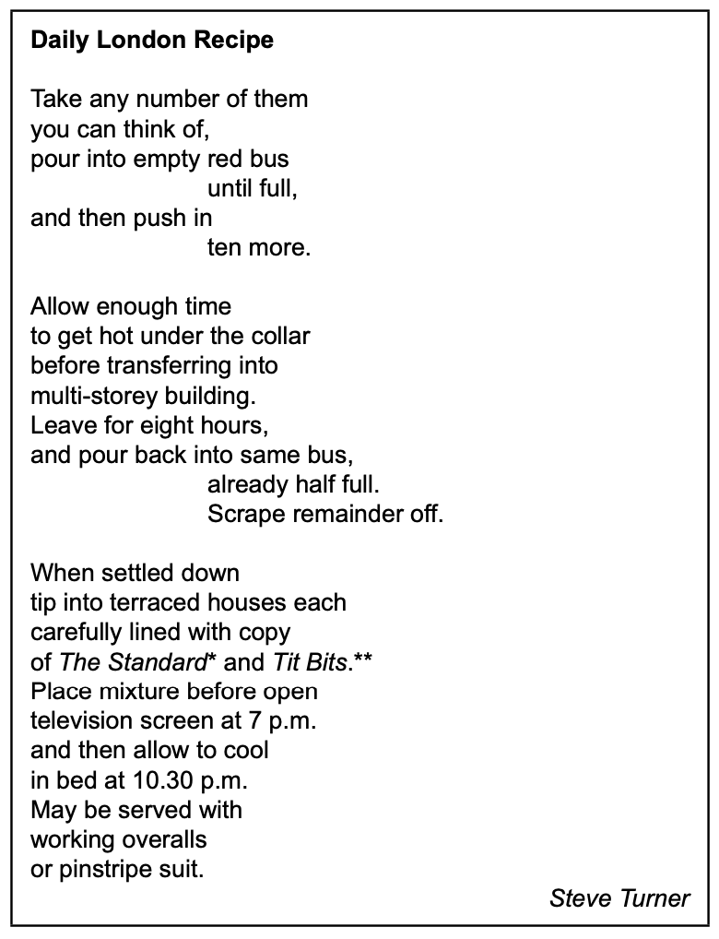

.
0
7
1
In ‘Daily London Recipe’ how does the poet present the speaker’s feelings about living and working in London?

[24 marks]

Section C: Unseen poetry

Answer both questions in this section.

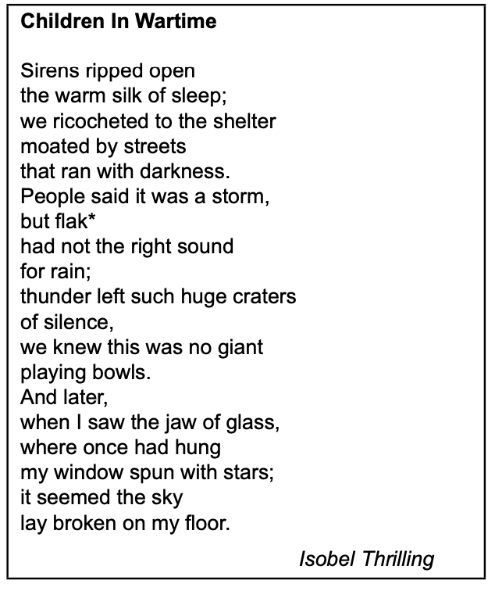

.
0
7
In ‘Children In Wartime’ how does the poet present the ideas about how children are affected by war?
1

[24 marks]

Section C: Unseen poetry

Answer both questions in this section.

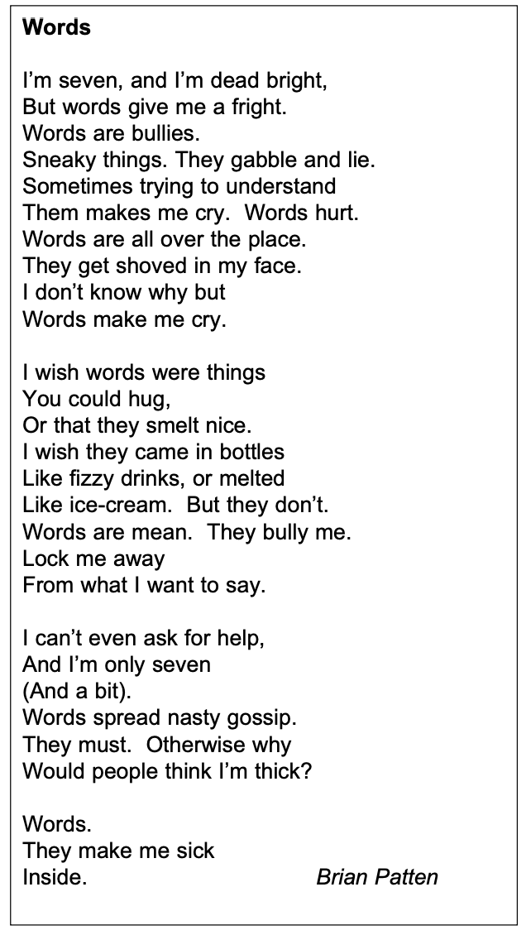

0
7
.
1
In ‘Words’ how does the poet present the speaker’s feelings towards words?

[24 marks]

Section C: Unseen poetry

Answer both questions in this section.

0
7
.
1
In ‘Words’ how does the poet present the speaker’s feelings towards words?

[24 marks]

Section C: Unseen poetry

Answer both questions in this section.

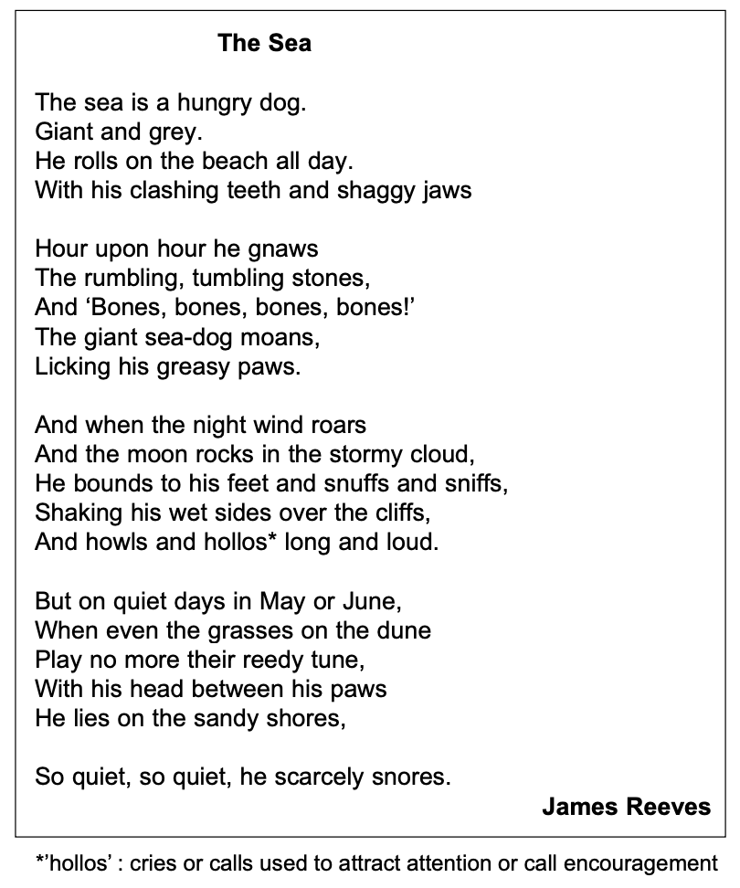

.
0
7
1
In ‘The Sea’ how does the poet present the speaker’s feelings towards the sea?

[24 marks]

Section C: Unseen poetry

Answer both questions in this section.

And Nothing Is Ever As You Want It To Be

You lose your love for her and then
It is her who is lost,
And then it is both who are lost,
And nothing is ever as perfect as you want it to be.
In a very ordinary world
A most extraordinary pain mingles with the small routines,
The loss seems huge and yet
Nothing can be pinned down or fully explained.
You are afraid.
If you found the perfect love
It would scald your hands,
Rip the skin from your nerves,
Cause havoc with a computered heart.
You lose your love for her and then it is her who is lost.
You tried not to hurt and yet
Everything you touched became a wound.
You tried to mend what cannot be mended,
You tried, neither foolish nor clumsy,
To rescue what cannot be rescued.
You failed,
And now she is elsewhere
And her night and your night
Are both utterly drained.
How easy it would be
If love could be brought home like a lost kitten
Or gathered in like strawberries,
How lovely it would be;
But nothing is ever as perfect as you want it to be.
Brian Patten

.
7
0
1
In ‘And Nothing Is Ever As You Want’ how does the poet present the speaker’s feelings towards the love and losing love?

[24 marks]

Section C: Unseen poetry

Answer both questions in this section.

Don’t Say I Said
Next time you speak to you-know-who
I’ve got a message for him.
Tell him that I have lost a stone
Since the last time I saw him.
Tell him that I’ve got three new books
Coming out soon, but play it
Cool, make it sound spontaneous.
Don’t say I said to say it.

He might ask if I’ve mentioned him.
Say I have once, in passing.
Memorise everything he says
And, no, it won’t be grassing
When you repeat his words to me –
It’s the only way to play it.
Tell him I’m toned and tanned and fine.
Don’t say I said to say it.

Say that serenity and grace
Have taken root inside me.
My top-note is frivolity
But beneath, dark passions guide me.
Tell him I’m radiant and replete
And add that every day it
Seems I am harder to resist.
Don’t say I said to say it.

Tell him that all my ancient faults
Have been eradicated.
I do not carp or analyse
As I might have when we dated.
Say I’m not bossy any more
Or, better still, convey it
Subtly, but get the point across.
Don’t say I said to say it.
Sophie Hannah

.
7
0
1
In ‘Don’t Say I Said’ how does the poet present the speaker’s feelings towards their ex-partner?

[24 marks]

Section C: Unseen poetry

Answer both questions in this section.

Frost

Frost the jailer
locks each ditch
and pool and pond
and slams the door
on moving water.

Frost the jeweller
fingers each gem
at the leaf’s tip
keen to account
for every drip.

Frost the miser
hoards the silver
leaves of winter
in dark hollows
under beech and poplar.

Frost the odd-job man
does up the garden
renewing each post
and leaning fence
at minimum cost.

Frost the magician
binds the day
in a silver spell
draping in white
fold and fell.

Frost the old man
who might not see April
taps with his white
stick in the garden
not feeling right.
Robert Hull

.
7
0
1
In ‘Frost’ how does the poet present the effects of the cold weather?

[24 marks]

Section C: Unseen poetry

Answer both questions in this section.

First Love

Falling in love was like falling down the stairs
Each stair had her name on it
And he went bouncing down each one like a tongue-tied lunatic
One day of loving her was an ordinary year
He transformed her into what he wanted
And the scent from her
Was the best scent in the world
Fifteen he was fifteen
Each night he dreamed of her
Each day he telephoned her
Each day was unfamiliar
Scary even
And the fear of her going weighed on him like a stone
And when he could not see her for two nights running
It seemed a century had passed
And meeting her and staring at her face
He knew he would feel as he did forever
Hopelessly in love
Sick with it
And not even knowing her second name yet
It was the first time
The best time
A time that would last forever
Because it was new
Because he was ignorant it could ever end
It was endless

Brian Patten

. In ‘First Love’ how does the poet present the speaker’s feelings
7
0
1
about falling in love?

[24 marks]

Section C: Unseen poetry

Answer both questions in this section.

Blessing

The skin cracks like a pod.
There never is enough water.

Imagine the drip of it,
the small splash, echo
in a tin mug,
the voice of a kindly god.

Sometimes, the sudden rush
of fortune. The municipal pipe bursts,
silver crashes to the ground
and the flow has found
a roar of tongues. From the huts,
a congregation: every man, woman,
child, for streets around
butts in, with pots,
brass, coper, aluminium,
plastic buckets,
frantic hands,

and naked children
screaming in the liquid sun
their highlights polished to perfection,
flashing light,
as the blessing sings
over their small bones

Imtiaz Dharker

. In ‘Blessing’ how does the poet present ideas about the importance
7
0
1
of water?

[24 marks]

Section C: Unseen poetry

Answer both questions in this section.

Love After Love

The time will come
when, with elation
you will greet yourself arriving
at your own door, in your own mirror
and each will smile at the other's welcome,
and say, sit here. Eat.
You will love again the stranger who was your self.
Give wine. Give bread. Give back your heart
to itself, to the stranger who has loved you
all your life, whom you ignored
for another, who knows you by heart.
Take down the love letters from the bookshelf,
the photographs, the desperate notes,
peel your own image from the mirror.
Sit. Feast on your life.
Derek Walcott

.
7
0
1
In ‘Love After Love’ how does the poet present the speaker’s hope for the future?

[24 marks]

Section C: Unseen poetry

Answer both questions in this section.

Thirteen

You will be four minutes from home
when you are cornered by an officer
who will tell you of a robbery, forty
minutes ago in the area. You fit
the description of a man? – You’ll laugh.
Thirteen, you’ll tell him: you’re thirteen.

You’ll be patted on the shoulder, then, by another fed
whose face takes you back to Gloucester Primary School,
a Wednesday assembly about being little stars.
This same officer had an horizon in the east
of his smile when he told your class that
you were all supernovas,
the biggest and brightest stars.

You will show the warmth of your teeth
praying he remembers the heat of your supernova;
he will see you powerless – plump.
You will watch the two men cast lots for your organs.

Don’t you remember me? you will ask.
You gave a talk at my primary school.
While fear condenses on your lips,
you will remember that Wednesday, after the assembly,
your teacher speaking more about supernovas:
how they are, in fact, dying stars
on the verge of becoming black holes.
Caleb Femi

7
.
0
1
In ‘Thirteen’ how does the poet present the speaker’s feelings towards the police and ideas about being a teenager?

[24 marks]

Section C: Unseen poetry

Answer both questions in this section.

Things I Have Stolen

From the highest shelf
my tiptoes could reach me
I stole a Mars bar & Haribo sweets.
It wasn’t a big deal: Mum said
their prices were a robbery anyway.

Later years, Marusha stole my heart,
jerked it out through the ribcage.
In desperation I stole another,
then another. Then a few more:
Fatima, Rihanna, Andrea.
Better to have and not need, I thought,
than need and not have.

Aylesbury estate, I saw Kevin steal Frank’s
white Air Force Ones. Do you know how long
it takes a fourteen-year-old yout to save
enough Ps to buy those trainers?
Kevin stole Frank’s soul, plucked it
like fruit in a swaying tree.

And I thought, what a game changer:
if Kevin can steal a soul, what else can be stolen?
So I stole the flavour from water
and I stole the solar eclipse.

Then I stole my torn name from the mouth
of the policeman who stops
and searches me
every week. Stole hunger pangs
from underneath our bed, at night.

Six years went by. At Kevin’s funeral
I reached into the air
and stole the family’s grief
Caleb Femi

0
.
7
1
In ‘Things I Have Stolen’ how does the poet present the speaker’s feelings towards stealing and life in general?

[24 marks]

Section C: Unseen poetry

Answer both questions in this section.

The Breather

Just as in the horror movies
when someone discovers that the phone calls
are coming from inside the house

so too, I realized
that our tender overlapping
has been taking place only inside me.

All that sweetness, the love and desire—
it’s just been me dialing myself
then following the ringing to another room

to find no one on the line,
well, sometimes a little breathing
but more often than not, nothing.

To think that all this time—
which would include the boat rides,
the airport embraces, and all the drinks—

it’s been only me and the two telephones,
the one on the wall in the kitchen
and the extension in the darkened guest room upstairs.
Billy Collins

0
.
7
1
In ‘December how does the poet present the speaker’s feelings about unrequited love?

[24 marks]

Section C: Unseen poetry

Answer both questions in this section.

How to Triumph Like a Girl

I like the lady horses best,
how they make it all look easy,
like running 40 miles per hour
is as fun as taking a nap, or grass.
I like their lady horse swagger,
after winning. Ears up, girls, ears up!
But mainly, let’s be honest, I like
that they’re ladies. As if this big
dangerous animal is also a part of me,
that somewhere inside the delicate
skin of my body, there pumps
an 8-pound female horse heart,
giant with power, heavy with blood.
Don’t you want to believe it?
Don’t you want to lift my shirt and see
the huge beating genius machine
that thinks, no, it knows,
it’s going to come in first.
Ada Limon

0
.
7
1
In ‘How to Triumph Like a Girl’ how does the poet present the speaker’s feelings about believing in yourself?

[24 marks]

Section C: Unseen poetry

Answer both questions in this section.

The Good Life

When some people talk about money
They speak as if it were a mysterious lover
Who went out to buy milk and never
Came back, and it makes me nostalgic
For the years I lived on coffee and bread,
Hungry all the time, walking to work on payday
Like a woman journeying for water
From a village without a well, then living
One or two nights like everyone else
On roast chicken and red wine.
Tracy K Smith

0
.
7
1
In ‘The Good Life’ how does the poet present the speaker’s feelings about money and hunger?

[24 marks]

Section C: Unseen poetry

Answer both questions in this section.

Brothers

Saddled with you for the afternoon, me and Paul
ambled across the threadbare field to the bus stop,
talking over Sheffield Wednesday’s chances in the Cup
while you skipped beside us in your ridiculous tank-top,
spouting six-year-old views on Rotherham United.

Suddenly you froze, said you hadn’t any bus fare.
I sighed, said you should go and ask Mum
and while you windmilled home I looked at Paul.
His smile, like mine, said I was nine and he was ten
and we must stroll the town, doing what grown-ups do.

As a bus crested the hill we chased Olympic Gold.
Looking back I saw you spring towards the gate,
your hand holding out what must have been a coin.
I ran on, unable to close the distance I’d set in motion.
Andrew Forster

0
.
7
1
In ‘Brothers’ how does the poet present the speaker’s feelings about his brother?

[24 marks]

