w/c 8th APRIL: LANGUAGE REVISION
Gold (1h 30 mins) | Complete bronze, then spend 40 minutes writing each response.
Silver (30 mins) | Complete bronze, then write your opening paragraph for each plan.
Bronze (10 mins) | Spend 5 minutes planning a response to each of the questions.

P1Q5

Either
Write a description as suggested by this picture or

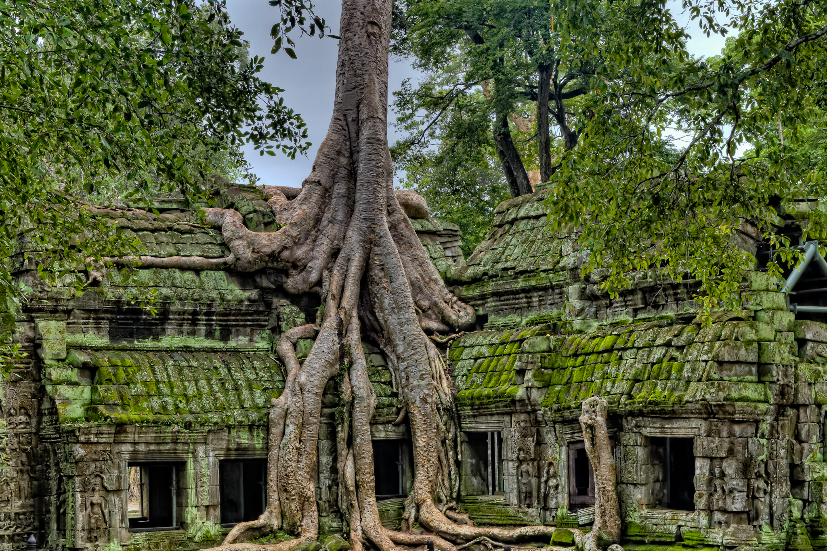

Write a story where nature takes control.

P2Q5

“All children should have to get a job from the age of fourteen. It would encourage independence, communication, and give them money to make their own financial decisions”.
Write an article which gives your viewpoint for or against this statement.

