KEY STAGE 4
English Language
Mini Extracts

English exam countdown
X
X
X
X
X
X
LITERATURE PAPER 2
‘Modern text, taught poetry, and unseen poetry 2 hours 15 mins
X
LANGUAGE PAPER 2
True or false, summarise and link, language analysis, comparison of viewpoints, viewpoints writing

LANGUAGE PAPER 1
List four things, language analysis, structure analysis, responding to a statement, creative writing
LITERATURE PAPER 1
Shakespeare and 19th Century– 1hour 45 mins
Name:
Class:
Teacher:

- Contents
Language paper 1 –  Question 2 and Question 5 | 1A Snow | 3
Language paper 1 –  Question 2 and Question 5 | 1B A living house | 6
Language paper 1 –  Question 2 and Question 5 | 1C A predator | 9
Language paper 1 –  Question 2 and Question 5 | 1D A busy city | 12
Language paper 1 –  Question 2 and Question 5 | 1E A storm | 15
Language paper 1 –  Question 4 and Question 5 | 2A A locust attack | 18
Language paper 1 –  Question 4 and Question 5 | 2B A frozen landscape | 21
Language paper 1 –  Question 4 and Question 5 | 2C A mystery | 23
Language paper 1 –  Question 4 and Question 5 | 2D The birds | 27
Language paper 1 –  Question 4 and Question 5 | 2E A downpour | 30
Language paper 2 –  Question 2 and Question 5 | 3A Prisoners and prisons | 33
Language paper 2 –  Question 2 and Question 5 | 3B Charities | 36
Language paper 2 –  Question 2 and Question 5 | 3C Zoos | 39
Language paper 2 –  Question 2 and Question 5 | 3D The seaside | 42
Language paper 2 –  Question 2 and Question 5 | 3E Theatres | 45
Language paper 2 –  Question 4 and Question 5 | 4A Begging | 48
Language paper 2 –  Question 4 and Question 5 | 4B Poverty in education | 51
Language paper 2 –  Question 4 and Question 5 | 4C The underground | 54
Language paper 2 –  Question 4 and Question 5 | 4D Floods | 57
Language paper 2 –  Question 4 and Question 5 | 4E Food markets | 60

1A / LANG P1 Q2 & Q5 : DESCRIBING SNOW
They seem tentative and awkward at first, then in a hastening host a whole brief army falls, white militia paratrooping out of the close sky over various textures, making them one. Snow is white and gray, part and whole, infinitely various yet infinitely repetitious, soft and hard, frozen and melting, a creaking underfoot and a soundlessness. But first of all it is the reversion of many into one. It is substance, almost the idea of substance, that turns grass, driveway, hayfield, old garden, log pile, Saab, watering trough, collapsed barn, and stonewall into the one white.  From Seasons at Eagle Pond, Donald Hall |  | USING THE EXTRACT:  02 How does the writer use language to describe the snow?  You could include the writer’s choice of  - words and phrases  - language features and techniques  - sentence forms |  |  |  |  |  |  |  |  | 
USING THE IMAGE:
05

EITHER
Write a description as suggested by this image

OR
Write the opening of a story that begins in the snow

1B / LANG P1 Q2 & Q5 : A LIVING HOUSE
No Human eye can isolate the unhappy coincidence of line and place which suggests evil in the face of the house, and yet somehow a maniac juxtaposition, a badly turned angle, some chance meeting of roof and sky, turned Hill House into a place of despair, more frightening because the face of Hill House seemed awake, with a watchfulness from the blank windows and a touch of glee in the eyebrow of a cornice. A house arrogant and hating, never off guard, can only be evil. It was a house without kindness, never meant to be lived in, not a fit place for people or for love or for hope. Exorcism cannot alter the countenance of a house; Hill House would stay as it was until it was destroyed. From The Haunting of Hill House by Shirley Jackson |  |  |  | USING THE EXTRACT:  02 How does the writer use language to describe the house?  You could include the writer’s choice of  - words and phrases  - language features and techniques  - sentence forms |  |  |  |  |  |  | 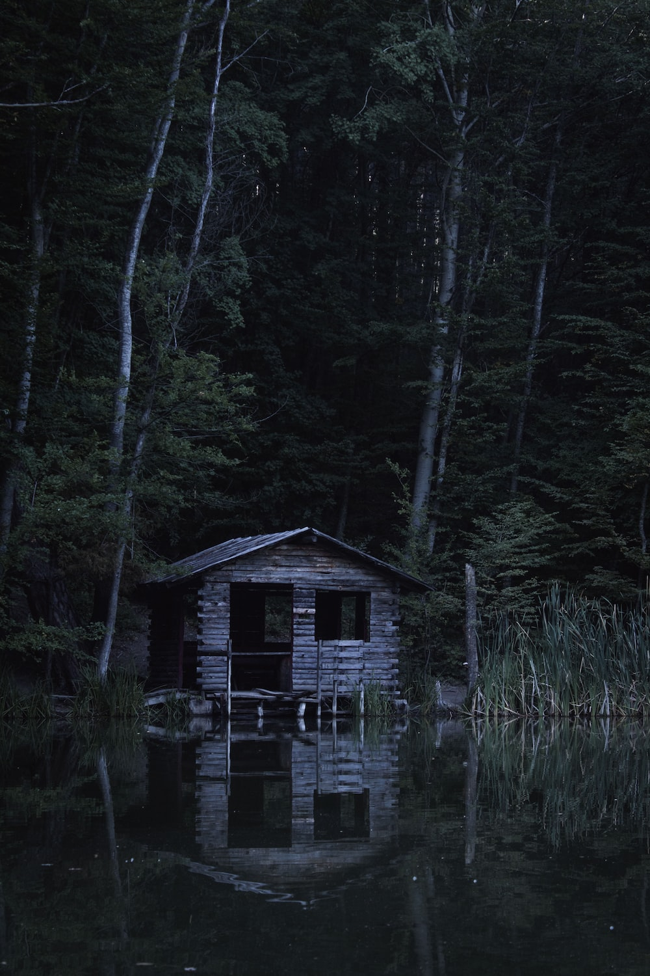
USING THE IMAGE:
05
EITHER
Write a description as suggested by this image
OR
Write the opening of a story that is set in an abandoned house.
1C / LANG P1 Q2 & Q5 : A PREDATOR
A black shadow dropped down into the circle. It was Bagheera the Black Panther, inky black all over, but with the panther markings showing up in certain lights like the pattern of watered silk. Everybody knew Bagheera, and nobody cared to cross his path, for he was as cunning as Tabaqui, as bold as the wild buffalo, and as reckless as the wounded elephant. But he had a voice as soft as wild honey dripping from a tree, and a skin softer than down.  From The Jungle Book by Rudyard Kipling |  |  | USING THE EXTRACT:  02 How does the writer use language to describe Bagheera the panther?  You could include the writer’s choice of  - words and phrases  - language features and techniques  - sentence forms |  |  |  |  |  |  |  | 
USING THE IMAGE:
05
EITHER
Write a description as suggested by this image
OR
Write the opening of a story that includes a predator.
1D / LANG P1 Q2 & Q5 : A BUSY CITY
Detroit exudes shame and decay. Those are its bright spots. You lock your doors and cringe and stomach going from the safety of point A to point B. You hope that you don’t break down in the broken down east side. Your heart races when you come upon a long red light and all you see is burned out buildings and church and barbeque hovels. Was that gunfire or backfire? You stare to the left and a beggar from the right knocks on your window looking for a “dolla”. You survive and relax under an umbrella table at an outdoor cafe in beautiful downtown, all gleaming and white. Your tale brings nervous smiles and shaking heads. I love mysteries and dark dilemmas. I love Detroit. From Detroit Noir by EJ Olsen and Jon C Hocking |  |  |  | USING THE EXTRACT:  02 How does the writer use language to describe Detroit?  You could include the writer’s choice of  - words and phrases  - language features and techniques  - sentence forms |  |  |  |  |  |  | 
USING THE IMAGE:
05
EITHER
Write a description as suggested by this image
OR
Write the opening of a story that is set in a busy city of your choice.
1E / LANG P1 Q2 & Q5 : A STORM
A reef of clouds and lightning raced across the skies from the sea. My hands were shaking, and my mind wasn’t far behind. I looked up and saw the storm spilling like rivers of blackened blood from the clouds, blotting out the moon and covering the roofs of the city in darkness. I tried to speed up, but I was consumed with fear and walked with leaden feet, chased by the rain. I took refuge under the canopy of a newspaper kiosk, trying to collect my thoughts and decide what to do next. A clap of thunder roared close by, and I felt the ground shake under my feet. On the flooding pavements the streetlamps blinked, then went out like candles snuffed by the wind. There wasn’t a soul to be seen in the streets, and the darkness of the blackout spread with a fetid smell that rose from the sewers. The night became opaque, impenetrable, as the rain folded the city in its shroud. From Shadow of the Wind by Carlos Ruiz Zafon |  |  |  |  | USING THE EXTRACT:  02 How does the writer use language to describe the weather?  You could include the writer’s choice of  - words and phrases  - language features and techniques  - sentence forms |  |  |  | 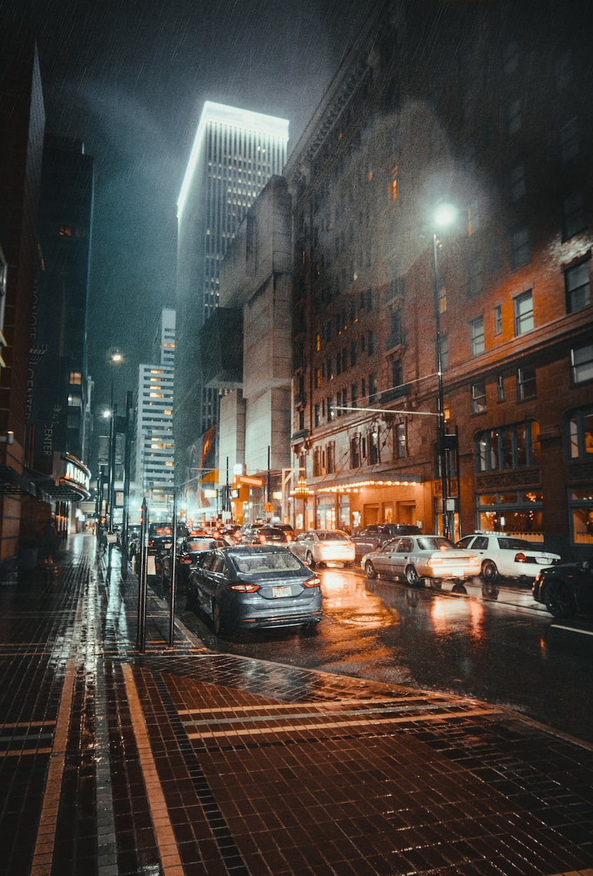
USING THE IMAGE:
05
EITHER
Write a description as suggested by this image

OR
Write the opening of a story that takes place during a storm
 | 2A / LANG P1 Q4 & Q5 : LOCUST ATTACK
 | By now, the locusts were falling like hail on the roof of the kitchen. It sounded like a heavy storm. Margaret looked out and saw the air dark with a crisscross of the insects, and she set her teeth and ran out into it; what the men could do, she could. Overhead, the air was thick—locusts everywhere. The locusts were flopping against her, and she brushed them off—heavy red-brown creatures, looking at her with their beady, old men’s eyes while they clung to her with their hard, serrated legs. She held her breath with disgust and ran through the door into the house again. There it was even more like being in a heavy storm. The iron roof was reverberating, and the clamor of beaten iron from the lands was like thunder. When she looked out, all the trees were queer and still, clotted with insects, their boughs weighted to the ground. The earth seemed to be moving, with locusts crawling everywhere; she could not see the lands at all, so thick was the swarm. Toward the mountains, it was like looking into driving rain; even as she watched, the sun was blotted out with a fresh onrush of the insects. It was a half night, a perverted blackness. Then came a sharp crack from the bush—a branch had snapped off. Then another. A tree down the slope leaned over slowly and settled heavily to the ground. Through the hail of insects, a man came running.  - A mild attack of locusts, Doris Lessing |  |  |  |  |  |  |  | 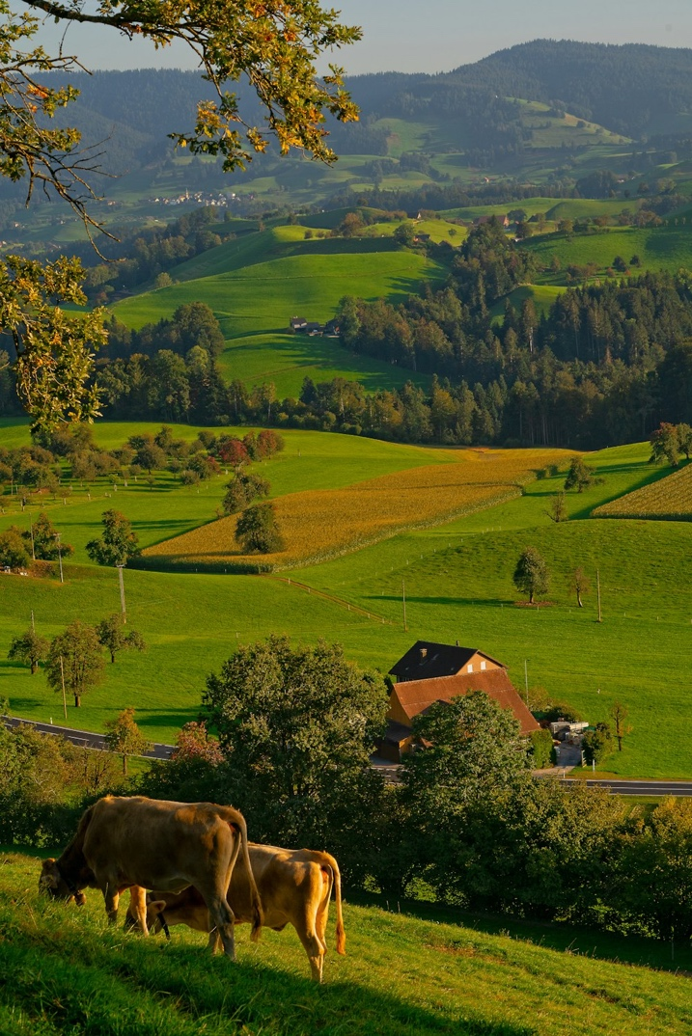
 | Q4: A student, having read this section of the text, said “I like the way the writer creates fear in the reader by making the locust swarm sound like a violent and terrifying attack”  To what extent do you agree? |  |  |  |  |  |  |  | Q5: Either  Write a description as suggested by this picture  or  Write a story involving a group of animals
 | 2B / LANG P1 Q4 & Q5 : A FROZEN LANDSCAPE
 | Dark spruce forest frowned on either side the frozen waterway. The trees had been stripped by a recent wind of their white covering of frost, and they seemed to lean towards each other, black and ominous, in the fading light. A vast silence reigned over the land. The land itself was a desolation, lifeless, without movement, so lone and cold that the spirit of it was not even that of sadness. There was a hint in it of laughter, but of a laughter more terrible than any sadness—a laughter that was mirthless as the smile of the sphinx, a laughter cold as the frost and partaking of the grimness of infallibility. It was the masterful and incommunicable wisdom of eternity laughing at the futility of life and the effort of life. It was the Wild, the savage, frozen-hearted Northland Wild.  But there was life, abroad in the land and defiant. Down the frozen waterway toiled a string of wolfish dogs. Their bristly fur was rimed with frost. Their breath froze in the air as it left their mouths, spouting forth in spumes of vapour that settled upon the hair of their bodies and formed into crystals of frost. Leather harness was on the dogs, and leather traces attached them to a sled which dragged along behind. – Call of the Wild, Jack London |  |  |  |  |  |  | 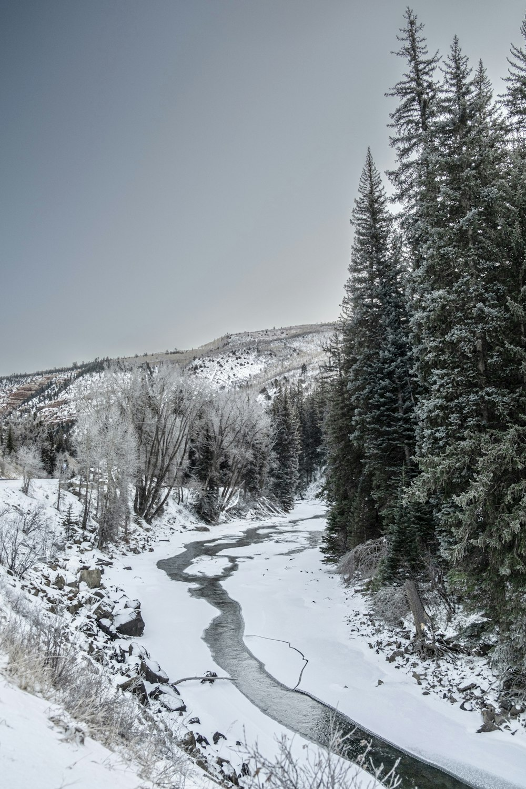
 | Q4: A student, having read this text, said “The writer creates a sinister and threatening setting which makes the dogs seem hard-working due to the harsh environment.”  To what extent do you agree? |  |  |  |  |  |  | Q5: Either  Write a description as suggested by this picture  or  Write a story set in a difficult environment.
2C / LANG P1 Q4 & Q5 : A MYSTERY
The little map Nan had drawn was in her bag, but she’d etched it on her memory. She turned away from the great stone walls, took the path toward the deep woods. Belatedly she remembered the umbrella in her bag, dragged it out, pushing her way forward into the evocative gloom of the rain-struck woods.  She hadn’t imagined the trees so big, with their wide, wide trunks, crazily gnarled branches. A storybook wood, she thought, thrilled with it even as the rain splashed over her boots. Through its drumming she heard the wind sigh and moan, then the rumble of what must be the river. Paths speared, forked, but she kept the map in her head.  She thought she heard something cry overhead, and for a moment imagined she saw the sweep of wings. Then despite the drumming, the rumbling, the sighs and the moans, everything suddenly seemed still. As the path narrowed, roughened, her heartbeat pounded in her ears, too quick, too loud.  To the right an upended tree exposed a base taller than a man, wider than her arm span. Vines thick as her wrist tangled together like a wall. She found herself drawn toward them, struck by the urge to pull at them, to fight her way through them to see what lay beyond. The concept of getting lost flitted through her mind, then out again. She just wanted to see.  - The Dark Witch, Nora Roberts |  |  |  |  |  | 
Q4: A student, having read this section of the text, said “I like how the writer creates a mystery. The girl seems brave because the setting seems strange.”  To what extent do you agree? |  |  |  |  |  | Q5: Either  Write a description as suggested by this picture  or  Write a story involving a map.
2D / LANG P1 Q4 & Q5 : THE BIRDS
They must go early to bed tonight. That was, if . . .  He got up and went out of the back door and stood in the garden, looking down toward the sea. There had been no sun all day, and now, at barely three o’clock, a kind of darkness had already come, the sky sullen, heavy, colorless like salt. He could hear the vicious sea drumming on the rocks. He walked down the path, halfway to the beach. And then he stopped. He could see the tide had turned. The rock that had shown in midmorning was now covered, but it was not the sea that held his eyes. The gulls had risen. They were circling, hundreds of them, thousands of them, lifting their wings against the wind. It was the gulls that made the darkening of the sky. And they were silent. They made not a sound. They just went on soaring and circling, rising, falling, trying their strength against the wind.  Nat turned. He ran up the path, back to the cottage.  “I’m going for Jill,” he said. “I’ll wait for her at the bus stop.”  “What’s the matter?” asked his wife. “You’ve gone quite white.”  “Keep Johnny inside,” he said. “Keep the door shut. Light up now, and draw the curtains.”  - The Birds, Daphne du Marier |  |  |  |  |  |  | 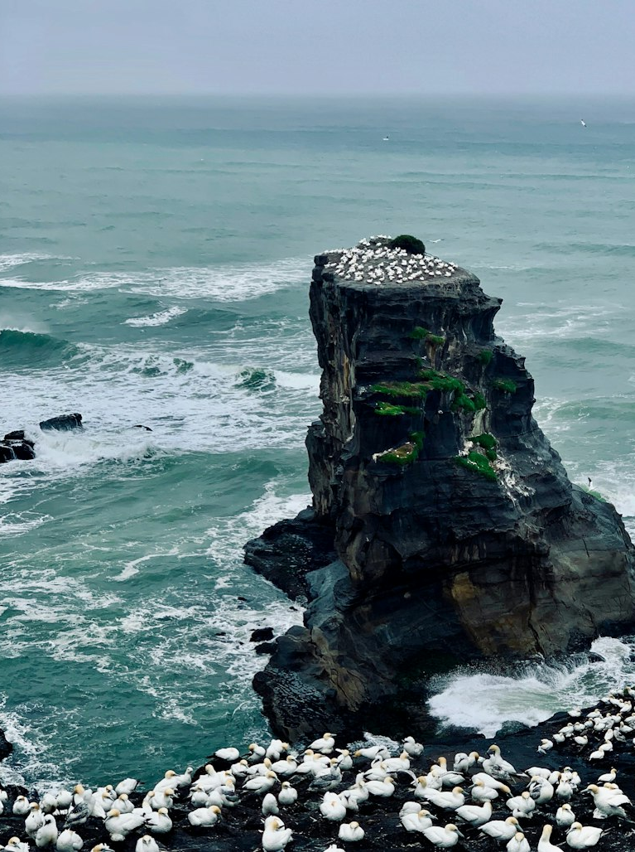
Q4: A student, having read this section of the text, said “The writer creates a scary atmosphere with the setting and the birds. It is clear the characters are afraid and tense.”  To what extent do you agree? |  |  |  |  |  |  | Q5: Either  Write a description as suggested by this picture  or  Write a story about an strange event.
2E / LANG P1 Q4 & Q5 : A DOWNPOUR
The rain continued. It was a hard rain, a perpetual rain, a sweating and steaming rain; it was a mizzle, a downpour, a fountain, a whipping at the eyes, an undertow at the ankles; it was a rain to drown all rains and the memory of rains. It came by the pound and the ton, it hacked at the jungle and cut the trees like scissors and shaved the grass and tunnelled the soil and melted the bushes. It shrank men’s hands into the hands of wrinkled apes; it rained a solid glassy rain, and it never stopped.  “How much farther, Lieutenant?”  “I don’t know. A mile, ten miles, a thousand.”  “Aren’t you sure?”  “How can I be sure?”  “I don’t like this rain. If we only knew how far it is to the Sun Dome, I’d feel better.”  “Another hour or two from here.”  “You really think so, Lieutenant?”  “Of course.”  “Or are you lying to keep us happy?”  “I’m lying to keep you happy. Shut up!”  The two men sat together in the rain. Behind them sat two other men who were wet and tired and slumped like clay that was melting. – The Long Rain, Ray Bradbury |  |  |  |  |  |  |  |  |  | 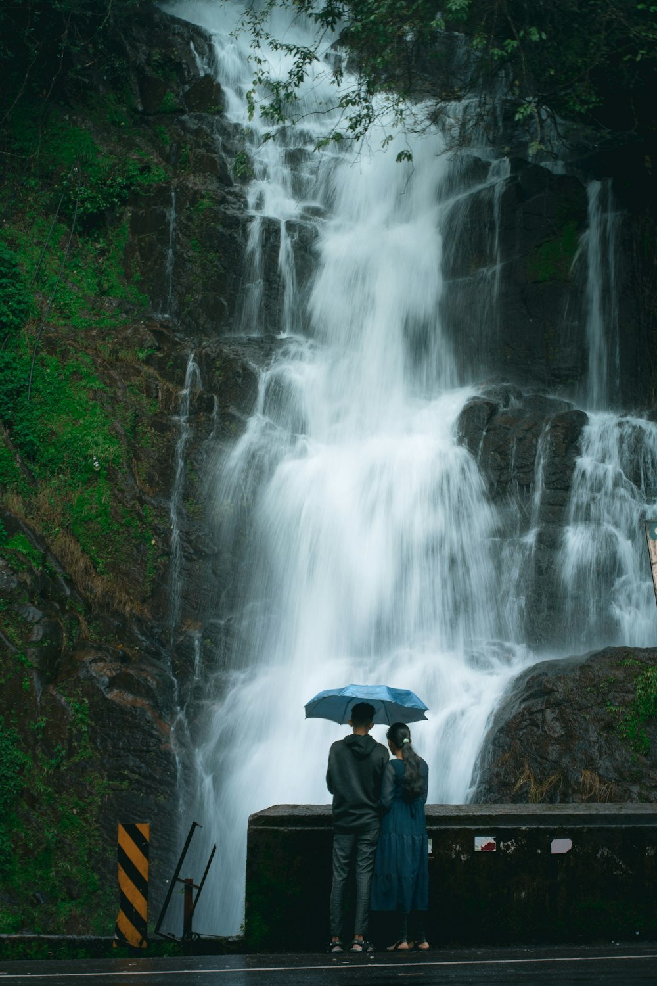
Q4: A student, having read this section of the text, said “The men seem frustrated and annoyed by the rain, which is presented as violent and attacking the landscape and men.”  To what extent do you agree? |  |  |  |  |  |  |  |  |  | Q5: Either  Write a description as suggested by this picture  or  Write a story set in a jungle.
3A / LANG P2 Q2 & Q5 : PRISONERS & PRISONS
Charles Dickens in Sketches by Boz, 1836. | Deborah Coles in the Guardian, 2022 |  | -QUESTIONS-
In the first apartment into which we were conducted - which was at the top of a staircase, and immediately over the press-room – were five-and-twenty or thirty prisoners, all under sentence of death, awaiting the result of the recorder's report - men of all ages and appearances, from a hardened old offender with swarthy face and grizzly beard of three days' growth, to a handsome boy, not fourteen years old, and of singularly youthful appearance even for that age, who had been condemned for burglary. There was nothing remarkable in the appearance of these prisoners. One or two decently-dressed men were brooding with a dejected air over the fire; several little groups of two or three had been engaged in conversation at the upper end of the room, or in the windows; and the remainder were crowded round a young man seated at a table, who appeared to be engaged in teaching the younger ones to write. There was very little anxiety or mental suffering depicted in the countenance of any of the men; - they had all been sentenced to death, it is true. | People in prison are some of the most marginalised in society, with experiences of institutional care, homelessness, educational disadvantage, addiction, mental and physical ill health, and abuse, underpinned by poverty and inequality.  Sarah Reed was a 32-year-old mixed-race Black woman who was remanded to prison for the sole purpose of obtaining psychiatric reports. Her mental health worsened severely in prison and she was treated as a discipline problem.  Mohammed Afzal was a 22-year-old man of Pakistani background who lost almost a third of his body weight during his 48 days in prison.  Thokozani Shiri was a 21-year-old Black man with HIV/Aids. Prison healthcare failed to provide him with life-saving antiretroviral medication during two periods of imprisonment. He told a prison officer: “I can’t breathe … I need to go to hospital,” but an ambulance was not called until five days later. |  | 02 Both sources describe the behaviour and appearance of prisoners.  Write a summary of the differences between the prisoners in each source.
05 “Prisoners have all committed crimes and so should have to live and suffer in difficult, harsh conditions.”

Write a speech offering your viewpoint on this topic.
3B / LANG P2 Q2 & Q5 : CHARITIES
Charles Booth in 1903.  Life and Labour of People in London. | Mark Brown in the Guardian, 2022  ‘Newcastle food bank struggles’ |  | -QUESTIONS-
(About the Salvation Army) In their slum work and in the provision of “food and shelter for the homeless and starving poor” the needs of East London are specially considered, and in East London is to be found one of the homes established by the Army in connection with their rescue work. Of the slum officers it is said that “they live amongst the people in the darkest and most wretched courts and alleys. They nurse the sick, care for the dying, visit the lodging-houses, hold meetings continually, and by their self-sacrificing lives win hundreds of poor outcasts for Christ.”  No one who has attended the services, studied the faces, and listened to the spoken words, can doubt the earnest and genuine character of the enthusiasm which finds in them its expression. Its members hold in single faith, and with a very passionate conviction, what are known as the truths of Christianity.  The ultimate results of providing food and shelter at uncommercial prices can hardly be evil, but even this is mitigated by the evident honesty of the effort. | Research by the Trussell Trust published on Thursday revealed the cost of living crisis is transforming the profile of the typical UK food bank user. Nurses, shop assistants and youth workers are among large numbers of people in low-paid jobs who use banks.  It is a trend recognised in Newcastle. Gemma Whaley, the food bank’s operations manager, said since June they have been giving out about 2,000 food parcels a month, which is 400 more than the previous average. “We have been able to cope … just,” she said. “We are having to buy a lot more in to meet that demand.”  The increase has coincided with a fall in food donations. “With the cost of living everybody is just struggling themselves. The people who used to give didn’t have a lot anyway, but now they’re really stretched so giving to charity drops off, I suppose.”  The food bank dispenses about 23 tonnes a month of food but only gets about nine to 10 tonnes a month of donations, which means it needs money to buy wholesale. |  | 02 Both sources describe the purpose and actions of charity organisations  Write a summary of the differences between the charities in each source.
05 “Charities just make people rely on others. It’s a harsh world and we need to look out for ourselves, not help others.”

Write an article offering your viewpoint on this topic.
3C / LANG P2 Q2 & Q5 : ZOOS
1844, Mogg’s Visitor’s Guide to London | 2023, Bristol Zoo Website |  |  |  | -QUESTIONS-
The museum of the Zoological Society, at present closed, awaits the erection of a building intended for its reception it contains several thousand specimens of stuffed birds and animals and a curious collection of horns. For the admirable arrangement of these beautiful grounds, and judicious distribution of the several buildings, the Society are indebted to the talent of Mr. Burton, whose well-known taste and judgment are throughout strikingly exemplified. This grand collection is here displayed to the greatest advantage; the selection of site, and form of dwelling, being rendered at all times as congenial to the habits of the animals as the extent of the premises and a due regard to safety will permit; and aviaries, dens, paddocks, and poles have all been formed in furtherance of that object; together with ponds for the beavers, water-fowl, &c. These gardens are one of the greatest attractions of the metropolis; they have long been the resort of rank and fashion, and enjoy, as they deserve, a large share of public patronage, not fewer than 112,000 persons having visited them in the course of one year. | Exciting CGI images of the new Bristol Zoo have been released today (Wednesday February 22), revealing that visitors will be immersed in nature from the moment they step foot inside.  Pictures of the first phase of the new zoo, which will be developed at Bristol Zoological Society’s Wild Place Project site, show plans for a Central African Forests area, home to the Western lowland gorilla troop from Bristol Zoo Gardens; a conservation learning campus, where visitors will be able to see scientists up close at work; and a stunning new wild entrance.  The new zoo will be home to some of the world’s most threatened species to reflect the vital conservation work that Bristol Zoological Society does with species and habitats around the world.  Images also show plans for a new conservation campus at the heart of the zoo, which will have purpose-built facilities for undergraduate and postgraduate conservation students to study, along with a conservation medicine centre, providing modern veterinary facilities to ensure the highest standards of animal welfare. |  |  |  | 02 Both sources describe the design and habitats of zoos.  Write a summary of the differences between the zoos in each source.
05 “In modern society we should not be caging wild animals for our own enjoyment /entertainment. We need to ban all zoos and protect our wildlife.”

Write an article offering your viewpoint on this topic.
3D / LANG P2 Q2 & Q5 : THE SEASIDE
1836, Sketches by Boz, Charles Dickens | 2017, TIMES, Mattie Lacey-Davidson |  |  | -QUESTIONS-
Silently and abstractedly, did that too sensitive youth follow his revered parents, and a train of smock-frocks and wheelbarrows, along the pier, until the bustle of the scene around, recalled him to himself. The sun was shining brightly; the sea, dancing to its own music, rolled merrily in; crowds of people promenaded to and fro; young ladies tittered; old ladies talked; nursemaids displayed their charms to the greatest possible advantage; and their little charges ran up and down, and to and fro, and in and out, under the feet, and between the legs, of the assembled concourse, in the most playful and exhilarating manner. There were old gentlemen, trying to make out objects through long telescopes; and young ones, making objects of themselves in open shirt-collars; parties, waiting on the pier for parties who had come by the steam-boat; and nothing was to be heard but talking, laughing, welcoming, and merriment.  The appearance of the sands on the morning after their arrival […] It was a fine, bright, clear day, with a light breeze from the sea. | Broadstairs is beautiful, and very popular with holidaymakers. Parking is limited so it’s good to arrive early, find a space at a car park in town and wander down towards the beach, which is perfectly sheltered by chalk cliffs. It’s a fabulous place to swim in the sea. I particularly love the lift that’s a boon for those who can’t manage the steep steps up to the top of the cliff at one end of the beach, the handy café and the beach cubicles that you can hire to keep all your buckets and spades and to change in if you are staying for a few days.  Youngsters will love the traditional rides and activities. It’s pretty much perfect for families.  With plenty of excellent eateries, fish and chip shops and an ice cream parlour with a dazzling array of flavours to choose from, it was hard to leave this gorgeous resort, but Margate was beckoning.  It has a very trendy vibe. The many vintage shops, cool coffee shops and, of course, the ultra-chic Turner Contemporary right down by the sea make this ideal territory for culture loving folk. |  |  | 02 Both sources describe the features of British seaside towns.  Write a summary of the differences between the locations in each source.
05 “Travelling to other countries is a crucial and important childhood experience for young people. All teenagers should have a chance to go abroad.”

Write a letter to your headteacher giving your views on trips overseas.
3E / LANG P2 Q2 & Q5 : THEATRES
1881, Life in the London Streets, Richard Rowe |  | 2023, The Independent, ‘Guys and Dolls’ |  |  |  | -QUESTIONS-
In the first theatre people were standing in close-packed tiers, a dozen deep, at the back of the pit, and when we mounted to the almost equally crammed gallery, the hot steam that filled it soon drove us down again. Most necessary seemed the fresh lime-wash on the unplastered bricks of the staircase walls. But what were these uncomfortably thronged East-Enders listening to in breathless attention? To their credit be it recorded, - Antony's speech over the dead body of Caesar. Nevertheless, the gratifying fact remained, - hundreds of people, not generally credited with refined taste, stood and sat spell-bound by Shakespeare, conscientiously, however crudely, acted. Far more rational entertainment that on both sides than music-hall howling, or what we witnessed in the next theatre. A crowd stood outside staring at a placard which announced "All places full." The lobby of the "dress circle" was choked with gazers standing on tiptoe. |  | In Nicholas Hytner’s production of Guys and Dolls, nothing stays still for long: not the cast, not the audience, not even the stage. After acclaimed immersive productions of Julius Caesar and A Midsummer Night’s Dream, the Bridge Theatre boss turns the auditorium into Depression-era New York, a place that exists in a constant state of flux. Performers dance inches away from the crowd. Audience members are ushered onto tables on the stage. A marching band traipses through the masses. The staging may be inventive, but this production already feels like a classic, knowing when to rock the boat and when to stick to what works. And boy, does it work.  The experience you have at Guys and Dolls will differ hugely based on whether you are seated or standing among the throng. The latter are led around by crew members (who, in a nice touch, are dressed like police officers), allowing Bunny Christie’s innovative set to rise out of the ground before the crowds. This proximity to the cast enables plenty of audience interaction. |  |  |  | 02 Both sources describe what happens in the theatres of London.  Write a summary of the differences between the theatres in each source.
05 “Going to the theatre is pointless in the modern world. With games consoles and Netflix, there is no need for live theatre”
Write an article giving your views on theatres.

4A / LANG P2 Q4 & Q5 : BEGGARS
Richard Grant, published in 1838 Sketches in London |  | Mark Johnson, in 2018, ‘Don’t Demonise Beggars’
I come now to speak of the other class of begging impostors. I mean those who are to be seen openly following their profession in the streets. The number of beggars is astonishing. Ten years ago it was estimated at 7,500; I am sure the number has not diminished since then; my impression is, that it has, on the contrary, considerably increased. I think it may be safely enough assumed, that the present number of beggars of this class, to be seen in the streets of London, is not under 8,000. It will startle those whose attention has never been called to the subject, when they are informed, that of the beggars who in so great a variety of ways, audibly and silently, solicit alms in the public streets, there is only one out of every twenty who is a proper object of charity; the remaining number are impostors. Suppose we take the proportion of street-beggars who are real objects of charity to those who are not, at nearly one in sixteen, that will give, on the above computation, the immense number of 7,500 of this class of impostors who are constantly on town. I have made inquiries of a gentleman who has been officially occupied with the subject for the last few years, as to what may be the average amount which the street-beggars annually receive from a generous but too confiding public; and he says that very few of them average less than thirty shillings a week. This will give the immense sum of 7,5001. per week, or 350,0001. per year, which these persons levy on a charitable public. |  | Homelessness has increased 170% since 2010 and more people are on the streets. And we are using a 200-year-old law to lock up homeless addicts for begging, in some cases sending them to already overcrowded prisons.  Vigilante groups are even naming and shaming rough sleepers they believe to be “professional beggars”.  The police reaction? Arrest, caution, lock them up. Lock people up and fine people with no money. What do the police think they are going to do when they come back on to the streets? Yet the level of debate rarely rises above “should we give to beggars or not?”  Researching a BBC Radio 4 documentary, The Truth About Britain’s Beggars, recently, I met people begging in Brighton.  I met a guy in Brighton who makes about a fiver a day – the most he has ever made is £30. He doesn’t see anyone making a comfortable living from begging.  In Cambridge, a police sergeant told me he felt his role was to make life as uncomfortable as possible for beggars. Luke, a homeless man I met there, a former chef, is now an addict with mental health issues. The sergeant had little sympathy. Someone who I saw as really ill was, in his eyes, “an adult capable of making his own decisions”. In other words, Luke had a choice and had chosen this existence, and the police felt they had every right to arrest him every time he came back on to the streets because society was uncomfortable and wanted him to find a solution.
04 Compare the writers’ attitudes and feelings towards beggars and begging. | 05 “People who are homeless are often unfortunate people in difficult circumstances. Society should show more kindness and compassion towards the homeless.” Write an article giving your viewpoint on this statement.
4B / LANG P2 Q4 & Q5 : POVERTY IN EDUCATION
George R Sims, published in 1883 How the Poor Live |  | Melissa Hemsley, written in 2022, for The Independent
I have said that the hardships entailed upon the poor by the Education Act are numerous. Let me quote a few statistics gleaned from the papers which I turn over on the chairman's desk by his kind permission.  They are cases in which the parents apply to have the fees remitted because they cannot afford to pay them:  1. Mrs. Walker. 7 children of school age, fee 2d. a week each. Total earnings of entire family 10s. Rent 5s. 6d. Husband once good mechanic, host employment through illness and deafness. Parish relief none. Character good. Is now a hawker - sells oranges and fish. Children half-starved. When an orange is too bad to sell they have it for breakfast, with a piece of bread.  2. Mr. Thompson. 5 children of school age. Out of work. No income but pawning clothes and goods. Rent 4s. Wife drinks surreptitiously. Husband, good character.  How these people live is a mystery. It is a wonder that they are not found dead in their wretched dens, for which they pay a rent out of all proportion to their value, by dozens daily. But they live on, and the starving children come day after day to school with feeble frames and bloodless bodies, and the law expects them to learn as readily as well-fed, healthy children, to attain the same standard of proficiency in a given time.  It is these starving children who are not allowed to earn money towards their support until they are thirteen, and in many cases fourteen. |  | I’ve cooked lunch for school kids in north London while volunteering with food charity The Felix Project, and some of these children have shared heartbreaking stories with me. Sometimes their school lunch is their main – or their only – meal of their day. These are not easy stories to tell – I truly admire these brave children who face not only feelings of hunger, but also of shame. Children should just be able to be children – and not have to worry about where their next meal is coming from.  Children are in school around 39 weeks a year. That’s 190 days annually, so school meals count for around half of their yearly lunches. Currently, a household must earn less than £7,400 – excluding benefits – to be eligible for free school meals for their children. That’s 800,000 children a year in England who are living in poverty and urgently need free lunches, but aren’t getting them. That’s 800,000 children in need who are going without one of their three meals a day because they don’t qualify for them.  As an example, a family with two children, living in poverty but not eligible for free school meals, currently has to pay around £450 a year if they’re buying a school lunch each school day. Teachers (and parents) tell us that children who receive a nutritious midday meal tend to be happier, healthier and more productive. At its most basic, we know that eating well will support children’s education and that going hungry will leave children tired, unfocused and unable to retain information. It’s a no-brainer.
04 Compare the writers’ attitudes and feelings towards poverty within education. | 05 “All children in education should be given a healthy, nutritious meal. Society should support every child to access education, and we can do this by providing free food for everyone.” Write a speech giving your viewpoint on this statement.

4C / LANG P2 Q4 & Q5 : THE UNDERGROUND
Edmondo Amicis, published in 1883 Jottings about London |  | Lottie Coltman, written in 2016, ‘Reasons we love the tube’
At one time, finding myself near a station, I thought I would make a trip in the Underground Railway. I go down two or three stairs and find myself suddenly thrown from daylight into obscurity, amid feeble lights, people and noise, trains arriving and departing in the dark. Mine draws up and stops; people jump down and people jump into the carriages; while I am asking where the second class is, the train is gone. 'What does this mean?' I say to an employee. 'Never mind,' he answers, 'here is another.' The trains do not succeed, but pursue each other. The other train comes, I jump in and away we go like an arrow. Then begins a new spectacle. We run through the unknown, among the foundations of the city. At first we are buried in thick darkness, then we see for an instant the dim light of day, and again plunge into obscurity, broken here and there by strange glowings; then between the thousand lights of a station, which appears and disappears in an instant; trains passing unseen; next an unexpected stop, the thousand faces of the waiting crowd, lit up as by the reflection of a fire, and then off again in the midst of a deafening din of slamming doors, ringing bells, and snorting steam; now more darkness, trains and streaks of daylight, more lighted stations, more crowds passing, approaching, and vanishing, until we reach the last station; I jump down; the train disappears, I am shoved through a door, half carried up a stairway, and find myself in daylight. But where? What city is this? |  | If the leading religions of the world have taught us anything, it is that hell is situated underground – a hot, horrible place full of writhing bodies, where you will see and experience things that can never be forgotten. And if that isn't an apt description of the Central line at rush hour then we don't know what is.  Yet, we are a city obsessed with the tube. The tube, it seems, is a bigger part of London life than novelty pop-ups, lost tourists and a hatred of estate agents. And we think we know why…  It doesn't discriminate: If you live in London and are not the Queen, Alan Sugar or one of those people from 'Made in Chelsea', you will inevitably spend a fair chunk of your time on the Underground, pressed up against your fellow Londoners. The good news is that every man, woman or child gets the tube in the same way – unlike other forms of travel where you can pay an extra 50 quid for a first-class upgrade and a bit of extra legroom. If we have to suffer then we're are all doing it together.  And lastly, dare we say it, it's actually quite good. Rubbish rhyming posters aside, the tube is a feat of Victorian engineering and one of the greatest transport networks in the world. The trains come every two minutes – anyone who's spent their adolescence in the countryside waiting half an hour for a bus can tell you how wondrous it is.So yes, it is dirty and chaotic and full of rats but it connects every corner of this place we call home.
04 Compare the writers’ attitudes and feelings towards the underground an its passengers. | 05 “Public transport should be more reliable, cheaper, and more family-friendly. The government should help people to explore Britain without having to worry about expensive fares.” Write a blog giving your viewpoint on this statement.

4D / LANG P2 Q4 & Q5 : FLOODS
J Thomson, published in 1877, Street Life in London |  | Ella Buckland, written in 2023, in The Guardian
THE sufferings of the poor in Lambeth, and in other quarters of the Metropolis, caused by the annual tidal overflow of the Thames, have been so graphically described as thoroughly to arouse public sympathy. The prompt efforts of the clergy and the relief committees in distributing the funds and supplies placed at their disposal, have done much to allay the misery of the flooded-out districts. Feelings of apprehension and dread again and again rose with the tides, and subsided with the muddy waters as they found their way back into the old channel or sank through the soil. The public have settled down with a sense of relief; and the suffering People returned to rekindle their extinguished fires and clear away the mud and debris from their houses; to reconstruct their wrecked furniture, dry their clothes and bedding, and live on as best they may under this new phase of nineteenth century civilization.  Meanwhile the Metropolitan authorities, lulled to a sense of temporary security, have adopted no satisfactory measures to prevent the recurrence of similar disasters. A dangerous experiment is being tried with the health of the community at a time when epidemic disease is only held in check by the most vigilant efforts of modern science. It would be difficult to conceive conditions more favourable to the growth of disease than those at present existing in the low-lying, densely populous quarters of Lambeth, that have been invaded by the floods. |  | It was the break of dawn, but still so dark.  The rain was beating down hard on the tin roof – harder than I’d ever heard in my life. I went out on to mum’s front deck. What I saw and heard will stay with me for ever.  A lake was encroaching, steadily moving up the road. Above the roar of the rain and helicopters buzzing, I could hear children screaming and voices crying: “Help! Help!” My daughter appeared next to me. “What’s that noise, Mummy?” she asked. “Why are those children screaming? Will someone help them?”  This wasn’t a moment I expected to have, living in this country. I wasn’t ready. I decided to evacuate us again. We drove up the hill and saw boats launching where we ride bikes on Sunday. As soon as we were safe, I went online and saw my friends asking to be saved.  My brain was still confused. I knew I’d lost my house and everything in it. I remember thinking it would be OK – that we’d all be looked after, that surely there was a flood unit somewhere that was being deployed. It didn’t happen. The government was just as unprepared as we were.  Climate change is supposed to happen somewhere else, to other people in other countries – to someone else’s children. It isn’t supposed to end up in my house, in my town. We’ve been hearing about it – warned about it – for years, but it was always something in the future, happening somewhere else. Now it’s here, in Australia, and we need to do something about it.
04 Compare the writers’ attitudes and feelings towards floods and changes in weather. | 05 “Climate change is everyone’s responsibility. We need to do more, like recycling, and saving electricity, and not doing so should be punished so that we all work together.” Write a speech giving your viewpoint on this statement.

4E / LANG P2 Q4 & Q5 : FOOD MARKETS
Charles Dickens Jr, in 1879, Dictionary of London |  | Ellen Jenne, written in 2023, in MyLondon Online
Clare Market lies hidden behind the western side of Lincoln's-inn, and can be reached either by the turning up from the Strand next to the new law courts, or through the archway in the western side of Lincoln's-inn. It is a market without a market-house; a collection of lanes, where every shop is tenanted by a butcher or greengrocer, and where the roadways are choked with costermongers' carts. To see Clare Market at its best, it is needful to go there on Saturday evening: then the narrow lanes are crowded, then the butchers' shops are ablaze with gas-lights flaring in the air, and the shouting of the salesman and costermonger is at its loudest.  The greater portion of those who are pushing through the crowd to make their purchases for to-morrow's dinner are women, and of them many have children in their arm. Ill-dressed, worn, untidy, and wretched, many of them look, but they joke with their acquaintances, and are keen hands at bargaining. Follow one, and look at the meat stall before which she steps. The shop is filled with strange pieces of coarse, dark-coloured, and unwholesome-looking meat. There is scarce a piece there whose form you recognise as familiar; no legs of mutton, no sirloins of beef, no chops or steaks, or ribs or shoulders. It is meat, and you take it on faith that it is meat of the ox or sheep; but beyond that you can say nothing. The slice of bacon on the next stall is more tempting, and many prefer a rasher of this for their Sunday's dinner. |  | I’m in Crystal Palace Park battling the end of winter chill permeating South East London and a new roster of street market stalls, apart from the few who’ve continued to linger about. This bustling corner of the park attracts anyone and everyone, bonding over their mutual love of food and carefully curated produce.  Barbequed meats, aromatic spices and sweet, sweet sugar danced through the air, making my job infinitely harder. Stalls displaying enviable baked goods, sizzling grills wafting intoxicating smoke and pungent cheeses is just how I like to spend a Sunday afternoon.  The market is held between 10am and 3pm on a Sunday, which makes it feel even more exclusive than the permanent food markets of Central London.  Even though the sky was hidden behind grey clouds, the weather didn’t deter visitors from perusing the goods the market put on offer. It’d be wrong of me to come away without at least one baked good, so I came away with five.  Hackney Wick’s Galeta Bakery piled face-sized cookies, mounds of doughnuts and buns sky high, catching every eye. I wanted it. I wanted it all. Two cookies wrapped up in a paper bag entered my possession. They’d last no longer than ten minutes once I got home.  It’s unpretentious in its appearance but knows how to make an impression. A revolving door of food stalls keeps people, like me, coming back. It’s the perfect Sunday excursion for any Londoner with a hankering for good food.
04 Compare the writers’ attitudes to food markets and the food available in them. | 05 “The government should ensure that healthy and nutritious food is cheaper for people to purchase than processed, prepared food. This would help the country’s obesity crisis.” Write a letter giving your viewpoint on this statement.
Additional space:

