Paper 2, Q4 and Q5 Mini Mock – Museums
Source A: Tristam Hunt, 2023, for Guardian Online: ‘Move over, stuffed teddies. Museums today need more to stimulate young minds’ | Source B: In 1859, a review was published for the South Kensington Museum (now the Victoria and Albert Museum). Writer unknown.
Museums across the UK are stepping up to support schools and teachers in the face of this creative crisis. The newly reopened National Portrait Gallery has a dedicated focus on family painting and making. At Sudbury Hall in Derbyshire, the National Trust has reconfigured the Vernon family seat into a Children’s Country House, using the historic collections to develop children’s visual connections with patterns, shapes and colours.  Indeed, it extends internationally as museums seek to connect with younger audiences nurtured on a digital diet. At the CSMVS Children’s Museum in Mumbai, curators hope to build “meaningful engagement with the arts”. At Louvre Abu Dhabi’s Children’s Museum, kids can discover the secret world of feelings in art works, and “explore emotions by playing, listening, drawing or acting”. And in Doha, the government of Qatar is building Dadu, Children’s Museum, dedicated to “open-ended self-led play”.  The need is there, and this week the Victoria and Albert Museum is reopening its old Museum of Childhood as Young V&A – championing creative confidence and cultural capital from toddlers to teenagers. Many Observer readers will fondly remember the old “Toy Museum” (as it was known) in Bethnal Green, east London, housed in what were once the boiler rooms of the 1851 Great Exhibition. It was a magical, creepy place of baby houses, Victorian table settings, and cots. But, truth be told, parents and grandparents always enjoyed visiting it more than children.  So, we have stripped it out to create a museum centred around play, imagination and design.  Part of the cruelty of the Covid lockdown was the way it undermined children’s ability to communicate, collaborate and explore their extrovert selves. Our Imagine gallery tries to unpick that harm with pantomime costumes, life-size puppets and lots of space for paracosm – those wondrous, intricate, never-ending imaginary worlds. We have a dedicated stage for storytelling, poetry readings, film screenings, and lots of dressing up.  Our Design Gallery helps 10- to 14-year-olds think about how objects are made, gain insights into the workings of design studios and encounter essential topics from sustainability to new digital processes.  For this surely is the route through the coming AI storm: the digital age demands more, not less creativity in schools and families. It is through play and imagination that we can rise above the robots. It is good for wellbeing and GDP. So, come and play at Young V&A. | It is, in the widest sense, an educational establishment, and no person who goes through it with moderate attention will go through it in vain. Should you wish to learn what to eat, drink, and avoid, pay a visit to the South Kensington Museum. A visitor, in short, to the South Kensington Museum may come away all the better for the visit having enlightened his understanding on a vast number of useful matters.  The "Science and Art Department," the object of which is to diffuse among all classes of the community those principles of science and art which are calculated to advance the industrial interests of the country. At the South Kensington Museum this science and art department has its head-quarters, with corresponding schools of art in the provinces. The central training institute for artists, with its schools, lectures, models, and library, is here located, and good work it is now doing, the influence of which is felt throughout the kingdom, both by diffusing knowledge of art, and by encouraging rising talent pupils being sent up from provincial schools as the reward of merit and industry, as tested by competitive examination.  Under the shelter of this Science and Art Departrnent, other institutions have found a temporary home. The Institute of British Sculptors have contributed their collection, and other societies, as well as liberal individuals, have helped to enrich the museum. We hope yet to see a range of buildings worthy of the nation, erected on the South Kensington estate, rich in objects for exhibition, and furnished with every appliance for popular instruction. Although the annual display of paintings by the Royal Academy, or the exhibition of a National Gallery of pictures by old masters, may be elsewhere, it is here that there ought to be the People's Palace of Art, with its galleries, collections, schools, libraries, and all accompanying. arrangements.  Already, even in the infancy of the museum, its popularity and usefulness are apparent. There are upwards of forty thousand visitors monthly on the free days of admission, and on the students' days a goodly number are also in attendance. The museum has not yet been open two years, and, when it is better known, it will be one of the most favourite places of resort. One thing will be admitted by every visitor, that there is no public institution in the kingdom where the convenience and comfort, as well as the amusement and instruction of the people, are more efficiently provided for.
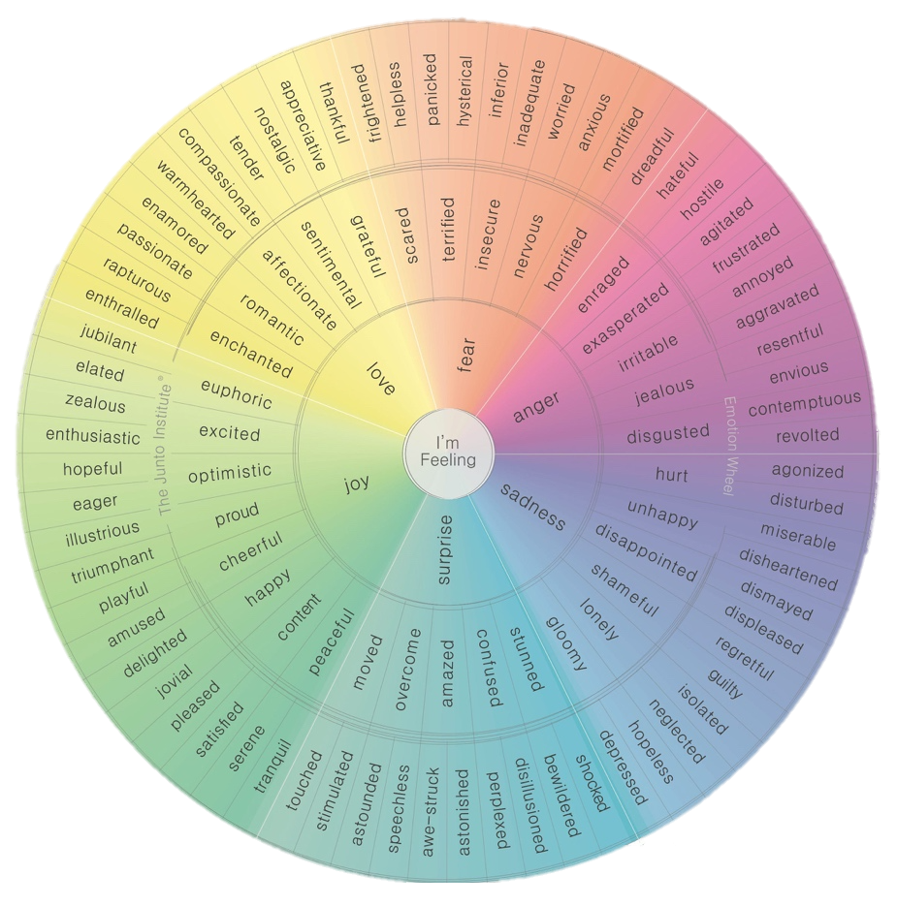

Question 4
For this question, you need to refer to the whole of Source A and Source B.
Compare how the writers convey their different feelings and perspectives on museums

In your answer, you could:
• compare their different feelings and perspectives on their experiences of museums
• compare the methods they use to convey their feelings and perspectives
• support your response with references to both texts.
Link |  | Source A | Source B
 |  | V:  Q:  A: | V:  Q:  A:
 |  | V:  Q:  A: | V:  Q:  A:
Question 5
“Museums, galleries and libraries should be funded by the government and offer free entry to everyone under 18. Teenagers should appreciate and value what these institutions offer”.
Write a speech giving your views on this topic.

