Source A ‘Have smartphones killed the art of conversations?’ on the Guardian Online, by Nosheen Iqbal in 2018 | Source B The following letter was written to Punch magazine in 1858 regarding the idea of a Telegraph being installed in the home.
News of the un-newsy kind this week, fresh from an Ofcom study designed to confirm a belief in our worst selves: we are a nation addicted to smartphones but are repelled by the idea of making or taking voice calls.  Is this the death of conversation? Not quite, but it’s certainly more than a blip in the cultural history of communication: in 2017, for the first time, the number of voice calls – remember, those things you did with your actual voice on your actual phone – fell in the UK. Meanwhile, internet addiction keeps growing, presumably because we haven’t quite worked out what to do with all those hours we’re saving on talking.  More than three-quarters (78%) of British adults own a smartphone, and we check them on average every 12 minutes. That adds up to 24 hours a week online via our phones – much of that time swallowed up by modern-style chat on WhatsApp and Facebook Messenger, with some left over for texting. It has taken a toll on talking, sure, but few smartphone users might claim to feel less connected as a result.  I hover near a generation in which long and pointless phone calls to the friends you’d spent all day with was an essential post-school afternoon ritual. Every minute was itemised, every telling-off for the small fortune this was costing, accounted for on the quarterly bill. Later, in my first taste of work as an intern at this paper, I was able to learn how journalists did their jobs because they were talking on the phone and to each other all day. Five years later, I was working at a start-up where real talk was at a minimum: conversations had migrated to the late, great MSN Messenger. Typing your talk officially took over.  Now, the idea of ringing someone for “a chat” has a quaint, retro quality. I can, and will, talk you under the table, but phone calls are a luxury usually reserved for about five people: my mum, my sister, two best friends and my editor, obviously. Even then, I’m rubbish at picking up.  Much is made about smartphones leading to dumber conversation - amid claims that the art of chatter has been lost. Arguably, however, conversation has simply been rebooted and reconfigured. Take the myriad ways in which we can and do communicate now. It’s a given that I will spend an embarrassing portion of my day glued to a screen (it’s work!) and much of that will be chatting (again, it’s work!). | A Telegraph all over London? The wires brought to within 100 yards of every man's door? A Company established to carry it out?  Well - I don't know. There's a good deal to be said on both side.  It certainly would be pleasant to be within five minutes of such a message as "Dine at the Club with me at seven;" or "SQUATTLEBOROUGH JUNCTIONS" at six premium; I've sold your hundred, and paid in the cash to your account;" or "Little stranger arrived safe this morning at twelve; mamma and baby doing well;" and one might occasionally be grateful for such a warning as "KITE and POUNCE took out a writ against you this morning - Look alive;" or "JAWKINS coming to call on you; make yourself scarce."  But think on the other hand of being within five minutes of every noodle* who wants to ask you a question, of every dun with a "little account;" of every acquaintance who has a favour to beg, or a disagreeable thing to communicate. With the post one secures at least the three or four hours betwixt writing the letter and its delivery. When I leave my suburban retreat at Brompton, at nine A.M., for the City, I am insured against MRS. P.'s anxieties, and tribulations, and consultings, on the subject of our little family, or our little bills, the servants' shortcomings, or the tradesmen's delinquencies, at least till my return to dinner. But with a House Telegraph, it would be a perpetual tete-a-tete. We should be always in company, as it were, with all our acquaintance. Good gracious, we should go far to outvie SIR BOYLE ROCHE's famous bird*, and be not in two places only, but in every place within the whole range of the House-Telegraph at once. Solitude would become impossible. The bliss of ignorance would be at an end. We should come near that most miserable of all conceivable conditions, of being able to oversee and overhear all that is being done or said concerning us all over London! Every bore's finger would be always on one's button; every intruder's hand on one's knocker; every good-natured friend's lips in one's ear.  No - all things considered, I don't think society is quite ripe for the House-Telegraph yet. If it is established I shall put up a plate on my door with "No House-Telegrams need apply."  * noodle: Victorian slang for a stupid person  * a famous Victorian saying: “it is impossible to be in two places at once, unless I were a bird”
Source A, first boxed section: Shade the boxes of the four true statements.
A. A new study says we’re addicted to smartphones but avoid voice calls.
B. Voice calls in the UK increased in 2017.
C. Internet addiction is falling as people return to traditional conversation.
D. More than 75% of British adults now own a smartphone.
E. On average, people check their phones every 12 minutes.
F. Smartphone users spend most of their screen time reading the news.
G. Messaging apps like WhatsApp and Facebook Messenger take up much of people’s online time.
H. Most smartphone users say they feel less connected to others.
Question 1

Question 2
Use details from both sources to write a summary of what you understand about the similar effects caused by advances in communication.
 | Source A | Source B
 | Evidence:  Suggestion: | Evidence:  Suggestion:
 | Evidence:  Suggestion: | Evidence:  Suggestion:
Source A, second boxed section.
How does the writer use language to describe how communication has changed?
Question 3
Question 4
For this question, you need to refer to the whole of Source A and Source B.
Compare how the writers convey their different feelings and perspectives on communication.
In your answer, you could:
• compare their different feelings and perspectives on their experiences of communication
• compare the methods they use to convey their feelings and perspectives
• support your response with references to both texts.
Link | Source A | Source B
 | V:  Q:  A: | V:  Q:  A:
 | V:  Q:  A: | V:  Q:  A:

Question 5
“We’re told smartphones bring people closer, but for many teenagers they just build walls; mobile phone use should be restricted to over 18s to protect the future generations”
Write an article giving your views on this topic.

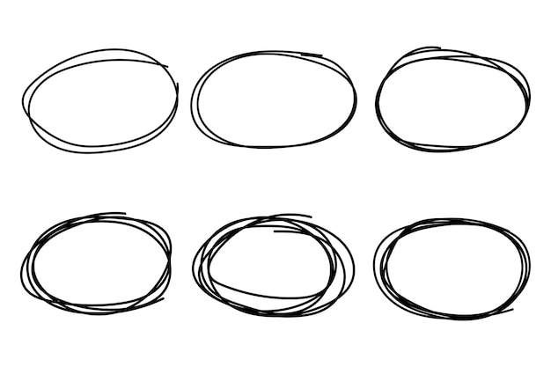



Language Paper 2 Overview
Q | Marks | Time | Focus | Tips
1
2
3
4
5

