Paper 2, Q4 and Q5 Mini Mock – death
Source A: Molly Conisbee, 2025, for Guardian Online: ‘I’ve studied the history of death’ | Source B: Dr John Simon, 1852,  ‘City of London Medical Reports: Special Report’
Many years ago, as part of a school homework project, I asked my grandparents what the most significant social change had been during their lifetime. Two of them answered “child mortality”. I was surprised. Weren’t there other, more significant experiences in long lives that had stretched from the first and second world wars to the 1980s?  But now that I am older and have experienced bereavement, I understand their replies. Both grandparents had sisters who died of diphtheria. And my grandfather’s younger brother died of sepsis, meaning his parents had buried two of their four children before the age of three. Their childhoods had been profoundly shaped by loss. Child mortality was, at that time, horrifyingly common, and from their earliest years many people spent a great deal of their lives coping with the emotional fallout of grief, which shaped their lives into older age.  I have spent the past 10 years researching the history of death, while also training as a bereavement counsellor. In my book, No Ordinary Deaths – A People’s History of Mortality, I argue that we have much to learn from the past, particularly in the compassion shown to those facing the end of life, and those struggling with the emotional chasm of grief and loss.  The differences between today and the past of even a few generations ago are enormous. Today, most people die in hospitals or care homes, but until well into the 20th century most died at home. Relatives or close friends usually washed and prepared the body for burial. The time between death and burial were understood as a dangerous and unstable moment for the spirit, and some communities developed elaborate wake rituals that could involve smoking, drinking, singing, games and “trickster” antics (such as lowering a shrouded body down the chimney, as recorded once in 19th-century Wales)  Wakes could last anything from hours to days and even weeks; an issue that horrified 19th-century public health campaigners. Indeed, such practices were regularly cited as one of the main reasons why burial reform was required, demanding that funerals should happen swiftly after death, and graveyards be moved away from city centres and into the suburbs. Nowadays, dying and death are, at least in wealthy, western societies, mostly institutionally managed and medically determined. Unless we work in healthcare or emergency services, seeing a dead body is a relatively unusual experience. | There is no part of the subject which I have considered with more anxiety than that which relates to delays in interment, and to the prolonged keeping of dead bodies in the rooms of their living kindred.  Evils arising in this source are unknown to the rich. Soldered in its leaden coffin, on tressels in some separate and spacious room, a corpse may await the convenience of survivors with little detriment to their atmosphere. Not so in the poor man’s dwelling. The sides of a wooden coffin, often imperfectly joined, are at best all that divides the decomposition of the dead from the respiration of the living. A room, tenanted night and day by the family of mourners, likewise contains the remains of the dead. For some days the coffin is unclosed. The bare corpse lies there amid the living; beside them in their sleep; before them at their meals.  The death perhaps has occurred on a Wednesday or Thursday; the next Sunday is thought too early for the funeral; the body remains unburied till the Sunday week. Summer or winter makes little difference to this detention: nor is there sufficient knowledge on the subject, among the poorer population, for alarm to be excited even by the concurrence of infectious disease in a room so hurtfully occupied... On an average, there would probably be lying within the City at any moment, from thirty to forty dead bodies in rooms tenanted by living person...  Among the wealthier classes, as I have said, this delay is practically unimportant, except in so far as every repetition maintains the custom. The longer interval, once rightly insisted on as necessary for the gathering of distant friends, has now, in the progress of events, become absurdly excessive: in a vast majority of cases, all those whose presence is needed, live within a narrow circle; and the more distant mourner, who, fifty years ago, would have spent several days in coming from Paris or Edinburgh, can now finish his journey in twelve hours. It is much to be wished that, under these changed circumstances, an altered practice might ensue in the upper classes of society, fixing their time of burial within three or four days of death.

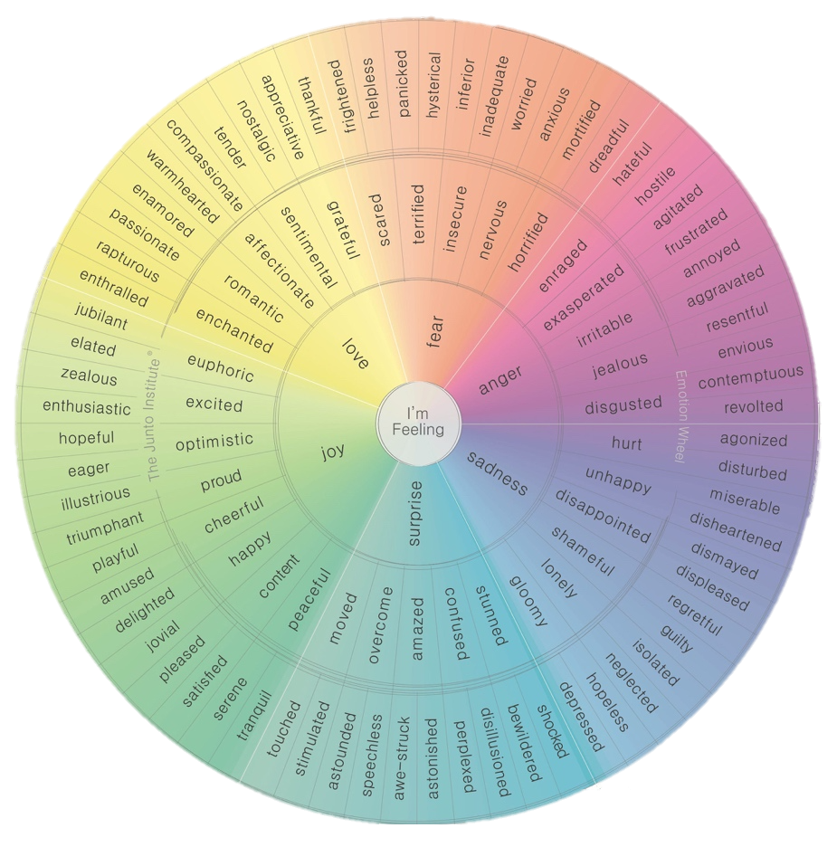

Question 4
For this question, you need to refer to the whole of Source A and Source B.
Compare how the writers convey their different feelings and perspectives on death and burials.

In your answer, you could:
• compare their different feelings and perspectives on death and burials
• compare the methods they use to convey their feelings and perspectives
• support your response with references to both texts.
Link |  | Source A | Source B
 |  | V:  Q:  A: | V:  Q:  A:
 |  | V:  Q:  A: | V:  Q:  A:
Question 5
‘Young people think they are invincible and that they will last forever. It is only when they begin to discuss and experience the reality of death that they begin to take life seriously’
Write a speech to be given to the teachers at your school offering your views on this topic.

