Paper 2, Q4 and Q5 Mini Mock – fresh produce
Source A: Franco Fubini, 2025, for Guardian Online: ‘A chance encounter took me to … a new life’ |  | Source B: J Thomson, 1877,  ‘Street Life in London: The Sweet Fruit Trade’
As I wandered out of my New York apartment, the snow compressing on to the sidewalk in that warming dusk light gave my walk to Citarella’s on Third Avenue a rhythmic glow. It was 1999 and Christmas was a few weeks away. In the northern hemisphere, December is the season for vibrant citrus, bitter leaves and pumpkins, yet behind me someone called out: “Where can I find peaches?” I turned around to see an affronted woman standing outside the greengrocer’s. The absurdity of the moment struck me – why would someone crave peaches in the middle of winter? It is just as absurd as sitting by the pool on a blistering summer day and reaching for a warm, woolly jumper.  I was already aware of the issues facing the food system; industrialised farming destroying our soils, the stomach of our planet, opaque supply chains leaving citizens powerless in making the right buying decisions, and the dominance of ultra-processed foods with zero nutritional value in supermarkets, schools and hospitals, to name a few. But this moment underscored our grave disconnect with nature and its seasons. We had normalised the idea that food can and should be eaten any time of the year. I couldn’t escape from this realisation, but little did I know that seemingly innocuous encounter in New York was to change my life for ever. After graduating from university, I was lured to the skyscrapers and energy of the Big Apple.  My escape was cooking, it always has been. When I came home from school in Buenos Aires; for my friends at university; and later while living in NYC, roaming its streets in search of unique ingredients, cooking was always my focus: the one thing I never tired of. In hindsight it should have taken me less time to recognise food was what my life should have been built around, that blurring of lines where life and work become one. My unhappiness with work was nothing new, it came and went throughout my life, but it was getting worse each year.  That was the catapult that shot me from a NYC skyscraper to the cold concrete pavement of London’s New Covent Garden Market at 2 o’clock in the morning, surrounded by towers of fruits and vegetables in the wholesale produce market that feeds the city. I made this leap in 2003, into the underbelly of the supply chain, working for Solstice, a fruit and vegetable supplier to top-end restaurants. It was a time when London restaurants wrote their menus based more on the origin of a recipe rather than seasons, before the real farm-to-table movement had started, and that was something I was passionate about changing. | The season for strawberries, the most delicious of English fruits, has ended. This delicacy was brought in numberless barrow-loads to the doors of the poorest inhabitants of London. The familiar cry, "Fine strawberries. All ripe! all ripe!" is silenced for a season by sounds less welcome. The fragrance of the ripe fruit wafted by the summer breeze from the coster's cart as it passed through the alleys, is replaced by less grateful odours - by the normal atmosphere of overcrowded neighbourhoods, by the autumn taint of animal and vegetable decay, which invests the low-lying districts of London.  One of the most agreeable phases of our modern civilization, is the supply of luxuries brought to the doors of the poorest inhabitants of this vast city, and offered at such prices as to place them within the reach of all. The illustration will convey some idea of the manner in which one luxury at least is distributed among the lower orders of the community.  The strawberry season began late this year, owing to cold winds in spring retarding the growth of the plant. The fruit was nevertheless so plentiful as to prove unremunerative to many of the growers. West of England strawberries should appear in the London markets about the end of May, and continue until about the 10th of June, after which the fruit grown around the metropolis takes the lead. The crop, when brought from the western counties, had to compete with supplies from other sources. The prices offered in Covent Garden were so low as to induce some of the growers to dispose of their entire crop at home.  Foreign strawberries during the height of the season are sold at prices ranging from ninepence to one shilling and sixpence per six-pound box. One of the wholesale merchants in Covent Garden, informed me that he thought about eighty pounds sterling would be the monthly value of the trade in strawberries in this market alone, while the fruit lasted. About one-half of the monthly supply of this fruit is bought by costermongers. But, as a rule, the costers do not venture to buy until the price falls so as to enable them to retail the fruit at fourpence or sixpence a punnet-basket.
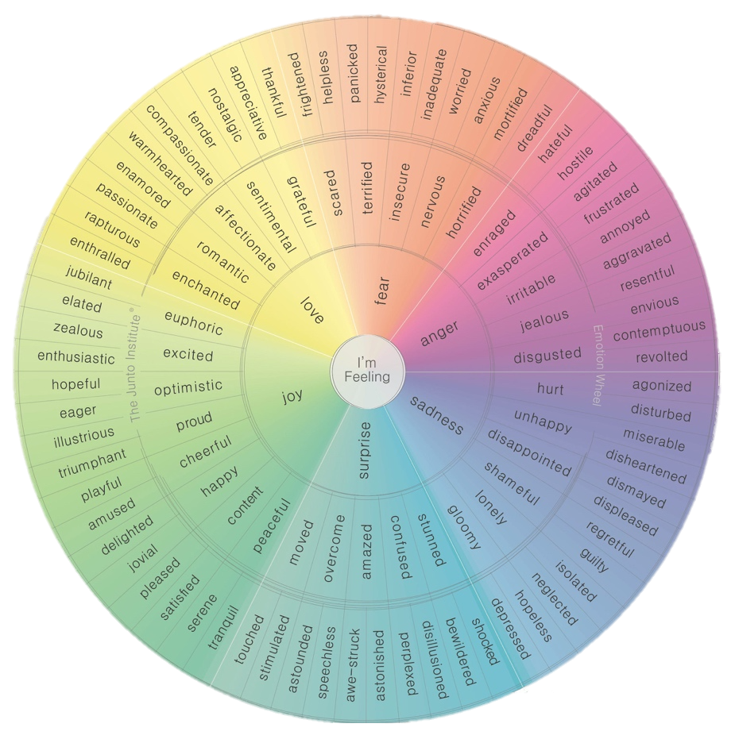

Question 4
For this question, you need to refer to the whole of Source A and Source B.
Compare how the writers convey their different feelings and perspectives on food/fresh produce.

In your answer, you could:
• compare their different feelings and perspectives on food and fresh produce
• compare the methods they use to convey their feelings and perspectives
• support your response with references to both texts.
Link |  | Source A | Source B
 |  | V:  Q:  A: | V:  Q:  A:
 |  | V:  Q:  A: | V:  Q:  A:
Question 5
‘"We are constantly told to buy organic, eat locally, and think sustainably when it comes to our food. But for many people, this kind of lifestyle simply isn’t realistic. Healthy, ethical eating is a privilege that most families can’t afford." Write an article giving your views on this topic.





